

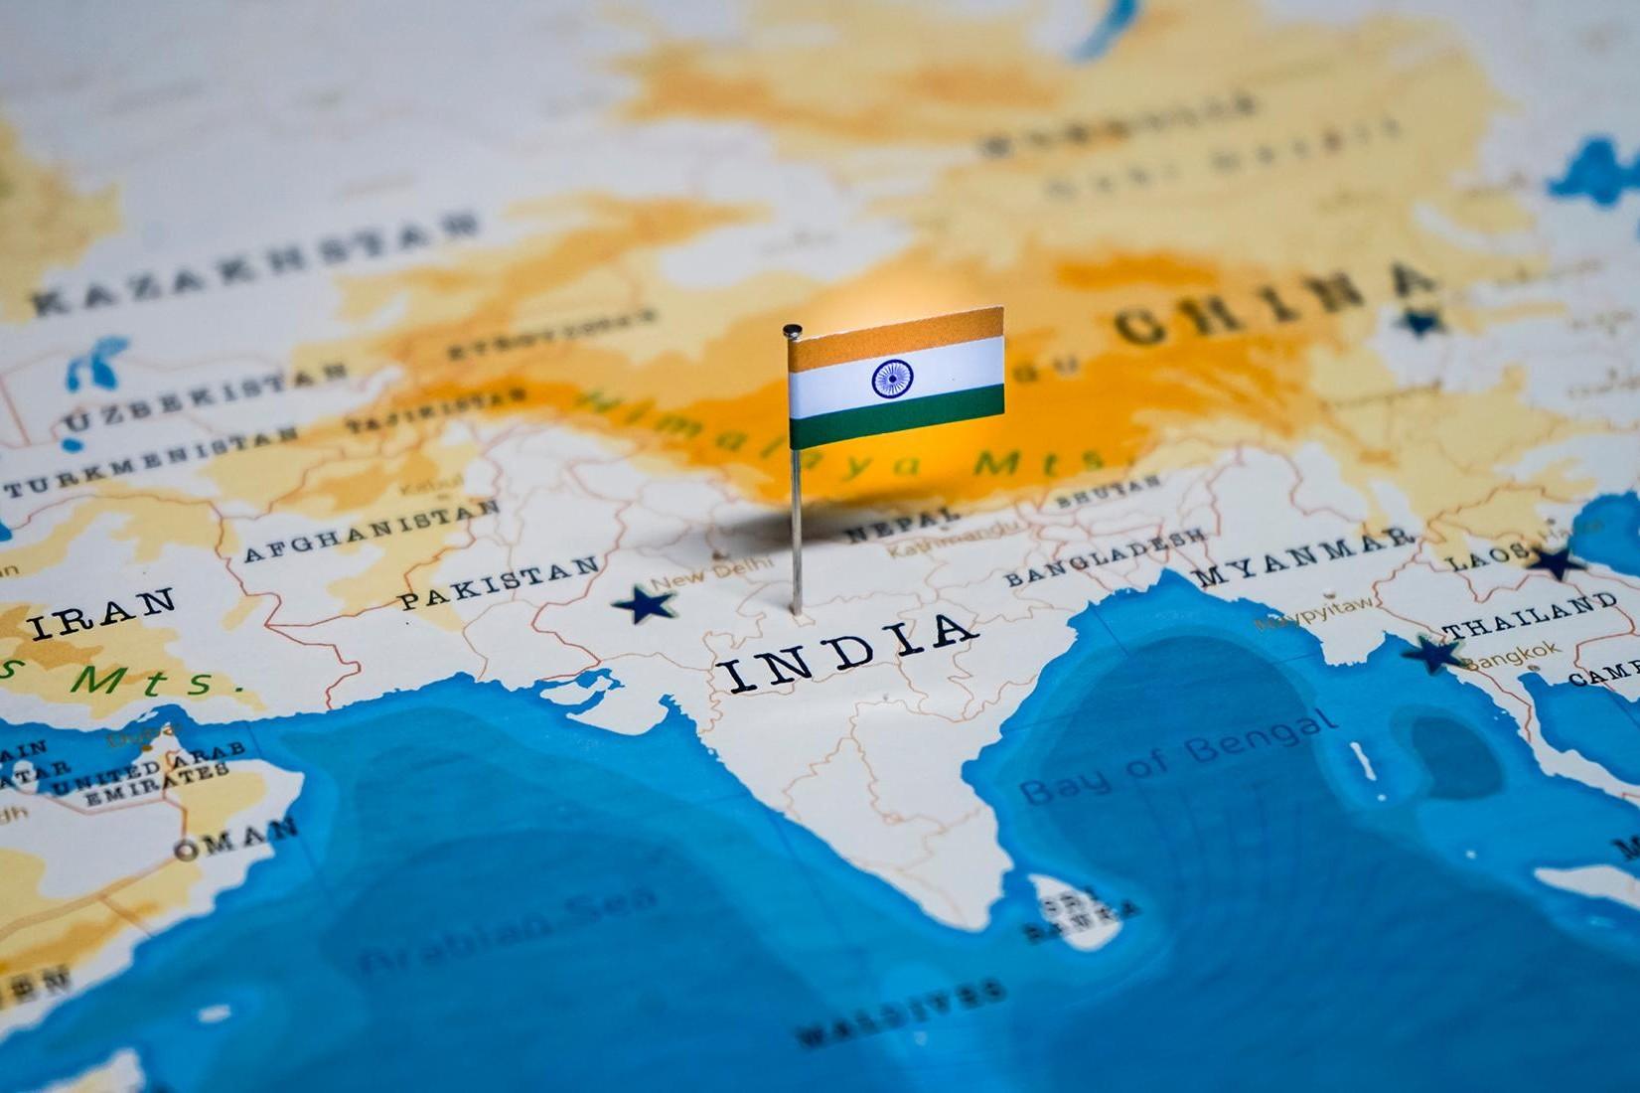

# GS2: International Relations

June 2025

###### Prepared together by:

Madhav Agarwal (<https://t.me/madhavagrawalair16>)

Ratnesh Agrrwal (Insta: <https://www.instagram.com/ratnesh13/>)

**Disclaimer:** These notes are for guidance & reference only, based on our study, experience, & memory. Some fun mnemonics/terms may be included just to aid recall—no offence is intended. Please use your judgment and keep them updated over time.

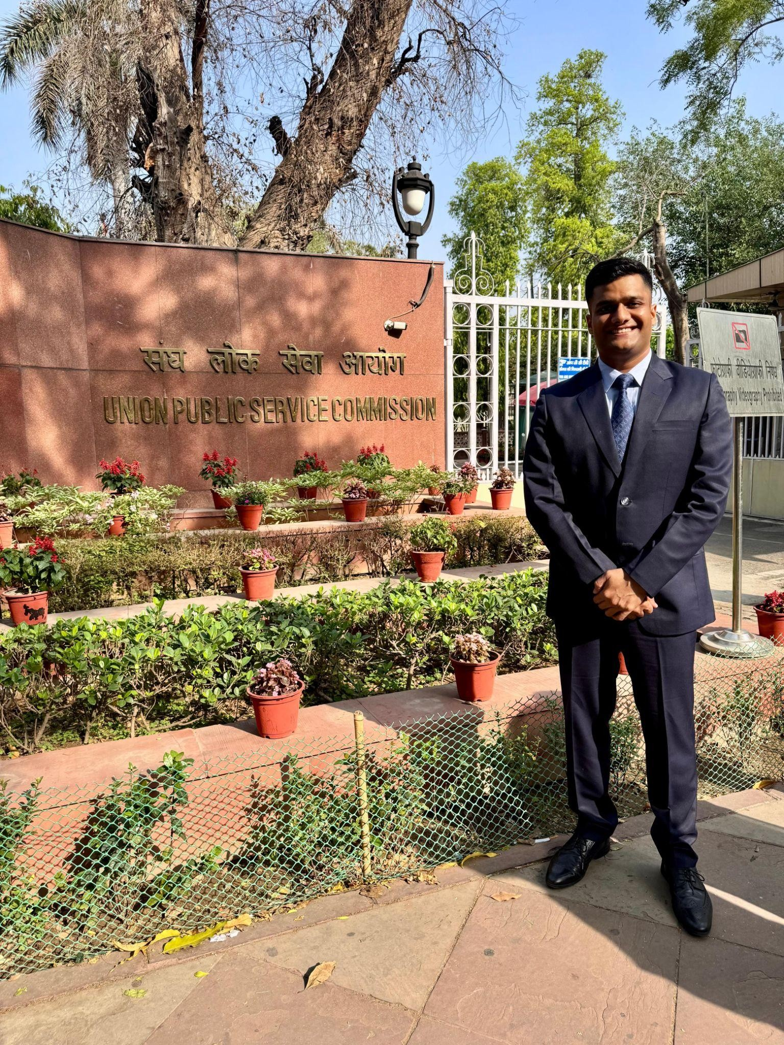**About Us**

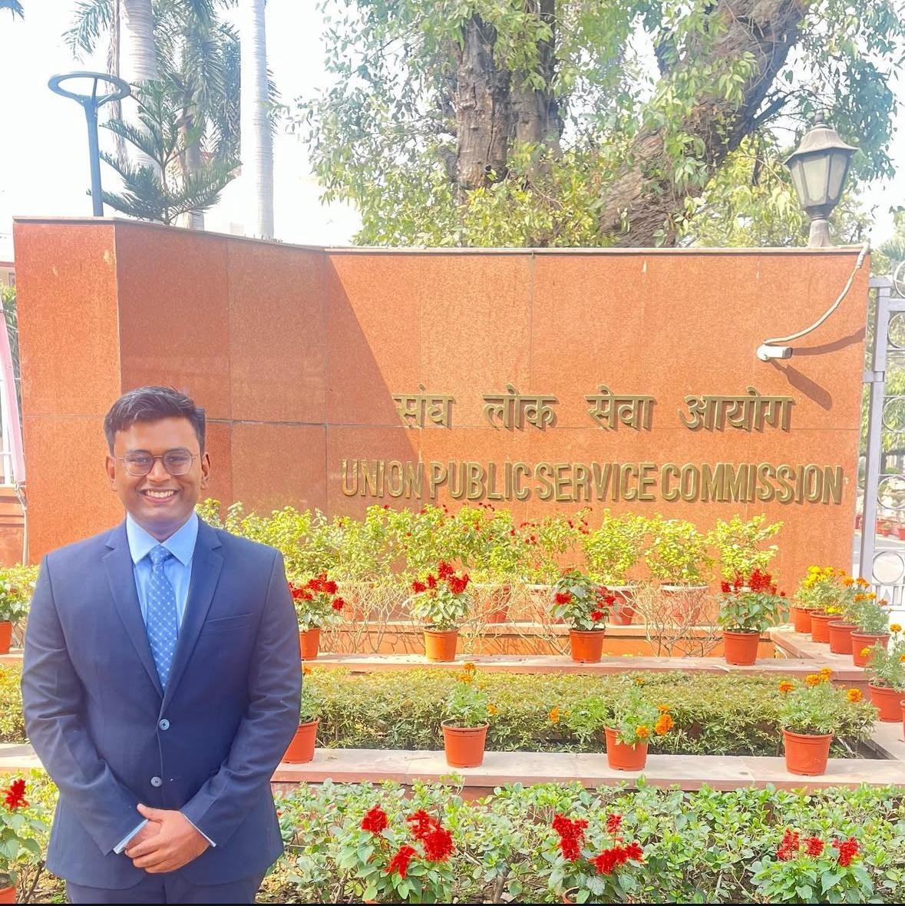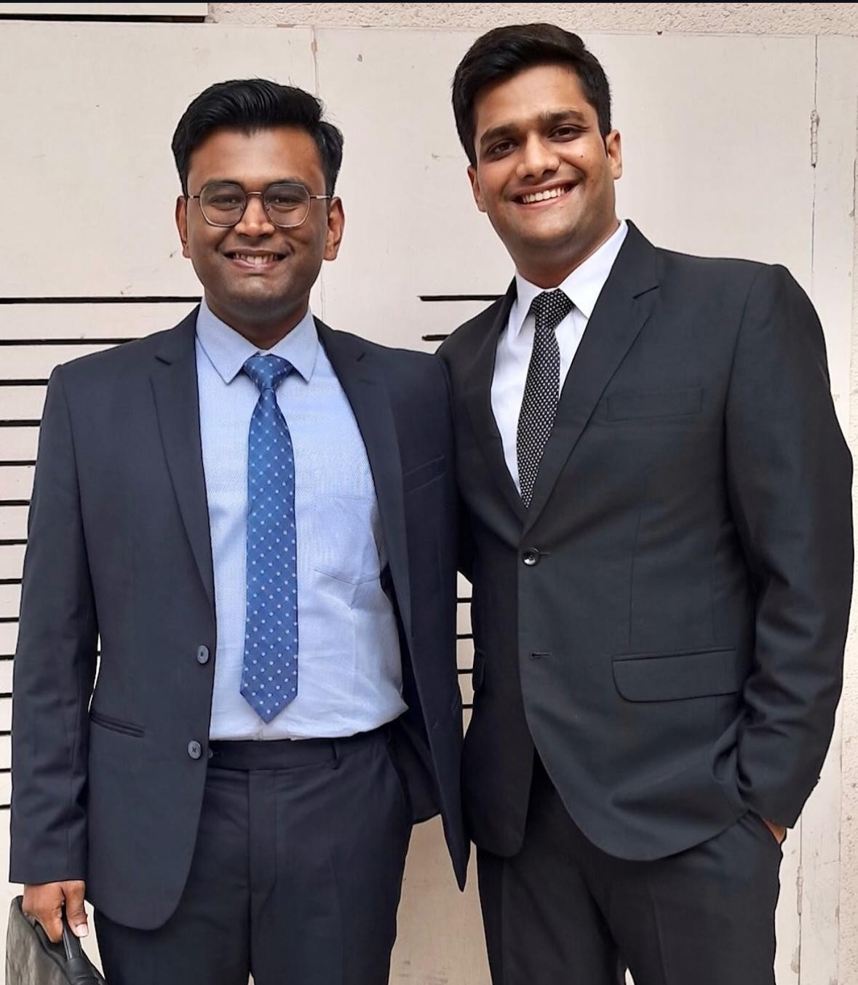

***Madhav Agarwal and Ratnesh Agrawal*** *— two friends, one mission, and a bond forged through shared dreams. From school classrooms to college corridors, their journey was always side by side. United by a common goal of cracking the UPSC, they spent over 300 hours on video calls — dissecting concepts, solving doubts, and building the notes that would become the backbone of their preparation.*

*Madhav went on to secure AIR 211 in CSE-2023 and then soared to* ***AIR 16 in CSE-2024****. Now set to join the* ***Indian Administrative Service****, he is living proof that quiet determination, when sustained with laser focus, can turn even the toughest dreams into destiny.*

*Ratnesh, who reached the* ***UPSC interview stage in CSE-2023****, chose a different but equally powerful path. With the same intensity and sharp thinking that marked his preparation, he stepped into the world of real estate. Today, he’s a* ***dynamic builder in Indore*** *— shaping skylines and lives with a vision rooted in public purpose and entrepreneurial fire.*

*These notes are a result of their shared struggle, deep friendship, and uncompromising pursuit of excellence — a* ***gift to future aspirants****, from two dreamers who refused to settle for average, each leaving a mark in his own way.*

**Index**

[GS-2 International Relations 4](#_TOC_250071)

[Syllabus 4](#_TOC_250070)

[PYQs Categorised As Per Syllabus 4](#_TOC_250069)

[Basic Structure Of Notes 12](#_TOC_250068)

[Bilarteral Relationships of India - Country Wise 13](#_TOC_250067)

[India-China Relations 13](#_TOC_250066)

[India-Maldives Relations 16](#_TOC_250065)

[India-Bangladesh Relations 17](#_TOC_250064)

[India-Sri Lanka 20](#_TOC_250063)

[India-Nepal Relations 23](#_TOC_250062)

[India-Pakistan Relations 26](#_TOC_250061)

[India-Afghanistan Relations 29](#_TOC_250060)

[India-Bhutan Relations 31](#_TOC_250059)

[Regional Engagements (SAARC, BIMSTEC) 32](#_TOC_250058)

[India-Myanmar Relations 34](#_TOC_250057)

[Indo-Pacific 35](#_TOC_250056)

[South China sea dispute 37](#_TOC_250055)

[India-ASEAN Relations 38](#_TOC_250054)

[India-Japan Relations 41](#_TOC_250053)

[India-West Asia Relations 42](#_TOC_250052)

[India-Israel Relations 45](#_TOC_250051)

[India-Iran Relations 46](#_TOC_250050)

[India-Africa Relations 46](#_TOC_250049)

[India-EU Relations 48](#_TOC_250048)

[India-France Relations 50](#_TOC_250047)

[India-Germany 51](#_TOC_250046)

[India- UK 51](#_TOC_250045)

[India-Russia Relations 51](#_TOC_250044)

[India-USA Relations 54](#_TOC_250043)

[India-Central Asia Relations 56](#_TOC_250042)

[India-Latin America Relations 58](#_TOC_250041)

[India’s Diaspora 59](#_TOC_250040)

[Bodies - Strucuture & Mandate 61](#_TOC_250039)

[UNSC 62](#_TOC_250038)

[United Nations Educational, Scientific and Cultural Organization (UNESCO) 63](#_TOC_250037)

[WHO 64](#_TOC_250036)

[NDB, AIIB, ADB 66](#_TOC_250035)

[NPT @ 50 years 67](#_TOC_250034)

[G7 68](#_TOC_250033)

[G20 70](#_TOC_250032)

[World Bank vs IMF 71](#_TOC_250031)

[SCO 73](#_TOC_250030)

[United nations 74](#_TOC_250029)

[ECOSOC 77](#_TOC_250028)

[UNHRC 79](#_TOC_250027)

[UN Peacekeeping 80](#_TOC_250026)

[Non Aligned Movement 80](#_TOC_250025)

[BRICS 82](#_TOC_250024)

[WTO 83](#_TOC_250023)

[Current Updates and Value Additions 88](#_TOC_250022)

* [Bangladesh Crisis 89](#_TOC_250021)
* [Myanmar 89](#_TOC_250020)
* [Neighbourhood 89](#_TOC_250019)
* [WA & Red-Sea 90](#_TOC_250018)
* [BRICS 90](#_TOC_250017)
* ICJ 91
* [IMEC 91](#_TOC_250016)
* UAE 92
* [Maldives 92](#_TOC_250015)
* [US President Elections 92](#_TOC_250014)
* [Russia 92](#_TOC_250013)
* [Sri Lanka 92](#_TOC_250012)
* [Africa 92](#_TOC_250011)
* [China 93](#_TOC_250010)
* Draw Maps + Quote policy 93
* [Key Value Added Terms 93](#_TOC_250009)
* [Quotes 94](#_TOC_250008)
* [Conclusions 96](#_TOC_250007)
* [G20: (made into G21 by India) 96](#_TOC_250006)
* [FTAs in News 98](#_TOC_250005)
* [India-USA Relations 98](#_TOC_250004)
* [Foreign Policy 99](#_TOC_250003)
* [Voice of Global South 100](#_TOC_250002)
* [Diaspora 100](#_TOC_250001)
* [Indo-Pacific 100](#_TOC_250000)
* Geopolitical volatility of 2022 is set to continue in 2023 0
* Multilateralism 0
* Multilateral Financial Institutions 0
* UN ECOSOC 0
* UNESCO 0
* India-France 0
* India-Egypt 0
* FIPIC 0
* Australia 0
* Germany 0

**Note:** These notes are the result of a group effort over the past few years. You'll find pink (or other coloured) highlights at the start of many topics—these usually mark key terms, definitions, quotes, etc., based on our memory cues at the time. While most content is updated, some sections—especially in **GS3**—may contain older material, so do cross-check and update where needed. Don’t get confused by the highlights; use what’s useful and feel free to build your own notes from them.

🔹 For GS2 – International Relations:

Please note that these notes were originally made in **2021**. They are still useful to understand the **basic structure and foundational elements** of bilateral relations and global institutions. However, international relations are dynamic, and many of these relationships may have undergone significant developments since then. Use these notes to grasp the context, and update them with recent changes as needed.

To assist with updates, we’ve added a **Current Affairs & Value Addition** section at the end of the notes. It can help you **enrich your answers (with quotes and key terms)** and also serves as a reference on how to make concise, effective short notes.

**GS-2 International Relations**

###### Syllabus:

* India and its neighborhood-relations
* Bilateral, regional and global groupings and agreements involving India and/or affecting India’s interests.
* Effect of policies and politics of developed and developing countries on India’s interests, Indian diaspora.
* Important International institutions, agencies and fora- their structure, mandate

###### PYQs Categorised As Per Syllabus

**India and its neighborhood-relations (Model ans of all neighbourhood relations on PESTEL dimension)**

1. Impact of China’s policies (eco, military, ocean) on India
2. 2012: Do you think that China’s emergence as one of the largest trading partners of India had adversely affected the settlement of the outstanding border problem?
   1. Angles to be covered:
      1. Fighting with wallet rather than bullet
      2. Excess dependence on chinese imports eg: Pharma API
         1. Atmnanirbharta,FDI rules, app bans after Galwan
      3. India and China’s stand: how one stresses on clarity and other does not want clear demarcation but confidence measures
      4. However complete eco cuts not desirable- more chances of war- manage issues at micro level
3. String of Pearls. Security and strategic impact on India, Steps to counter (Repeat question)
   1. String of Pearls(talk about various chinese ports,bases,BRI etc)
   2. Steps of Counter: ASEAN centrality, Stratgic partership with Indo-pacific nations, Quad, SAGAR, String of flowers, IFC-IOR, Coop with France/Japan, In neighbourhood with SL/Maldives, Project Mausam, Theatre command at A&N islands, Military excercises, Duqm port, etc, I at China neighbourhood- SCS positions, Vietnam hydrocrabon, Taiwan swearing in, foundational defence agreements with USA,
4. South China Sea: Dispute? Analyse I-C relations keeping SC as the context?
   1. Covered below in nots
5. Economic and strategic dimensions of India’s Act east policy, impact of ASEAN in post cold war
   1. India started following the ‘Look East Policy’ in the early 1990s when at the end of the cold war it sensed a change in the locus of world economic power from ‘west’ to the ‘east’.
   2. Economy- post 1991, tiger economies, more trade for growth, etc
   3. Strategic- China, SCS, sea lines of communication, choke points, conflict in region affect india’s economy etc
   4. Also cover aspects of growing proximity with ASEAN - quote evolution of relationship
6. Project Mausam. Does it have strategic dimension? Other Indian ocean schemes for maritime neighbourhood as net security provider? Other MEA schemes
   1. Schemes covered in Indo pacific question 3 above
   2. Mausam by Min of culture- better ties, knowledge of monsoon and how it shaped ties, strategic dimesions- exchange of info btw nations, seen as soft counter to BRI at that time.
7. 2015: India-Pakistan relations. Use of soft power (sports,cultural exchanges) for diplomacy? Other examples
   1. P-P ties- pawri diplomacy, musical ,literary, cinematic exchanges, cricket analysis by Pak players on Indian cricket
   2. Kartarpur corridor, both sides have dreamt of combined team of

India-Pak in their young age, shared for music eg: Coke Studio Pakistan being more famous, Modi enroute visit to Islamabad

* 1. However issues wrt Pak state spon of terror issue- write strategic options- doval doctrine , smart power rather than only soft or hard etc

1. Maldives political developement as concern for india? Indian policy towards Maldives
   1. Significance of maldives then current policy with issues and wayforward
   2. [https://indianexpress.com/article/india/political-development-in-maldive](https://indianexpress.com/article/india/political-development-in-maldives-a-matter-of-concern-mea-5237646/) [s-a-matter-of-concern-mea-5237646/](https://indianexpress.com/article/india/political-development-in-maldives-a-matter-of-concern-mea-5237646/)
2. India-Sri Lanka relations. Indian domestic factors influence foreign policy?

Impact on new goverment change in SL

* 1. Tamil Nadu and Tamil SL issue , refugee influx issues (Peace keeping forces, Rajiv gandhi assasination)
  2. 13th amendment, Diplomactic statements from India, Recent visits of EAM/NSA, Quote relevant developmental assistance provided by India from Tamils in SL
  3. All this has created a historic baggage for Delhi’s relation with Colombo in recent times

10. 2012: India Nepal relations. Issues with constitution logjam? Boundary issues

1. Madhesi issues- federal province on horizontal basis (so that all of them come under one province rather than getting divided) but nepal const 7 vertical provinces , 2015 blockade after EQ, Boundary issues-Kalapani,

11. 2013, 1997: Gujral doctrine. Relavent today? (repeat question)

1. Key Points: Non-reciprocity principle (give without expecting anything in return), No south asian should allow its territory to be used against interest of other SA nation, Resolve disputes with peaceful means,

Respect - terrirorial integrity/sovereignty/non-interference

1. Relevant today- yes with also focus on terror response, china factor, nepal encroaching on sov , using anti-india rhetoric for politics etc- manage with diplomacy and projects
2. Gujral doctrine gave a base for Neighbourhood First 2014

12. Indus Water treaty. Current challanges on both sides ? Review required?

a. [https://www.drishtiias.com/daily-updates/daily-news-analysis/60-years-of](https://www.drishtiias.com/daily-updates/daily-news-analysis/60-years-of-indus-water-treaty)

[-indus-water-treaty](https://www.drishtiias.com/daily-updates/daily-news-analysis/60-years-of-indus-water-treaty)

**India’s Extended Neighbourhood**

1. 2020: India **Japan** relations: Global and strategic partnership that will have great significance for Asia and the world. Comment
   1. 2013: Economic ties below potential? What are the policy constraints?
2. 2018: “India’s relations with **Israel** have, of late, acquired a depth and diversity, which cannot be rolled back.” Discuss
   1. Covered

**Bilateral, regional and global groupings and agreements involving India and/or affecting India’s interests**

1. Central Asia
   1. 2018: Implication of joining the Ashgabat Agreement?
      1. Connectivity with CA countries, boost to Connect CA policy
      2. Better ties with Iran, Afghanistan
      3. Boost trade and investments in the region
      4. Good for energy security - oil, atomic minerals
   2. 2011: Importance of the region country wise? Opportunities and bottlenecks in enhancing relations?
      1. Covered below
2. Global Groupings
   1. 2019: “The long sustained image of India as a leader of the oppressed and marginalised nations has disappeared on account of its new found role in the emerging global order.’ Elaborate
      1. CC negotiations- stance moderating due to int pressure, Trade policies diplomacy
      2. India inc growth- ability to take care of developing C diplomacy?
      3. UNSC PS aspirations, G7,G20 diplomacy
      4. Boycotting Pakistan in SAARC is ‘seen’ to be at cost of regional integration’
      5. Involvement of India in pursuing its own national interests as done via Quad
      6. Increasing convergence with US, Neglect of NAM, IBSA
      7. These inferences are pointing towards shift in India’s approach from the leader of the oppressed countries to a great power in its own terms. India’s approach is shifting from **Idealism to Realism** and is prioritizing its national interests over the collective interests of the developing countries
      8. However

1. Efforts for dev of poor nations- AAGC with japan, ITEC, insistence for Doha round- Public stockholdinng, island nation interest in CC talks etc

1. 2017: The question of **India’s Energy Security** constitutes the most important part of India’s economic progress. Analyze India’s energy policy cooperation with **West Asian** Countries
2. 2013: Withdrawal of US forces from Afghanistan - Impact on India? Challenges? How to safeguard our interest?
   1. Covered below
3. 2020: Quadrilateral Security Dialogue (QUAD)’ is the transforming itself into a trade bloc from a military alliance, in present times – Discuss. **(Answer in 250 words)**
   1. Recent first summit level meeting of QUAD, covered above

**Effect of policies and politics of developed and developing countries on India’s interests**

1. 2018: US-Iran Nuclear Pact Controversy. Impact on India? How should India respond? Impact on relations with Iran after sactions? with USA?
   1. Iran imp- regional connectivity, energy, chabhar, afghanistan,pakistan
   2. US ties imp but withdrawing from deals bad precedent
   3. WF- strategic autonomy
2. 2012: Why have the resource rich African and South Asian countries remained poor for decades? Explain
   1. Colonialism impact, Burecracy, no EODB, pol crises, cold war era
   2. Geography: Countries near the equator witness rainfal everyday thus hindering infra strucutre development efforts
3. 2019: What introduces friction into the ties between **India and United States** is that Washington is still unable to find for India a position in its global strategy, which would satisfy India’s national self-esteem and ambitions’. Explain with suitable examples.
   1. Afghanistan peace process- India out for long time, criticsm by US president saying India build libraries, not recognising contributions
   2. Iran nuclear deal- issues wrt Farzad gas fields, affecting india’s energy security, chabhaar issues whereas USA unilaterally withdrews from JCPOA
   3. CAATSA wrt arms purchase from Russia(not considering sensitivities)
   4. WTO (blocking of judges, hampering doha round)
   5. CC (neglect of adaptation funds, Spcl and diff treatment issues)
   6. Withdrawal of GSP status of Inida, Remarks of tariff king.
   7. However
      1. Renaming pacific command as Indo-pacific command
      2. Recent efforts for bringing into G7,NSG, Afghan peace process,

Anti-China policies

* + 1. From estranged to engaged democracies

1. 2018: Protectionism? Other countries policy towards India? Impact on India?
   1. US protectionism, neglecting WTO role, more focus on plurilatral agreements rather than reforming WTO, Atmanirbharta
   2. Impact on India- API issues etc but also inc exports for growth ect
   3. Protectionsim covered in GS3
2. 2020: What is the significance of Indo-US defence deals over Indo-Russian defence deals? Discuss with reference to stability in the Indo-Pacific region. **(Answer in 250 words)**
   1. Question to be read in light of all 4 foundational agreements being signed with USA, CAATSA, S400
   2. China challange- inc imp of US defence, Indo-pacific,quad,south china sea, issues of russia-china axis
   3. However Russia too time tested ally, largest defence imports, more tech tranfer without much conditions

**Important International institutions, agencies and fora- their structure, mandate**

Points to cover for each institution

* Intro (how formed,member,fundings etc- basic details)
* Structure and mandate/functions in brief( Also cover some positive story)
* Current status and issues with the org
* Reforms needed
* India- focus(i.e how India benefits from it, what India should do for its interest wrt org, how India can play leadership role wrt other small nations etc)

1. Critically examine the role of **WHO** in providing global health security during the COVID-19 pandemic. **(Answer in 150 words)**
   1. Covered below in WHO content= mention +ve as well -ve aspects
   2. Highlight in the end need for reforms to ensure better preparedness towards such health crisis in the future
2. 2014: Some of the International funding agencies have special terms for economic participation stipulating a substantial component of the aid to be used for sourcing equipment from the leading countries. Discuss on merits of such terms and if there exists a strong case not to accept such conditions in the India context
   1. Asked in context of conditional aid by WB,IMF
   2. Merit- directed for social sector expenditures, reduces leakages as targeted
   3. Impact- less flexibilty to use funds, promotion of free market economy, one size fit all terms decided by IMF technocrats neglecting local conditions
   4. Thus buillding alternative arrangements such as NDB, AIIB etc
3. ‘Too little cash, too much politics, leaves **UNESCO** fighting for life.’ Discuss the statement in the light of US’ withdrawal and its accusation of the cultural body as being ‘anti-Israel bias’.
   1. Mention significance of UNESCO
   2. Why USA left the body: In 2011, UNESCO recognised Palestine as a member state. Soon after that, there is US congressional resolution that if any UN body accepts Palestine as member, no funding can go from US. So funding has not been there since six years. In 2017, UNESCO

designated the old city of Hebron in the West Bank as Palestinian World Heritage site which the Israelis duly objected to.

* 1. Cover other issues related to UNESCO
  2. Conclude with way forward how such politicization needs to be controlled to ensure ... (write objective of UNESCO)...

1. What are the aims and objectives of the McBride Commission of the **UNESCO**? What is India’s position on these?
   1. McBride Report of 1980: The comprehensive report of the MacBride Commission is also named “Many Voices, OneWorld”.
   2. It analyzed communication problems in modern societies, particularly relating to mass media and news, consider the emergence of new technologies, and to suggest a kind of communication order (New World Information and Communication Order) to diminish these problems to further peace and human development. There was concern that the communication, particularly mass media was dominated by developed countries. It was feared that their perspective, culture, and ideas gained prominence.
   3. It suggested the democratization of communication technologies and strengthening of national media to avoid dependence on external sources.
   4. India welcomed the report. The Commissions Seminal session to address the problems was hosted in New Delhi in 1979. India called for equitable access and took measures to further strengthen the national media. The Prasar Bharathi Act 1990 was enacted to provide legislative support.
2. What are the key areas of reform if the **WTO** has to survive in the present context of ‘Trade War’, especially keeping in mind the interest of India?
   1. India’s Perspective on Doha Round of WTO (repeat question)
   2. Mandate of WTO? How binding are its decisions? Critically analyse India’s stand on food security talks?
   3. Current importance of WTO in the light of various opportunities and challenges at the global level
      1. Covered below
3. **ECOSOC**: Mains functions? different functional commissions attached to it? (Prepare the other six organs of UN; Other UN Bodies in news)
   1. Covered
4. **SAARC**: Current relevance?
   1. Covered
5. 1980: What are the principles underlying the concept of nonalignment? Has this policy been fruitful? Give reasons for your views. (Mains 365 2020 Pg 68)
   1. Covered
6. Impediments India is facing in its pursuit of a permanent seat in **UN Security Council?** India’s effort in this regard?
   1. Impediments:
      1. There is lack of consensus on how to reforms rather than the need to reform. Need to address questions such as veto power, size of enlargement, regional representation, etc.
      2. Efforts of G4 are blocked by United for Consensus (aka Coffee club)
      3. Only France has made outright promise for India while other are ambigous or against
      4. India’s neutral stand and status of soft power is used to doubt its power to take hard stands required at UNSC
      5. India not a member of NPT, CTBT can also be a impediment
      6. Allegation of lack of capacity in terms of funds, alleged HR violations stand in the way of India
      7. No clarity among G4 itself, as in who will go first?
      8. P5 are reluctant to share power with other nations
   2. Efforts: Covered below

10. 2014: The aim of Information Technology Agreements (ITAs) is to lower all taxes and tariffs on information technology products by signatories to zero. What impact would such agreements have on India’s interests?

1. India signed ITA-1 but hesitant to join ITA-2
2. Aim of zero tariff on IT products, Indian IT exports benefit
3. Issues wrt digital tax, recent aus- google issue, technocracy inc eco potential, issues wrt huge import of electronics when domestic capability inadequate
4. WF- Make in india, better elec industry then will benefit bu 0% rate
5. Role of **NDB and AIIB**? Differences? Strategic significance for India? (cover it within the theme of countering westerm dominance in financial institution such WB, IMF)
6. **WB, IMF**: Differences & Common points in their role, functions and mandate
7. Significance of **IBSA and BRICS** in the context of India’s multilateral diplomacy
   1. BRICS covered, IBSA less imp given- need for IBSA for South-soth co-op and countering China

**Indian Diaspora**

1. ‘Indian diaspora has a decisive role to play in the politics and economy of America and European Countries’. Comment with examples. **(Answer in 150 words)**
2. Indian Diaspora has an important role to play in South-East Asian countries’ economy and society. Appraise the role of Indian Diaspora in South- East Asia in this context.
   1. Historical,cultural angle- Buddhism,Bali,Ramayan, Cambodia and Laos temples etc
   2. Bollywood, Ayurveda popular
   3. Today, Malaysia and Singapore have local Indians who comprise 7 and

9.1 % of the total population respectively, and are seen as a minority in both

* 1. Eco-Singapore based indian industries-Flipkart, IT migration, huge indian diaspora worlking in ASEAN countries
  2. Other basic diaspora points wrt remittances, political imp in nations, inflluencing culture towards india etc

1. Write a short analytical note on Indian Diaspora. How is the “New Diaspora” different from the “Old Diaspora”?
   1. three subsets of our diaspora: the Old Diaspora, the New Diaspora, and the Gulf Diaspora. There is one consistent theme to all three categories. They were, and continue to be, created by a labor migration – unskilled labor starting two centuries ago, and highly skilled labor after the

mid-1960s. The first wave of the Indian Diaspora is what we call the “Old Diaspora.” It began during the early 19th century and continued until the end of the British Raj. Indentured labour went to Mauritius, Suriname, Trinidad, Fiji (Caribbean, Africa, and Asia)

* 1. Today this “Old Diaspora” constitutes 60% of our Indian diaspora, or approximately 18 million PIOs. The Old Diaspora is primarily a pre-WWII phenomenon. The New Diaspora, on the other hand, consists of migrants who left India in large numbers from the mid-1960s onwards – primarily to developed countries like the UK, US, Canada, Australia, and Western Europe.

###### Basic Structure Of Notes

* Introduction

○

* Significance

○

* Conflicts and future challenges

○

* Current measures for cooperation

○

* Way forward

○

* Conclusion

## Bilarteral Relationships of India - Country Wise

🔹 For GS2 – International Relations:

Please note that these notes were originally made in **2021**. They are still useful to understand the **basic structure and foundational elements** of bilateral relations and global institutions. However, international relations are dynamic, and many of these relationships may have undergone significant developments since then. Use these notes to grasp the context, and update them with recent changes as needed.

To assist with updates, we’ve added a **Current Affairs & Value Addition** section at the end of the notes. It can help you **enrich your answers (with quotes and key terms)** and also serves as a reference on how to make concise, effective short notes.

###### India-China Relations

* Introduction
  + Two countries of growing importance in this era with rich and fractured history. Their relationship is reactive due to geo-startegic competition btw the two
  + I-C have complex and multi-layered relations which are undergoing frictions in recent times
* Significance
  + Combined 2.7 Billion population-if cooperate- strong asian century a reality
  + GDP comparison - Chinese GDP = 5 times of India GDP
* Conflicts and future challenges
  + Border disputes (draw map)
    - Border not clearly demarcated as no mutually agreed LAC
      * Western border- dispute wrt Aksai Chin (India considers Johnson line and China considers Mcdonald line which puts Aksai Chin under its control)
      * Middle sector- Both broadly agreed and maps exchanged
      * Eastern sector- Dispute wrt Macmohan line (China claims Aru. P and Sikkim)
    - Unilateral attempts to change status quo - Galwan clash- 20 Indian soldiers killed- first deadly clash on border in last 45 years, Doklam dispute 2017
    - Infra dev by both C- Daulat beg Oldie road by India
    - Challenges increase manifold once dual front security issues as well as USA’s withdrawal from Afghan (making Taliban stronger) is taken into consideration
    - Difference in appraoch: India insists on clarification of LAC whereas China likes ambiguity and focuses on CBM rather than demarcation
    - India’s Stand: *in simple words* - clarify everything at border first before easing relation across other sectors (similar to stand wih Pak which says terrorism & talks cannot move together)
  + Water sharing issues (India = lower riparian)
    - China building dams on upper reaches of Brahmaputra, no formal treaty over sharing of Brahmaputra river water, Proposed project on ‘Great Bend of BH’
    - Issues: Lack of comprehensive river water agreement; Irregularity in sharing data (no data shared in 2017); Ltd. data sharing ie. only during monsoons
  + Economic issues
    - Cheque book diplomacy by LOC to most of the South Asian countries.
    - Total Bilateral Trade $90+ bn (from 3bn in 2000)
    - Trade deficit of $51 bn (China-I 2nd largest partner but I in top 10)- protectionist policy hindering Indian co.
    - Causes for deficit: Nature of goods we export is basic vs we import is value added; Regulatory barriers for our competent areas such as Pharma; Deep reliance on China (70% of API)
    - Depsite border tensions, China replaces US to become India’s top trading partner amid COVID-19 restrictions
  + Geo-political and strategic competition
    - India’s participation in QUAD, Malabar Excercise, Supply chain resillient initiative (for finding alternate supply chains) seen by C as alliance of democracies to contain it
      * China’s aggressive diplomacy from other states of south asia to join Quad in future (eg: aggressive stand towards bangladesh which was later corrected)
    - BRI affects India’s sov as passes through POK
    - China open support to Pak- UNSC Masood Azhar, NSG- enabling Pak to continue assymetric warfare.
    - Increasing presence in Indian ocean- Hambantota port,Cocos island in Mynamar,Gwadar- string of pearls, owns 70% debt of maldives, nuclear plant building in Bangladesh (Beijing’s expanding footprint in S Asia and beyond)
    - Other issues of friction: NSG memb, UNSC seat, Close door meetings on issue of J&K
    - Dalai lama and tibetan govt-in exile in India
  + Global issue
    - Coronavirus backlash- India supported resolution for fair probe at WHA for origins of COVID
    - Structural issues with BRI (NB Pg 76) leading to frictions bw partners
* Current measures for cooperation/counter
  + Border Dispute settlement
    - 5 agreements signed in btw 1993 and 2013 (for peace and tranquility at LAC, CBM’s for military etc) which provide modus operendi for diplomatic and military engagement as well as status quo commitments in case of disputes
    - Dialogue at military level. Flag post meetings, Hotlines
  + Global cooperation
    - counter western dominated institutions with asain alternatives(BRICS, credit rating agency,AIIB), cooperate on climate change,WTO strenghtening etc
  + Economic measures
    - To Counter
      * Supply chain resillient initiative (for finding alternate supply chains)
      * Restrictions on FDI from border states; Banning 200+ apps
    - For Cooperation
      * High level Economic and trade diologue mechanism for inc trade- both seeks to build “manufacturing partnership”
  + Geo-strategic measures
    - Platforms: BRICS, RIC Trilateral, SCO can be leveraged
    - Taiwan- Indian MP attending swearing in of president of Taiwan(China not considering india sensitivies in POK)
    - Vietnam- Imp wrt SCS- India inv oil and gas exploration, pivotal state in containing China
    - “String of flowers”: Coop with islands such as Agalega Isl, Assumption Isl, etc.
    - USA and QUAD and ‘QUAD-plus’ (young concept) (all theses measures are for external rebalancing/external signalling)
  + Cultural/People to people
    - Year of India-China cultural exchanges to celebrate 70th Anni of diplo relations, Sister-state relationship btw TN and Fujian province
    - 10 Pillar Agreement 2018 to enhance cultural & P2P ties
  + Leadership
    - Wuhan spirit- focussing on respecting each other sensitivity, strategic guidance to their respective militaries,simultaneous
* Way forward

emergence of I and C with independent FP as reality, Mammallapuram summit

* + Functionalism (solving issues pieces by pieces) important for better India-China relations
  + Indian Army proposal to study ‘Tibetology’ (hist, cult, lang) - Need to further build upon understanding on China
  + Quest for l’ship is natural for any large country but the same quest for dominance & aggrression becomes an issue
  + Long term solution - Building Comprehensive National Strength by building economy, defence, R&D, social cohesion
  + Framework by SS Menon: Respect for core interests, newer areas of coop eg: climate change, counter-terrorism
* Conclusion
  + China should understand that Asian century can’t be **just** Chinese century

###### India-Maldives Relations

* Introduction
  + Share ethnic,linguistic,cultural,comercial links from ancient times. India among first countries to recognise and est diplomatic relationship after Maldives independence in 1965
  + Maldives currently has self proclaimed “India first” policy
* Significance
  + Strategic- close proximity so chances of third nation naval presence a big risk, situated at hub of commercial sea lanes(75% I’s trade by value passes through this region)
  + Ambitions of India for being a ‘net security provider’ in IOR calls for closer military and naval ties with Maldives
  + Other general points similar to SL
* Conflicts and future challenges
  + China inroads
    - Increasing pressure of national debt of C on Maldives (40% of GDP)
    - FTA of Maldives with China, land grab issues agreed by Mhd Nasheed
  + Political instability as democracy not yet ripe- termination of GMR project of India, take back helicopters, No indian should appl, Yameen-imposed emergency (However currently Solih govt- good India relations-Modi at swearing in)
  + Increasing radicalisation → 200 ppl joining ISIS
  + Rising Anti-India sentiments - eg: #saveAddu (after new consulate proposed), Lakshadweep Development Authority Regulation (LDAR impacted maldvies as it had historic/ethinic ties with indian there), India Out campaign, taking back of helicopters
* Current measures for cooperation
  + Economic aspects: ~280 mn (in favour of India)
  + Development assistance:
    - Funds provided for Greater Male Connectivity Project (connects islands)- largest civilian infra in maldives
    - $1.4 bn for High Impact Community Development Projects such as ambulances, police centres, drug rehab,Indira Gandhi memorial hospital, etc.
    - Operation Neer 2014 - to avert water crisis in Maldives
    - COVID assistance: Meds and vaccines
  + Connectivity
    - New ferry service from Cochin, submarine cables for telecom
  + Defence: Meeting 70% of Maldivian National defence training needs, SAGAR initiative
  + P2P ties:
    - Indians are the 2nd largest expatriate community- 25% doc and teachers indians
    - Popularity of hindi films, music, TV serials; Indian Cultural Centre at Male conducts courses on Yoga/classic music, New cricket stadium
* Way forward
  + Maldives currently a diplomatic success but another election could be risky thus need more high impact projects along with faster completion and LOC’s to reduce dependence on China
  + It is hoped that India in the UNSC and the Maldivian President of the UNGA will work in tandem as New Delhi pursues its goals for multilateral reform,
* Conclusion
  + Build upon convergence b/w India's Neighbourhood First and Maldives India First policy to further cement ties

###### India-Bangladesh Relations

* Introduction
  + India first country to recognise Bangladesh as a separate and independent state in 1971 (treaty of friendship 1972)
  + There is much that unites the two countries − a shared history and common heritage, linguistic and cultural ties, passion for music, literature and the arts
* Significance
  + Connectivity of NE and bridge to SE-asia
    - Transit opportunities for landlocked NE, Bridge for Act-east policy
  + Security of NE
    - friendly Bangladesh can control anti-India activities. Helped in arresting leaders of ULFA,National democratic front of bodoland.
  + Neutral BG will help in containment of assertive China
  + Eco-BG growing continuously at 8%- scope for NE dev and other eco co-op
  + Bangladeshi toursist account for 21.6% of total tourist visiting India in 2018; Contribute to 50% of India’s heath tourism revenue
* Conflicts/Future challenges
  + Teesta Water Dispute (Litmus test for I-B r’ship)
    - 4th largest river (out of 50+ rivers) btw both countries, BG want equitable (50%) distribution on lines of Ganga water treaty,1996 (Currently by 1984 agreement- divides 75% of water- 39 to I and 36 to BG)
    - 2011 deal shelved (Gave 42.5% to I and 37.5% to BG) due to opposition WB CM
    - India reluctance- Not enough water flowing for our irrigation needs in Bengal.
    - Hydropower projects on Teesta in Sikkim also conflict, similarly Tipaimukh on Barak
    - Ganges treaty ending in 2026
    - New moore island dispute went to UN tribunal
  + Illegal migration
    - Illegal migration inc refugees and eco migrants estimated to exceed 15 millions (issues of national sec, eco resources, conflicts in Assam)
    - Dhaka not acknowledge illegal migrants from 1971 nor taken effective measures to control them
    - Rohingya Issue - tightspot for India - ‘Operation Insaniyat’
    - Border killings by security forces to curb illlegal cattle trading (rather than taking legal proceedings route)
  + Political issues
    - CAB political rhetoric issues (Some actions of political figures in India are detrimental to the consolidation of cordial bilateral ties)
    - Issues of BG govt- change of govt leads to change in relations(recent win of sheikh hasina opp for better relations
    - 2021: Attacks on hindu minorities during Durga puja celebrations
  + Economic Issues
    - Trade imbalance, market access issues raised by BG
    - Delay in project execution (less than 10% of commitments disbursed) - due to delay in implementation by BG and red tapeism in India
  + China Factor
    - Part of BRI, Military imports from China, China is BG strategic partner
    - India can leverage cultural linkages, better ‘implement’, use geography well
* Current measures for cooperation/ Successes
  + Leader summits
    - R’ship is characterised by frequent political visits at the highest level
  + Economic measures
    - Trade stands at over $9 bn (potential 4 times), FDI into BG ~570 mn
    - Duty free access to 98% exports of BG
    - Border haats & ICPs (eg: Petrapole-Benapole)
  + Connectivity measures (game changer)
    - Rail: 5+ rail routes eg: Akhaura-Agartala, Chilahati-Haldibari
    - IWT: NW1 and NW16 to be linked; Protocol for IWT 1972 is guiding
    - Ports: Transshipment at Mongla & Chittagong; Interested in Pyra
    - Lines: Siliguri to Parbatipur Pipeline
    - Direct Bus from Kolkata to Agartala via Dhaka (cutting distance from 1650 km to 500 km)
  + Security & Energy
    - Defence: Military equip and tech transfer eg: Army Ex - Sampriti, Border Mgmt Plan & Extradition treaty since 2011
    - Energy: India is providing personnel training, consultation & construction support for Civil Nuclear Plant @Roppur (tripartite-Russia)
    - BG regiment at Republic day parade
  + Cultural
    - Common celebration of 50 years of liberation of BG(2021), MK Gandhi birth anni (2019), Sheikh Mujibur rahman birth centenary(2021)
  + Other successes:
    - Agreements for land/ maritime boundaries
    - Biggest dev partner of BG (LOCs worth $8bn)
* Way forward (solutions to current issues)
  + New trade agreement as & when BG graduates from LDC status along with that visa liber/banking linkages
  + Need a comprehensive defence agreement
  + Teesta: Take fwd 2011 draft agreement;Co-op on alternate rivers such as Torsa; Research in agri diversification to ensure water conservation; Factor in voice of local ppl on both sides(Idea of water peace rather than water wars- can use for China too)
  + Capacity building to reduce pull factor attraction; Work permits for ppl who voluntary disclose; Enacting National Refugee Law to differentiate b/w refugee and illegal immigrants
  + BG expressed interest to join IMT Trilateral Highway - r’ship has potential for regional growth
* Conclusion
  + India should forget history and Bangladesh should forget geography (India's role in liberation and Bangladesh's location as transit territory)
  + Modi − current phase of bi-lateral relations as “Sonali Adhyay”

###### India-Sri Lanka

* Introduction
  + Deep historical & civilizational linkages from 2500 yrs ago. Both C have legacies of intellectual, cultural,religious and linguistic interaction.
  + Buddhism and Tamils found their way to Srilanka from India
* Significance (same for Maldives as well)
  + Neighbourhood First and SAGAR doctrine
  + Located near international sea routes, Sea lanes of communication
  + Maritime & Coastal security of India
  + SL allocated largest chuck of its budget on defence → Market for India
* Conflicts and future challenges (suffer from Prangs of Proximity)
  + Fishing Dispute
    - Arrest of fishermen & confiscation of boats; Firing at indian fishermen; SL’s concern over crossing maritime boundary; Bottom trawling in Palk Bay area
    - Both sides have fished without boundaries for centuries (boundary came in 1974)
  + Ethnic Issue
    - British favoured Tamils (Eng lang)- post independence citizenship made diff for T, Sinhalese only official lang- refugee crisis for India (failure of majority to accommodate aspirations of minorities)
    - Tamil discontent and demand for independent Tamil eelam- Indo SL accord-13th amendment for provincial devolution aimed to share power withTamil but later IPKF fought with LTTE issues- RG death (perpetual sense of suspicion with strategic neighbour)
    - India’s Stand: Supported action against terrorist forces but rights of tamils also must be protected
  + China Factor
    - Given its vital location (closer to sea lanes of communication, trade route), SL has attracted interest of multiple countries, most signif China in recent times
    - SL is an imp node in BRI’s maritime silk route component
    - Cheque book diplomacy eg: Hambantota Port
    - India has conveyed its sensitivities & SL govt has assured that presence will remain purely commercial
    - India has historic baggages (trust issues) whereas China no baggage and only strategic perspective
    - SL issuing coin to commemorate CPC centenary
  + Other frictions: Unilateral cancellation of ECT (and counter offer of WCT - In all there are 5 terminals at colombo port one of which is also controlled by China - the stake at port is siginficant for our transhipments at this port); SL under debt burden
  + Security Challenges
    - Common threats such as radicalisation and terrorism
    - Concerns related to piracy and drug trafficking
  + Political challenges
    - Coming of Gotabaya govt- was hard on Tamils during military time also Mahinda favouring China- huge debt led to Hambantota to China
    - SL UNHRC issue- what stance to take- need to manage Tamil interest as well as broader rlship
* Current measures for cooperation
  + Fishing dispute
    - Joint working group formed in 2016, Talks b/w representatives of fishermen
    - Patrolling by joint forces
  + Economic measures
    - India = largest partner of SL (bilateral trade $4-5 bn), SL second largest trading partner after BG in SAARC
    - FTA signed in 2000 (but only covers goods)
    - Joined India-Japan agreement to dev East container terminal(however recently SL offered West container T), India signed MOU to develop Trincomalee port, offer to operate Mattala airport
  + Developmental cooperation
    - Pledged $2.63 bn LOC (total commitment)
    - Construction of 50k houses for internally displaced people
    - India repaired tsunami damaged Colombo-Matara rail link, building infra in North and East provinces- upgrading Jaffna-Colombo rail track
    - Capacity building through vocational centres, cultural centres @ Jaffna, Small Development Projects such as schools, health, ambulance service (named Suva Seriya)
    - Civil Nuclear Agreement 2015
  + Infrastructure:
    - West Coast Terminal (WCT) to be developed along with Japan (issue not yet finalised)
    - India - Interested in development & operation of Trincomalee harbour, Mattala Airport
  + Security
    - Trilateral Maritime Sec Coop 2011 - revived in 2020 with expanded scope of intelligence sharing, money laundering, cyber sec, climate change (I-SL-Maldives)
    - NSA Level Trilateral Maritime Sec Coop (revived after 6 yrs)
    - Exercises: SLINEX (naval), Mitra Shakti (Army)
* Way forward
  + Extending FTA to services and investments by signing ETCA (Economic and Technology Co-operation Agreement)-scope for trade-in services inc freedom of movement - currently under discussion
  + SL Ranil Wikramsinghe- Economic integration road map for 5 southern states and SL
  + Ethinic issue can be solved via national reconciliation through political settlement (EAM S Jaishankar asked to boost national reconciliation policy with Tamil community)
  + Fishing dispute: Phase out bottom trawling; Develop multi-day fishing capabilities of Indian fishermen; Boats with GPS; Speed up estab of hotline b/w coast guards
* Conclusion
  + Recent assurances and visit by President Gotabaya shows SL ready for fresh start- should move ahead with SL being sensitive wrt India’s security interests and India respecting sovereignty along with nudging for CB measures for Tamils.
  + The bilateral relationship between both countries is an important cornerstone of a peaceful and prosperous South Asia. (Global success of coop b/w Singapore-Malaysia and New Zealand-Australia - similar size of India-SL)

2013: In respect of India-Sri Lanka relations, discuss how domestic factors influence foreign policy

Ans:

1. India voted in favour of a US sponsored resolution in UNHCR in 2013. It was alleged that it was due to domestic political pressure. None of the other neighbours voted in favour of the same thus safeguarding their bilateral relations with SL. India’s stand: SL did not fulfill assurances given through the bilateral channel
2. Intervening during civil war in SL through Peace Keeping forces backfired towards India → Trust deficits → Assasination of PM. All this was due to pressure of domestic factors and concern of rights of tamilians

###### India-Nepal Relations

* + Introduction
    - Shared historic, geographic, P2P, cultural ties (hinduism, buddhism)
    - R’ship is characterised with close cooperation along with great potential but involves periodic frictions as well (‘Perception’ of India’s interference)
    - ‘Roti-Beti’ ka Rishta
    - Treaty of Peace & Friendship 1950 - weapon access, national treatment of nepal businesses, vice-versa
    - 8th schedule(languages recognised by constitution) even contains Nepali
  + Significance
    - Security angle wrt china- open border makes it even more vulnerable
    - South asia engagement- Nepal a significant voice in forums such as SAARC,BIMSTEC
    - Flood control in Bihar is contingent upon inter-governemental cooperation b/w the 2
  + Conflicts and future challenges
    - Water sharing dispute
      * 250+ small & large trans-boundary rivers (refer map in NB)
      * 2 sides of coin: On one side has potential of power/irrigation/tourism and on other side can lead to devastating floods if not planned properly
      * Nepal(like SL) has hydropower potential but lacks tech, fin and market for the power (shows complementarities)
      * Issues: Kosi agreement & Gandak agreement are cause of concern; Large projects such as Pancheshwar stuck for decades; Ironically, India is net exporter of power
    - Border Dispute
      * Nepal new map including Kalapani, Limpiyadhura and Lipulek of Uttarakhand after road construction by India in that area for Kailash Man yatra
        + Kalapani (east corner of UK) dispute- 37000 hectare dispute, trijunction of India-China-Nepal- Kali river demarcated boundary btw I and N (by Sugauli treaty 1816)- however dispute wrt to origins of river which makes Kalapani, limp, lipulek area disputed
        + Unlike Kalapani which was an existing dispute, New claims have been raised by Nepal wrt Limpiyadhura and Lipulek
        + 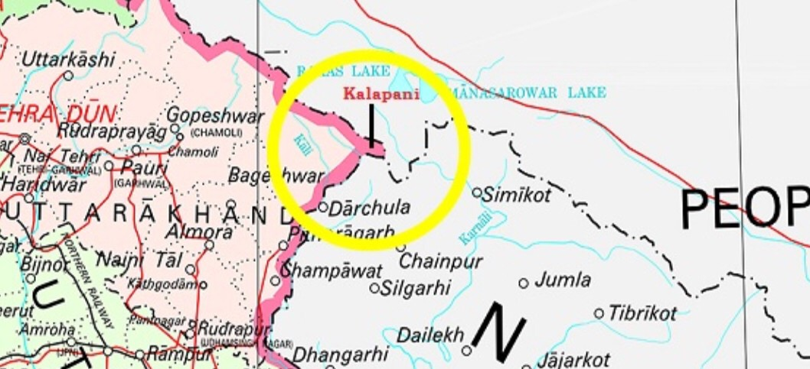India’s stand: Revised map by Nepal is unilateral step, issue must be dealt by dialogue
      * 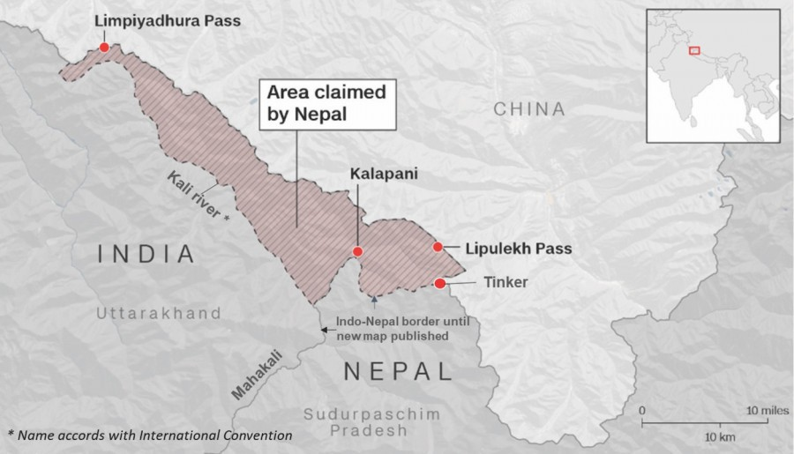Susta dispute- due to changing course of river Gandak
    - China Factor
      * Renewed interest in r’ship after constitutional logjam, friction in relations with India
      * Political visits at highest levels
      * Gave access to Trans-Himalayan Railway as well as road connectivity in T-H Multi-dimesional network
      * Proximity due to communist ideology
      * Possible challanges for India- erosion of buffer state in case of India-china war, effect on Bhutan etc
    - Political
      * India’s Big brotherly attitude- insecurity in citziens- political parties flip flop wrt pro-india anti-india positions, India accused of meddling in Nepal
      * 2015 blockade as percieved by Nepal after Nepali constitution failing to address Madhesi (plain people living near UP-complain of stepmotherly treatment by Nepal govt) demands- mistrust wrt India
      * Instability after parliament dissolved by PM Oli
    - Other- Human trafficking issues (other mentioned in security notes)
  + Current measures for cooperation
    - Economic
      * Since 1996, bilateral trade grew 7 times (currently $8bn+)
      * India a/cs for Nepal’s 2/3rd of merchandise trade, 1/3rd of service trade, 1/3rd of FDI
      * ICPs at Birgunj, Biratnagar
    - Energy
      * Transmission lines: Raxaul-Parwanipur, etc.
      * Power exchange agreement(buy power from nepal) for border areas, India launched Arun 3-for hydropower generation
      * Petroleum lines: Motihari to Amlekhgunj
    - Security
      * Training & modernizing Nepalese army
      * Gorkha regiment in India; Surya Kiran = Jt. Exercise
    - Water sharing
      * 3 tier bilateral mechanism set up in 2008
    - Development cooperation/ Cultural ties
      * Grants & building 45k houses
      * Ramayan circuit for tourism, riverfront dev at pashupatinath
    - Border
      * Peace and Friendship treaty 1950- accepted open border btw them- free movement
  + Way forward
    - Water sharing: Need to sign larger framework agreement for coop; Frequent meetings under current framework; Local solutions; Use India-Bhutan template for this relation
    - Border dispute can be reolved by appointing Joint Boundary Demarcation commitee; Need to ratify strip maps prepared by Boundary commission in 1981
    - Report of Nepal-India Eminent Persons group 2016 can guide future economic course of r’ship
    - Leverage institutional aspects of India-Nepal Joint Commission at EAM level
    - India needs to stay fully engaged with Nepal at all levels of political spectrum as the hands off policy would create space for other external influences (such as China) which could be hostile - Shyam Saran
  + Conclusion
    - Principles of equality, mutual trust & mutual benefit need to guide relations

###### India-Pakistan Relations

* + Introduction
    - Complex and difficult relations
    - Characterised by cycles of D-D-D (Dialogue - Disruption - Dialogue)
    - Reasons for difficult r’ship (differences in narratives, deep state within Pak, Asymmetry and seach for strategic parity by Pakistan, Role of external actors) - NB Pg 6
  + Significance
    - Security- Need to manage relationship by keeping India interest as well as not worsening too much (Nuclear issues)
    - Need for both countries to divert money from arms to human dev
    - Relations with Pakistan are not just a bilateral matter but is essential for India to transform South Asia (thus we need to see the relation from a larger lens - this is also an advantage for peaceful relations)
  + Conflicts and future challenges
    - Terrorism
      * T is used as an instrument of state policy, bleed with thousand cuts, assymetric warfare
      * Promotion of cross border actors
      * Pakistan deep state- diff to find co-op due to deep state motives not clear
      * India’s stand: Talks and terror cannot go hand in hand; Onus is on Pak; Pak needs to take concrete and irreversible action against T
    - J&K & LoC dispute
      * 2020 had more than 5k ceasefire violations (highest in 19 years)
      * Internationalisation of issue by Pak
      * India’s Stand: J&K is integral part; Bilateral route only; Issue is only wrt that part of J&K which is occupied by Pak
      * Recent granting of provincial status by Pak to Gilgit-Baltistan
    - Indus Water Treaty 1960 -NB Pg
    - Sir Creek Dispute & Siachen
      * Differences in interpretation of Para 9/10 of treaty
      * Trust deficit (access to Shaksam valley at stake) has stalled demilitarisation of Siachen despite human & eco costs
        + India’s stand: Jt. demarcation of AGPL followed by Jt. verification and redeployment at the end
      * Fishermen issue - Recently Indian fishermen was killed off GJ coast; Both sides have several prisoners who are in misery
    - Death sentence to Kulbhushan Case
      * Ball is the court of Pak to either improve relations or strain it further
    - China factor (all weather friend)
      * Chinese projects such as Kohala hydro-P project, Diamer Bhasha dam, Karokaram highway in GB and POK regions despite objections by India
        + Issues of third party coming in Kashmir issue, mobility in case of 2 front war as permanent close proximity
        + 2020: Signed a new military memorandum of understanding to boost their already close defence relationship
      * Supply of military warship by China to Pak Navy
      * Possibility of two-front war
    - Other external players
      * USA: Convergence wrt terrorism but USA’s interest are in Afghanistan and India’s is wrt to LeT, JeM
      * Role played by USA, France, UK in lisiting Pakistan on the list of FATF
  + Current measures for cooperation
    - Economic engagement
      * Trade not significant despite potential of $37 bn (World Bank)
    - Positive developments
      * Visa free travel via Kartarpur Sahib Corridor
      * Jt. statement to adhere to India-Pak Ceasefire Agreement 2003 (Feb 2021)
    - People to people
      * Musical exchanges, Internet connections by independent artists, cricket, daily soaps
    - Border dispute
      * 2003 cease fire agreement; Composite dialogue process (2004-08) is the most comprehensive and multi-layered process (got disrupted after 2008 mumbai attack)
      * Pre-notification of military excercise, Pre-notification of Ballistic missile flight tests
  + Measures to contain
    - Response to Terrorism
      * Military: Air strikes 2016, 19
      * Economic: Revoked MFN status, Tariff duties increased
      * International diplomacy- FATF, UNSC, CCIT
      * Hit terror financing, deradicalise youths
      * Kashmir- steps for integration- better eco opp with peace and soft measures to stop their alienation
      * Diplomatic: Direct reference to Baloch issue in PM independece day speech, Isolation by not attending SAARC (dead since then) International pressure through (quote eg:); Highlighted Pak’s role in Nagrota Attack,
  + Way forward
    - Manage differences in such a way that they do not escalate into conflicts
    - Acknowledge that democratic & stable Pak is our best bet but much of it is beyond our control
    - Tool Kit with India
      * Hard/Coercive power *when needed*:
      * Soft/Persuasive power *when possible*: Concentrated information campaign to win hearts/minds;
    - Arrive at a ‘set of rules’ to actually govern the ceasefire agreed again in 2021
  + Conclusion
    - PM Modi said let’s fight our common enemy which is poverty, unemployment
    - Smart Power which is combination of hard power as well as soft power

###### India-Afghanistan Relations

Intro: KM Pannikkar (Indian statesman) rightly said that developments in Kabul valley inevitably affect the empires of the Gangetic plains

Afghan reconcillation process

* + Taliban emerged to fight Soviets- however 9/11- US campaign against Al-quaeda and Taliban- meanwhile elected afghan govt but 1/3rd area contested and no peace
  + US Taliban peace deal will lead to Taliban gaining centrality in Afghan affairs but India supports the Ashraf Ghani government and backs the idea of an

Afghan-led, Afghan-owned, and Afghan-controlled process.

* + India critical of Taliban due to terror activities (IC 814 plane hijack)
  + US military engagement became a strategic liability for them as priorities shifted to Indo-pacific to contain China

India’s Interest in Afghanistan

* + Economic and Strategic Interest
    - Afghanistan gateway to the oil and mineral-rich Central Asian republics(imp for India), anyone who is in power in Afghanistan controls the land routes
    - reconstruction plans offer a lot of opportunities for Indian companies
    - India has investments in Afghanisatan
  + Security Interest:
    - to prevent Pakistan from setting up a friendly government in Afghanistan and prevent terrorism from Pakistan supported groups such as Haqqani network(anti-india Taliban militant group)
    - to avoid the return of jihadi groups, like al Qaeda, which could strike in India.

Measures (What is our approach and role)

* + Indian projects- the Afghan Parliament, the Zaranj-Delaram Highway, and the Afghanistan-India Friendship Dam (Salma Dam), along with India’s assistance of more than $3 billion in projects, hundreds of small development projects (of schools, hospitals,library and water projects) have cemented India’s position in Afghanistan.
  + Latest dam for cooperation: Shahtoot Dam on Maidan River
  + Traning Afghan cricket team- Dehradun home ground
  + Duty free access to indian markets, training diploamts along with military, 1000 scholarships to students
  + Peace process: EAM addressed initial session of Intra-Afghan peace talks, indian envoy present at US-Taliban deal
  + Approach: India has avoided any military presence in Afghan and advocates need for international secuirty presence till afghan becomes self-reliant

Challanges

* + India’s Dilemma
    - Continue with “Afghan-led, Afghan-owned and Afghan controlled process'' (considering that the elected Afghan Government is hardly in control, the peace process has become US led and Taliban controlled)
    - OR entering into direct talks with the Taliban (major departure from its consistent policy of dealing only with recognised governments)
  + Dent in India’s Goodwill: Afghans insipred by inclusive democracy as well as india’s dev projects-dent due to recent events in India, especially the controversy over the CAA
  + Exclusion of India: India finds itself on the margins of international diplomacy in Afghanistan despite developemt work (not invited at 6+2+1 summit by UN sectariat (included China,Pak,Us,Russia etc)
    - Recent- US brought India into peace plan for Afg, whereas Russia plan kept India out
  + Connectivity challenges: Denial of transit by Pakistan
  + Taliban/Haqqani network rule- want to reimpose sharia law and issues of human rights may emerge- refugee problem for India (due to past incidents of attacks, abduction of indians)

Way forward

* + Efforts take to bridge the Ghani-Abdullah divide(two power centres in Afghan polity), and bringing together other major leaders who have pro-India attitude
  + Diplomatic route to be included in 6+2+1 process
  + Pakistan peace efforts recent ceasefire agreement should be used for co-op for Afghan peace
  + India can consider special envoy, Track II diplomacy or direct diplomacy with the Taliban given growing international legitimacy of T and chances of controlling govt in future for security interests
  + Need to rope in regional players such as Iran, China and Russia who have convergent interest in seeing settlement in Afghanistan

In the current situation, it is essential for India to maintain its strong links with the

Afghan government, build and support its traditional Afghan allies and open lines of communication with the Taliban

India’s Stand: Peace process must not create any areas that leave space for proxies to thrive → Calls for for greater engagement will all sections

* + Indias’ engagement with Taliban led Afghanistan
    - Strategic necessity: Rising violence in J&K, Support to terror groups in Pakistan
    - Policy of engagement must be guided by **regional diplomacy** rather than bilateral engagement eg: Moscow 10 engagement led by Russia
    - Also pressure must be mounted on Taliban to make **govt inlcusive, refrain** from allowing use of **afghan soil for terror**

###### India-Bhutan Relations

* + Introduction
    - All weather friend of India which is time tested involving sacred ties & common heritage
  + Significance
    - Friendship Treaty 1949 - India has role in guiding Bhutan’s foreign policy
  + Conflicts and future challenges
    - Rising debt to India (~77% of country’s debt is towards India)
    - Cost overruns due to delays eg: cost doubled for Mangedechu project
    - Environmental concerns over areas of cooperation such as BBIN Initiative, VISA permits to indian tourists (ended free travel for Indian passport holders)
    - Chinese encroachments in northern Bhutan with an aim to trade the land for a patch of disputed territory on Bhutan’s western border - would bring china close to India’s strategic Chicken’s Neck
  + Current measures for cooperation
    - Multiple visits at highest political level are keeping the r’ship vibrant
    - Hydropower cooperation- Mutually beneficial to both sides
      * Tala , Kholongchuu hydro-P project, Dorjilung project(trilateral with BG)- I help in hydro projects and buy back power from them, utilisation of untapped potential of similarly in Nepal,bang etc
    - Development assistance: India supporting the Tax Inspectors Without Borders program of Bhutan by sharing tax admin & audit knowledge (TWIB is a program of UNDP & OECD)
    - Economic development: Largest trading partner of bhutan; Duty free access to india along with transit access to 3rd countries; 100mn standing credit facility
    - Security: Integrated protection through eastern command of Army/air force; CT operations such as Op. All Clear; Training military, Doklam coop
  + Way forward
    - Need a calibrated approach wrt demarcations of boundaries with Bhutan & China
  + Conclusion
    - PM Modi said Bhutan’s req would be ‘top priority’ for India
    - President Kovind said security of Bhutan is indivisible and mutual

###### Regional Engagements (SAARC, BIMSTEC)

* + SAARC
    - Est in 1985 with signing of SAARC charter in dhaka(Sec in Nepal) For welfare and improving life of people of SA with eco integration,territorial integrity.
  + Issues with SAARC
    - Last summit in 2014, 2016 in Pak boycotted by almost all after Uri,Pathankot, Recently in SAARC Foreign minister meeting2019- both minister boycotted speeches
    - SAFTA that came into force in 2006 as outcome of SAARC- insufficently working due to sensitive list of items
    - Pak non-coop stalled SAARC Motor vehicle agreement and SAARC sattelite (alternative BBIN,South asia satellite), other issues of terrorism of Pak
    - Assymetry btw India and other- Big brother syndrome- reluctance to imp various agreements
    - Other basic issues such as shortage of resources,dedicated staff etc
    - South Asia is one of the least integrated regions in the world with intra-regional trade teetering at barely 5% of total South Asian trade, compared to 25% of intra-regional trade in the ASEAN region
  + Need for revival
    - SAARC- South asian identity - common cultural, lingusitic,religious,culinary affinity along with common challanges like terrorism, hydro-politics, climate change- need for working platform
    - BIMSTEC can complement but not subtitute it- SAARC 32 year old org with extensive regional centres,conventions as well as permanent secretariat but various issues with BIMSTEC
    - If SAARC redudant- neighbours may join china-dominated org such as SCO compared to India dominated SAARC, should not lead to alienation of neighbours wrt india helding hostage SAARC for bilateral issues
    - Asian centruy and neighbourhood first requires greater SA co-op(Like Europen co-op vital for west dominance)
  + Way forward
    - Reach consensus among C, informal dicussion (such as COVID virtual), formal meets are imp, SL insistance regularly for revival, make SAFTA smooth by addressing tariff and non-T barriers, expediate BBIN for trust etc
    - Bangladesh PM S. Hasina said ‘*Pluralism is fundamental to South Asia, we should shun majority-minority mindset*’
  + Other options for co-op
    - SAARC minus one
    - Sub-regional functional cooperation
      * South Asia Subregional Economic Cooperation (SASEC)
        + project based partnership for regional crossborder connectivity,boosting trade formed by ADB for eco-cop btw BBIN
      * SA co-op env prog(SACEP-all 8 members)and SA co-op seas prog(SASEP- 5 members inc I,P)
    - Trans-regional cooperation: also includes SE asian countries
      * BIMSTEC
      * estb in 1997(Sec in Dhaka), co-op in trade, env and DM, Security, Agri, transport and communication, S&T, innovation etc along with principles of non iterf, peaceful existence etc
      * Significance
        + Eco- intraregional trade better compared to other groupings, BOB -25% trade passes- also has potenial of natural gas (future of power supply) and other resources
        + Integrate SA as SAARC dis-func, bridge btw SA and ASEAN, Counter Chineses influence in the region
        + Dev of NE- potential for BIMSTEC FTA, connectivity with Myan, Thailand and beyond
      * Challanges
        + Dormancy in org(since 1997 met only 4 times at summit level), lack of pol will among other C, little progress on FTA, Inst- Sectariat- inadequate contri,funding issues, Charter finalised after 23 yrs on inception(working under Bangkong agreement till now)
        + Regional geoP- Nepal and thailand did not participate in anti-terror military exercise in2018 due to China factor
        + India dominance issues like SAARC- BG believes when I dicuss connectivity - only I interest is seen
        + Bilateral issues such as Rohingya crisis causing bitterness bw BG and Myanmar
        + the org has not adopted any charter despite 23 years of existence
      * WF- should focus less on geo-P and more on common regional concerns of eco dev, conclude FTA, inc membership by incl singapore,malaysia,indonesia, empower sectariat etc

###### India-Myanmar Relations

* + Introduction
    - Buddhism connect, ties related wrt ethnic, security interest,culturally, gateway to ASEAN, Neighbourhoood first.
  + Significance
    - Location: Proximity to NE states as well as A&N islands + our gateway to SE Asia(bridge of neighbourhood first and act east)
    - Resources: Untapped hydrocarbon resources, huge market for indian goods
    - Indian partnership has both pvt. sector and G2G relations
    - Kin ship ties between people facilitated by Free Movt. Regime
    - Partner to fight insurgency- crucial strategic importance(thats why conflict wrt to supporting pro-democracy or military janta when ruling)
  + Conflicts and future challenges
    - Political instability after latest military coup in 2021
    - China-myanmaar eco corridor, Issue of border security (FMR used for smuggling and IS threats), Kyaukphyu port being developed by China
    - Rohingya Issue - Delicate balancing role b/w BG and Myanmar (India’s stand = safe, secure & sustainable return of rohingyas)
  + Current measures for cooperation
    - Economic: large investment by I on oil and gas in Myanmar; Trade numbers are low which shows untapped potential
    - Dev Assistance- India-Myanmaar Friendship project- houses in Rakhine areas, High impact community dev projects, launch of Rupay card, $25 mn assistance for pre-fabricated houses for Rohingyas
    - Connectivity- Kaladaan multi-modal (involves Sittwe port), bus service btw Imphaal and Mandalay, Myanmar’s component of IMT is being built by India;
    - Security and Defence: landmark defence co-op agreement in 2019, bought india-made submarines, Operation sunshine 1&2
    - Cultural: Restoration of Ananda temple work by ASI, Mekong-Ganga Cooperation (NB Pg 85)
    - Regional coop: ASEAN, BIMSTEC, Observor @ SAARC
  + Way forward
    - Cultural connect- Buddhist circuit (B majority nation)
    - Recent conflict- manage relationship wrt refugee issues due to military coup, need for democracy preseveration while co-operating with military for insurgency

###### Indo-Pacific

* + Integrated theatre that combines Indian ocean and the Pacific ocean inc land masses that surround them with a view that their interests are linked (not considering both oceans as sep)
  + Geographic interpretation differ- Like US see it till Indian shores but India,Japan extends it till African shores
  + In the 21st century, the destiny of the world will be decided on its waters
  + Importance
    - Imp sea lines of communication with critical choke points- Mozambique channel, Malacca strait,Bab-el-madeb
    - Trade- 62% of world GDP and almost 50% of merchandise trade
    - Threats like piracy,trafficking,terrorism,env protection require collab effort, richness in natural resources- hydrocarbon,sea-bed minerals etc
    - China factor- BRI,disregard on Int rules (disobey PCA on SCS), Militirisation- djibouti naval base, Hambantota etc
    - India specific interests- geopoplitcal aspiration as net security provider needs expanding presence in the region, Indian ocean carriers 90% of Indian trade and its energy resources
    - Inclusion of I-P strategy, means India can never be confined b/w Malacca Strait & Gulf of Aden
  + India’s initiatives:
    - India’s stand: wants a ‘Inclusive’, free & open I-P; ASEAN Centrality is key; Equal acess to sea and air, rules based order is key part of I-P- PM keynote speech at Shangrila diaologue
    - Indo-Pacific Division at MEA- collab with BIMSTEC,IORA,Mekong-ganga for Indo-pacific
    - Indo-Pacific Ocean Initiatives 2019, IONS (for maritime co-op and sec), Vision SAGAR- holistic policy for promoting I multi-dim intrest in indian ocean with co-op), Project Mausam (understanding how knowledge on monsoon has shaped interaction in history and focus on shared Knowledge in future)
    - Security provider and first responder for HDR in Maldives,Mauritius and other nations (Operation Vanilla at Madagascar)
    - Dialouges at various levels Quad, Trilateral dialougues, ASEAN centered institutions,
  + Challenges faced:
    - Differences in understanding of players eg: at Quad as well as whole Indo-pacific- each has varying deegrees of priority as well fruitful China rlship
    - Antoginse china- while othe players sits far, for us C at border
    - Limited nature of Indian capacity - lack of military base wrt China, issues in assumption islands, slow pace of dev in Asia-AF growth corridoor (AAGC)
  + WF- should engange other players such as Micronesia islands, QUAD+ to include SK,Vietnam,NZ etc
    - Italy showed interest to join trilateral with India/Japan on Indo-Pacific framework; India can tap this as to solve today’s complex geo-pol problems, traditional rigid alliances do not show results
  + Quad
    - Formed in 2007 (revived in 2017), Quad is a group of 4 like minded democracies of Indo-Pacific aiming to discuss issues of mutal interest such as free, open and inclusive Indo-Pacific and rules-based international order
    - Not a formal agreement; However discussions now take at foreign minister’s level
    - Signficance: *Quote importance of Indo-Pacific, bilateral relations with memb*
      * Post covid supply chains imp
      * Supplementing India’s defense capabilities through joint patrols, exchanging information(2+2 with all members, 4 agreements with US, logistics exhange mechanism with Japan,

mult-exercises-Malabaretc)

* + - * Convergence with other nations ranging from France to Japan (various nations are bringing out their Indo Pacific strategies)
      * Demonstrates a united front to check belligerent activities of China (China is expecting its South asian partner to stay away from Quad

- this could be further benefit Quad as nations unite towards pushing back China’s belligerence)

* + - Challenges:
      * Lack of clarity on the agenda of Quad - difference in opinions of members - India promotes freedom of navigation but is reluctant in using warships through EEZ, For Japan,Aus-Pacific is imp but for I , indian ocean takes primacy
      * Asymmetry among members in terms of finances, military, etc which may lead to an imbalanced partnership & burden sharing. Quad is seen to pivot around USA
      * China percieving it as anti-china coalition along with strong eco ties with others (Quad appears to be cross purposed with India’s membership at SCO, BRICS, RIC); Chinas
      * India is the only country in Quad which is not in Pacific as well as shares land border with China
      * Standoff at Ladakh has raised questions on Quad and India-US relations as the fight with China is continental whereas cooperation at Quad is marine
    - Way Forward: Strategic imperatives alone cannot drive cooperation for long, we need wider areas of cooperation to sustain the relation. India’s steps such IPOI are in the right direction
      * Malabar Exercise with Quad should be accompanied with India acquiring requisite combat and deterrence capabilities (such as anti-submarine warfare tech) to generate long term gains rather than short terms. If this is not achieved, India’s deterrence potential in the IOR will not be increased

India-Australia- 2+2 elevated to FM, mining co-op, mutual logistics agreement, Comprehensive strategic partnership, Aus announced ‘India eco strategy to 2035, civil nuclear co-op, diaspora(students),supply chain res initiative( issues- CECA inconclusive, RCEP disagreements

###### South China sea dispute

Importance of South China Sea

* + China is using the ‘Salami Slicing Strategy’ in SCS and Himalayan region (taking series of small steps rather than one large action which would be outrightly illegal)
  + Strategic Location: One third of global shipping, or a total of US$3.37 trillion of international trade passes , 80% beijing oil passes
    - half of India’s trade passes through strait of malacca, ASEAN one of the largest trading partner, Any instability in region- affects India’s economy
    - Military angle-choke points in case of war
    - India’s 55% of trade passes through SCS and Malacca St (as per MEA)
  + Key natural resources such as NG, 10% of fishing stock of world imp for countries there

Issues with South China Sea

* + Territorial conflict: Philippines, Vietnam, China, Brunei, Taiwan and Malaysia hold different territorial claims China claims more than 80 per cent of it through its “nine-dash line” which extends upto 2000 km from mainland(remember EEZ 200 Nautical milles- around 332 km)
  + Vietnam, China claims sovereignty over the Paracel Islands and the Spratly Islands(Philippines claims this too)
  + Violation of International rules: In 2016, China rejected UNCLOS Arbitral Tribunal ruling.(said China cant encroach on EEZ of other states)
  + Challanges to US hegemony- ASEAN,Japan,SK are US allies- China hegemon undermines US hegemony in region. Also inc militarisations of region by both affects freedom of navigation for countries such as India and others

Global Response

* + ASEAN hints for balancing China with India,US along with steps for collab with China
  + US conducts Freedom of navigation operations to maintain its hegemony
  + India has favoured inclusivity and plurality,need to be respectful of the region’s preference for consensus-based approaches.
    - (to counter- QUAD,Vietanam hydrocarbon)

###### India-ASEAN Relations

* + Introduction
    - India's Act East Policy provides the guiding framework to take forward the ASEAN-India Strategic Partnership to the next level and recognizes connectivity in its broadest sense to include physical, economic, political and people-to-people connectivity(earlier Look east- eco dimesion predominate but Act east includes political/strategic)
    - ASEAN-India Plan of Action for 2021-2025 (newly adopted) is the guiding force covering variety of areas such as Political Cooperation, Maritime Cooperation, Counter-Terrorism, trade, Transport, Agriculture, ICT, S&T, Climate change. etc.
  + Significance
    - ASEAN is central to India's Indo-Pacific Vision and India's Act East Policy and contributes to SAGAR
    - Geo-Strategic choke points such as Malacca strait and signif trade passes through Indian Ocean
    - ASEAN is a pivotal consumer market (with rising consuming class)
    - Counter China’s power projection which is a common challenge for both
    - Common interests to promote rules-based order, peace and stability, unimpeded commerce, ensuring freedom of navigation and overflight, etc. as well as concerns related to terrorism, radicalisation, drug trafficking, human trafficking
    - Religious, cultural and historical linkages
  + Conflicts and future challenges
    - Economic issues: Trade deficit is rising (~24bn in 19-20); Market access issues faced by India in areas such as agri/marine goods; Resistance in opening labour market thus india dissatisified with progress on FTA in services
    - Failure of RCEP
    - Limited capacity of India while providing development assistance, market access, etc.
    - Infrastructural deficiencies is acting as a hindrance to development of region
    - Chinese influence with ASEAN being China’s largest trading partner
  + Current measures for cooperation
    - Economic coop:
      * Bilateral trade ~$90 bn - ASEAN is India's fourth largest trading partner
      * FDI inflows are there from both sides (more by ASEAN than India)
      * FTA for goods signed in 2010, for services in 2015
    - Connectivity:
      * IMT Trilateral Highway, Kaladan Multimodal Project
      * $1 bn LoC to support ASEAN connectivity
    - Poltical & Security coop:
      * 30 Dialogue Mechanisms between India and ASEAN, cutting across various sectors and multilayered from Summit level discussions to Minister level meetings to track 1.5 events such as delhi dialogue
      * Mechanisms such as ASEAN Regional Forum (ARF), the East Asia Summit (EAS), ASEAN Defence Ministers’ Meeting plus
      * Defence cooperation agreement with Indonesia including port facility at Sabang Port (Indonesia)
    - Socio-Cultural coop:
      * Training Programmes for ASEAN diplomats, 1000 phd fellowship at IITs, major tourist destinations for Indians
      * Indian Diaspora in the ASEAN region, which constitutes about 20% of India's total diaspora
      * Cooperation in the field of S&T, R&D, environment
  + Way forward
    - Possible extension to IMT Highway to Cambodia, Lao PDR and Viet Nam is also under consideration
    - Cooperation can be enhanced through convergence between India's Indo-Pacific Oceans Initiative and the ASEAN Outlook on Indo-Pacific
    - Bringing ASEAN in Supply Chain Resilience Initiative (SCRI) will strengthen our value chain linkages
    - India should actively engage with ASEAN to fast pace review of the FTA

RCEP Negotiations

* + Significance: World’s biggest free trade pact; Almost half of world’s population; one third of global GDP; Trade b/w them makes upto 25% of global trade
  + Why India pulled out?
    - Trade deficit has been increasing - Current deficit of $ 100 bn+ (of which china is 53 bn)
    - India wanted RCEP to exclude MFN obligations from the investment chapter to balance its recent FDI policy with bordering nations
    - Lack of protection to domestic industries as proposals for strict rules of origin and auto-trigger mechanism to impose tariffs were not accepted
    - Shallow coverage for service sector while steep opening for goods segment
    - Lack of convergence in areas of e-commerce, IPR, shifting base year from 2014 to 2019
      * In contrast to commitments for goods under RCEP, the service sector has seen shallow coverage of areas (example resticting movement of natural persons)
    - Domestic issues: Concerns of manuf, dairy, agri and labour groups
  + Implications
    - Withdrawal from RCEP, call for self-reliance, etc. might be perceived as India taking a protectionist stance
    - Isolation, loss of potential investments and lack of competition might affect India’s performance in terms of exports
    - Impact on bilateral ties with memb nations as they will focus more on the bloc; Similarly it may impact India’s revival in the post COVID world
  + Way Fwd:
    - Future course of discussion must accomodate concerns of India. Meanwhile India should work towards EoDB, Infra, to ensure it can reap adequate benefit while being part of the global value chain
    - Mere signing of an FTA does not guarantee an increase in exports. FTAs can ensure market access **to only** the right quality products made at competitive prices. Country cannot become a significant part of **global**

**value chains** unless it has efficient ports, customs, shipping, roads and a regulatory compliance infrastructure

###### India-Japan Relations

* + Introduction
    - Since civilisation contact btw both began 1400 years- two countries have never been adversaries. There is absolutely nothing in I-J history that could derail rlship (also Asia’s two big democracies)
  + Significance
    - Ties are free from diputes of ideology, culture, territory
    - 21st century has witnessed dramatic transformation in bilateral ties evidenced by signing of Spcl Strategic & Global Partnership
    - Commonalities and complementarities- Japan has demographic disadvantage- India D adv, Japan has surplus capital,I needs investemnt
    - Collaborated development in NE, SE Asia, Africa, etc.
    - Historical angle: SC bose, Rashbehari bose (INA), Tagore, Judge Radha Binod Pal, Japan helped India during 1991 crisis
  + Conflicts and future challenges
    - Eco- Japanese co. 8 times in china than India, Japanese co. bogged down by paperwork(Modi to investors- no red tape only red carpet)
      * Current issues like divergence over Osaka track(e-commerce rules),RCEP,delay in AAGC
    - India data localisation norms and reluctance to accese to Budapest convetion come in the wat in cooperation in sections such as AI, 5G, Cybersec and other emerging tech
  + Current measures for cooperation
    - Personal level-Modi-Abe - “A good friend is timeless and sees no borders”
    - Strategic- I-J has Special strategic and global partnership- designation that I accords to no ther partner,Chinese angle,Indo-pacific co-op, 2+2 since 2010
    - Economic cooperation: (CEPA signed in 2011)
      * Committed to invest JPY 3.5 trillion & double japanese cos. presence in India
      * Mega-infra projects such as Mumbai-ahd bullet train, NE dev (built 1200+ km roads)
      * Bilateral trade ~$15 bn which is way below potential given its close ties (J-C- 350bn$),
        + There is consistent trade deficit which is increasing
      * Supply Chain Resillience Initiative, Currency swap agreement of

$75bn (shows steps are being taken for trade)

* + - Developmental partneship
      * Largest official bilateral donor for India- Delhi metro
      * Asia-Africa growth corridor which will be consultative process unlike BRI
      * Similar strategy also being adopted for Iran and ASEAN
    - Security: Acquisition and Cross-Servicing Agreememt (allow both military to exhange supplies and services on reciprocal basis during excercised in which both participate) signed, Malabar
    - Others: First annual bilateral space diologue and other S&T co-op, security cooperation, UNSC reforms via G4, space cooperation bw ISRO & JAXA for joint lunar polar exploration mission (LUPEX)
  + Way forward
    - Bilateral trade has great potential considering both countries fall under Top 6 in terms of GDP
    - Defence cooperation can be increased by clearing the long pending defence deals
    - Complete AAGC projects faster
  + Conclusion
    - As both seen as indispensable partners- strong co-op will contribute for prosperity in Indo-pacific region and beyond

###### India-West Asia Relations

* + Introduction
    - Indian diplomacy wrt West Asia said to be miracle- managing relationship with actors who are at conflict with each other- Israel, Palestine, Saudi Arabia, Iran etc
    - Evolution of WA policy from ideological to non-ideo (more by eco calculation than pol rhetoric)
  + Significance
    - Energy security: 60% of our oil imports are met from W. Asia; Also gas imports, gateway to energy rich central asia (WA is imp for uninterrupted availability of energy at affordable rates)
    - Cultural & P2P ties: Diaspora of ~11 mn (need peace for their security) bringing remittances of ~ $35 bn (compared to military budget of india

$50 bn), Haj pilgrimage

* + - Trade & Investment: GCC region trade amounting to ~$100 bn, India can tap sovereign wealth funds, SA and other oil rich countries wanting to diversify its economy by inv in markets such as India
    - Security & Strategic Interest: Did not condemn 1998 nuclear test, Facing common challenges of radicalisation, terrorism(26/11 attack on Chabad house), maritime diplomacy, collaborated investment in Africa , co-op to contain Pak(many countries supports India- recent SA statements supporting Kashmir UT status)
    - Securing vital sea lanes in areas such as Strait of hormuz, Gulf of Aden, Red sea
    - UNSC PS significance, counter-terrorism,CC, Global Trade co-op to counter west
    - Iran- Chabhar( route to afghanistan and CA , next to gwadar) , Saudi arabia , UAE
    - UAE - Renewable Energy cooperation through International Solar Alliance,
  + Conflicts and future challenges
    - Factors affecting our relations: Internal faultlines within states,- shia-sunni , Historical rivalries b/w states which affects our foreign

policies (managing Iran-SA,Israel and arab states), Role of State (USA, EU, Russia) and Non-state actors (ISIS), Rising chinese influence in Iran

* + - Issues wrt oil pricing mechanism, cartel behavior by curtailing outputs (OPEC and OPEC+)
    - Issues faced by workers: Delayed wages, Exit Visa issues, False police cases, non-fulfillment of contracts, HR violations (Nature of workers only 30% skilled, rest unskilled), SA’s Nitaqat system (saudi nationalism which ‘may’ impact our workers)
    - Look west adopted in 2005 not as active as Act-east policy- no ASEAN like forum to co-operate holistically
    - Issues with access to pharma exports to Arab world where current procedure is cumbersome
    - OIC- statements on Kashmir, used by Pak for its own ends, Pakistan angle- relation with SA, Afghanistan depth
  + Current measures for cooperation
    - Energy security: West Coast Ratnagiri Refinery Project with ARAMCO- billed as world’s biggest JV, High level of bilateral visits, Cooperation at Zakum oil fields with UAE
    - Welfare of workers:
      * Labour agreements have been signed with GCC, UAE, SA
      * Indian Community Welfare Fund, Indian Worker Resource Centre in Dubai
    - Economic Ties:
      * UAE’s promise to invest $75 bn, for this we have made special desk named ‘UAE Plus’, UAE was the first to invest in NIIF
      * SA- intent to invest 100B$- identified as one of the 8 strategic partner country under its Vision 2030
      * Ties are also led by Indian private cos and business houses
    - Security Ties:
      * Security & Defence Agreements with SA, UAE, Oman, Qatar
      * Intelligence agreement for cooperation in financial crimes, money laundering
      * India-SA rejected terrorism as an instrument of state policy, estb of Strategic Partnership council
      * Duqm port at Oman (Military use)
    - Institutional/summitry- 1st Arab-India ministrial conf in 2016,first FM invite in OIC
  + Way forward
    - ‘Look East’ Policy succeeded because South-East Asia began to ‘Look West’ to India, seeking a balancer to China. ‘Look West’ Policy will succeed because West Asia is ‘Looking East’ worried about the emerging strategic instability in its own neighbourhood and the structural shift in the global energy market.
    - Win-win situation: Arab investments in agri areas (after agri reforms) will make farmers prosperous as well as food secuity for farmers
    - India’s policy: Approach is non-prescriptive, non-interference, regional stability and mutual cooperation
    - Need to diversify sources of oil import so that India is not held hostage to arbitrary production cuts by OPEC+ members. The move would have high initial costs but would pay off in the long term
    - Former Indian diplomats have even suggested an idea equitable to an ‘importers OPEC’, led by Asian states which today have a much larger stake in West Asia’s oil than the West
    - Rising importance of Egypt (brokered peace after 11 day Israel-Palestine conflict) peacalls for looking at the regions as WANA and not just West Asia

###### India-Israel Relations

* + Introduction
    - India for long time benefited from Israeli co-op however visit by Modi to Israel cemented ties to a point from where there is no going back, From hesitation(domestic compulsions) to confidence in ties- acquired depth
    - India has de-hyphenated its relationship with Israel and Palestine to treat both the countries mutually independent and exclusive
  + Significance
    - Significant role in ‘Look West’ Policy
  + Conflicts and future challenges
    - India’s ties with Iran and US-Israel stiffness in policies limiting India’s diplomacy
    - India’s stance towards 2 state solution (as backed by UN resolution)
  + Current measures for cooperation
    - Personal relation: Israel PM said on our relations: ‘This is a marriage made in heaven but we are implementing it here on earth’
    - Defence: 41% of Israeli’s defence export are to India; Israel is 3rd largest supplier of arms eg: Phalcon AWACs, drones
    - Security: Cooperation in Homeland Security which includes border mgmt, police modernisation, Foreign exposure visits to IPS trainees, RAW and MOSSAD co-op
    - Agriculture: Centres of Excellence in Agriculture have been setup in various indian states; Various sectors such as horticulture, nursery, micro-irrigation, post-harvest management, improving dairy farming; Drip Irrigation which is an Israeli tech is widely used
    - Innovation: Promoted by setting up of $40 mn Innovation Fund
    - P-P ties- Isreali youth fascinated by India- mini-Israel in HP towns, India only big country where Jewish never discriminated in history
    - Space: Cooperation betweem space agencies of both nations in various areas such as atomic clocks, academic collaboration
    - Other areas: Film production. MoU in Oil & Gas sector, Air service agreement, diamond and precious metals major share of exports from India
  + Way forward
    - India-Israel relations, which had remained defence-centric, need to acquire more broad-based character bringing the start-up nation and the world’s fastest growing economy in a tighter embrace
    - India’s close diplomatic relationship with Israel is vital for India’s national interest. Despite the criticism of India abandoning the Palestinians, in the current juncture, it is necessary to undertake a balancing in the highly unstable West Asia so that there is room for change when the need arises.
    - Rising importance of Egypt diplomacy (brokered peace after 11 day Israel-Palestine conflict) calls for looking at the region as WANA and not just West Asia

###### India-Iran Relations

Importance- Chabhar,energy,Pakistan neighbour, another pole in west asian politics so good reltions will increase I’s clout in west-asian geo-P

Irreplaceable country went it comes to a regional partner for settlement in Afghanistan

Issues

* + Iran’s growing proximity to China
  + US sanctions due to JCPOA
  + Further, Iran sceptical of India’s diplomatic ties with the USA, Israel, Saudi- Arabia.(very clear in statements of Iran ministers)
  + Farzad-B gas Field- Difficulties in acquiring that - Iran proceeded with dev on own ,India needs gas and Iran remains one of the best options as geographically
  + Chabahar Zahedan railway line hampering due to US sanctions/pressure (work slowed down which led to India being dropped)

Way forward

* + India needs to play a balancing act between the USA and Iran. Need for clear showing of intent of I’s independent FP
  + In a world where connectivity is seen as the new currency, India’s loss on account of these projects can become gain for some other country, especially China

###### India-Africa Relations

* + Introduction
    - Not just linked by history and culture but by geography (india part i- Indian ocean doesnt divides but unites
    - India’s vasudhaiva kutumbakam in consonance with African ubuntu (humanity towards others) philosophy
    - Historical- Afro-Asian solidarity due to NAM
  + Significance
    - Countries having cummulative GDP comparable to India - regional approach ✔
    - Number becomes imp for UNSC reforms(54/193 C), SDG goals, climate change. WTO common demands wrt safeguarding MSP regime at Bali2013-currrent demand for permanent soln
    - Fastest growing population both in number and prosperity - Huge markets for Indian exports, need capacity building to young population through ITEC
    - 30% of global untapped minerals are there in Africa
    - ~10% crude oul imports are from Africa
    - Commonalities of challenges such as hunger, poverty, colonial history, trans-national terrorism (ISIS, Boko Haram)
    - Complimentarities such as need for development vs need for resources
    - Build upon growing chinese resentment due to not creating jobs for locals (rather recruites chinese), poor compliance with safety/env norms, strict conditions related to technology usage, focusing on only elites rather than all locals
    - Significant partners of trade - South Africa, Egypt and Nigeria
  + Conflicts and future challenges
    - Trade & investment potential low compared to china (trade 60bn vs 200+ bn), India promises but China delivers (Indian investment are one-third of China’s investments)
      * FTA btw India and Africa still being negotiated
    - Dominance of India’s pvt sector- resentment, Racist attack on African student community in India
    - Nature of trade is limited with natural resources & precicious stone from Af and sending pharma/refined fuel and vehicles from India
    - Strategic interests - China’s port at Djibouti
    - Political instability
    - Global competition - Africa is experiencing the third scramble
  + Current measures for cooperation
    - Focus Africa Approach 2002 - to promote trade & investments
    - India-Africa Forum Summits - discussion platform for heads of states
      * In 2015 Summit -participation by 41 heads of states, India gave 500 mn grants and duty free access to various countries
    - Current trade of $ 60bn has seen 8 fold incease since 2001 (however, it is showing decling trends with peak in 2014-15)
    - Developmental partnership:
      * Capacity Bldg Initiatives: Educ, Pub transport, Clean energy, scholarships, SME support, pharmacy(indian drugs for fighting HIV), vaccination, sharing democratic experience, training on usage of EVMs for elections
      * Deployment of ICT to make Af as knowledge eco: Payment systems, Indi-Technical and eco cooperation, Pan Africa e-Network (which incl tele-med, tele-edu, e-gov, resource mapping, etc.)
      * Asia Africa Growth Corridor
      * LoCs totalling ~11 bn (through initatives such as India-Africa dev fund)
    - P-P- companies such as Airtel strong presence
    - Security coop to tackle piracy in Indian Ocean, 30k personnel in UN Peace keeping forces
  + Way forward
    - Trade can double if awareness is created, financial support to Af traders and infra support is provided. A need to to diversify limited nature of trade
    - India can converge with other like minded nations (EU, Quad) to counter chinese competition. Moreover it can also leverage large Indian diaspora and B2B ties
    - Need to conduct the long pending 4th India-Africa Summit
    - Focus on deepening collaboration in health, space and digi tech
  + Conclusion
    - Modi- partnership beyond strategic considerations but relationship of emotions- Our geography is linked, past is linked, future is linked
    - India’s cooperation based on model of coop which is ‘demand driven & free of conditions’
    - Poverty in Africa- scar on human conscience- instead of rivalry co-operate for mutual developement

###### India-EU Relations

* + Introduction
    - If India seemed unwilling to think strategically about Europe, Brussels too took a bureaucratic view of India. That is changing now
    - Ramnath Kovind- “Europe is irreplaceable in India’s determination to achieve the goals it has set for itself and the world.
  + Significance (factors shaping relations in current times)
    - EU strategy on India 2018 views EU-India relations in the context of broader geopolitical developments (countering rise of China);
    - Convergence of interests in the Indian Ocean as the Indian Ocean is the main conduit for global trade and energy flows
    - Retreat of the U.S. from global leadership has created space for both sides to colloborate for dev in areas such as Middle East, Central Asia and Africa
    - Commonality on views of rules-based multilateral trading system at UN and WTO
    - Common ideals such as democracy,HR and challenges of

counter-terrorism, maritime security, and nuclear non-proliferation

* + - Green Governance: Convergence on areas of environment/circular economy (Green Deal of EU wants to become carbon neutral by 2050)
    - Post-COVID, both can collaborate on areas of supply chain (thus removing dependence on China)
    - Untapped export potential of $39.9 bn
  + Conflicts and future challenges
    - Stalled EU-India BTIA- negotiated since 2007, diff on crucial issues such as wine(France), automobiles (Germany), IPR (pharma issues- same as US, India’s data localisation, norms for movemenet of workers, huge subsidy by EU to dairy industrySanitary and technical barriers to trade (alphonso mango), Demand for Data secure status for India’s IT industry
    - Trade - India account for only 2% of EU goods trade (China-14%),

EU-Veitnam FTA- affect India’s exports (also various nations are part of China’s BRI)

* + - India’s perception of EU as trade block- lack of substantive agreement on security and connectivity with EU rather bilaterally with France etc
    - Human right concerns of EU- EU parliament critical of both Kashmir 370 decision and CAA, Italian marine issue
    - There is an untapped export potential of $39.9 bn. India benefits from EU’s GSP, however major products have either graduated or are on the brink of graduation under the same. This highlights for a need for BTIA (to deepen trade and investment ties)
  + Current measures for cooperation
    - Economic Ties: India's largest trading partner (in terms of bloc) accounting for ~11% of total indian trade; FDI from EU are also the highest accounting for 22% of inward FDIs (2018)
    - Defence & Security: Convergence of IFC-IOR and Maritime Security Centre estab by EU Naval forces; India-EU have a strategic partnership; Growing ties with France
    - S&T: Coop in the field of 5G, biotech, AI, cutting GHG emission
    - P2P: 50k students are studying at EU, Exchanges for cultural heritage such as Yoga, ayurveda, festivals
    - Recent India-EU Summit- “India-EU Strategic partnership: A roadmap to 2025 adopted to guide co-op, agreement btw Indiia-EURATOM (atomic energy community) for co-op in peaceful use of NE, declarations of circular economy ,maritime security etc
  + Way forward
    - As Europe steps out from America’s protective shell, it will need new strategic partners for in Eurasia annd Indo-pacific
    - EU strategy on India 2018 highlighted India EU should take their relations beyond “trade lens”, recognizing their important geopolitical, strategic convergences

###### India-France Relations

* + Introduction
    - India and France have traditionally close and friendly relations. In 1998, the two countries entered into Strategic Partnership
  + Significance & measures of cooperation
    - Defence: France remains a vital source of arms supply to India eg: Rafale, Scorpène submarines; Both sides also signed reciprocal logistics support agreement. There is a estab of strategic dialogue between NSAs
    - France was the first European country to launch an Indo-Pacific strategy and India is a key pillar in that strategy (specific interests in the Indian Ocean such as Reunion Islands & Mayotte)
    - Strategic convergence over rising Chinese profile in Indo Pacific as well as breakdown of the rules based global order (both share interest in developing a coalition of middle powers)
    - France is among the countries that have consistently supported India’s permanent membership to UNSC. France offered unstinted support for India on surgical air strikes as well as issues of J&K
    - Civil Nuclear Cooperation Agreement in 2008. Both side decided to six nuclear reactors at Jaitapur (when developed
    - Space cooperation: Helped in development of Sriharikota launch site. Future joint satellite mission named ‘TRISHNA’
    - France is also helping in the Smart Cities Mission for cities such as Chandigarh, Nagpur and Puducherry
    - Global agendas- Climate change, biodiversity, renewable energy, terrorism, cybersecurity and digital technology (eg: International Solar Alliance)
    - The India-France Administrative Economic and Trade Committee (AETC) provides an appropriate framework to assess and find ways to further promote bilateral trade and investment
    - By leveraging the potential of convergences, France can be India’s gateway to Europe and India France’s first strategic partner in Asia
  + Conclusion: France, which had sought strategic autonomy within the framework of its alliance with the US, and India, which has valued independent foreign policy, are **natural partners** in building the new coalitions for an uncertain era.

###### India-Germany

* + Significance and measures
    - Germany- I’s largest trading in Europe, Make in India Mittelstand prog- Inv of german co. in india, High technology partnership group for collab, UNSC (G4) co-op, Supported India’s bid for NSG, German Parliament passed resolution on boosting ties with India
    - German Chancellor Angela Merkel pledged to invest 1 billion euros over the next five years on environmentally-friendly urban mobility in India
  + Way forward - China threat- G diversifying global partnership, need for robust defence and security ties

###### India- UK

* + Significance and measures
    - India second largest investor in UK,800+ indian co. in UK, agreed to estb ‘Enhanced trade partnership- first step towards FTA(Brexit effect), defence exercises(Ajeya warrior etc), 2017- UK India year of culture, very influential diaspora(Rishi sunak- Finance min), cricket diplomacy
  + Issues- active participant in BRI, Brexit specific(below),Colonial hangover affects relations
  + WF- nudge for UNSC reforms,NSG membership, post-Brexit lifeboat( commonwealth)- can strengthen for mutual benefit.

Brexit

* + UK officially left from EU
  + Positive Impact on India
    - FTA- conclude with UK whereas EU FTA stalled
    - Indian skilled labour benefit, high tech exports to UK
    - Easy market access to Indian co. due to post brexit opp such as easy tax breaks, attracting co. from EU capitals
  + Negative impacts
    - Weaker EU- more right wing parties- uncertainty to indian co. and interest
    - Dual negotiation for FTA may hamper EU negotiations

###### India-Russia Relations

* + Introduction
    - Throughout 2017 India and Russia organized events to celebrate 70 years of diplomatic ties
    - Ties with immense awe from Indian side
  + Significance
    - Russia has the largest known natural gas reserves of any state on earth, along with the second largest coal reserves, and the eighth largest oil reserves
    - In the immediate-term, Indian and U.S. perspectives are less convergent in India’s continental neighbourhood. Connectivity and cooperation with Afghanistan and Central Asia need engagement with Iran and Russia (rather than USA)
    - ~~Convergence on Indo-Pacific~~ (there is no such convergence as Russia sees Indo-Pacific as American construct & seen as an effort to contain Russia-China)
    - Historical- communist revolution inspired many INM leaders-Nehru, Bhagat singh, 1971 treaty, space co-op
  + Conflicts - check if there are other conflicts
  + Reasons for recent downturn in relations
    - India’s growing proximity to the United States which came side by side with Russia’s growing hostility with the West. Russia views Quad as tool used by Western powers to engage India into anti-China games
    - Diversification in defence partnership with USA, Israel has led to fall in share of Russia (Russian imports fell from 79% between 2008-2012 to 62% between 2013-2017)
      * With USA, we have signed four foundational agreements showing enhanced interoperability b/w militaries. India Russia relation lacks this aspect
      * Trade has been one-dimensional (defence based) and below potential compared to India’s trade with other nations
    - General Issues: connectivity issues, distance, weak banking links, cumbersome regulations on both sides and Russia’s restrictive visa regime
    - Russia’s changed foreign policy posture:
      * Towards Pakistan where it lifted arms embargo in 2014 and conducted military exercises, building Stream gas pipeline recently
      * Towards China: Ties range from military, endorsement of BRI, energy (Power of Siberia pipeline)
        + (After RR 1917- USSR renounced its imperialist claims over China unlike west- shows current bonhomie)
        + Moscow is downplaying China’s display of coercion at Indian border and is uncritically supporting China’s global vision
      * Russia is showing inclination towards Taliban in Afghanistan while India continues to have concerns about the group
      * All these changes impact Russia’s ability to act as balancing power for India
  + Steps taken to address the downturn in relations
    - Relation elevated to "Special Privileged Strategic Partnership” at Sochi Informal summit btw Modi and Putin
    - Reinforcement of defence ties: Su-400 air defence systems and nuclear-powered submarine (Chakra III) deal, Trilateral exercise under the name INDRA
    - India Russia Strategic Economic Dialogue 2018 to build upon trade ties and achieve revised targets
    - India participated in Eastern Economic Forum (2020) which aims to support the economic development of Russia’s resource rich Far East - for which india contributed $1 bn LoC; Proposed Chennai-Vladivostok Maritime link
    - Other misc: Collaborated investments in Vietnam; India voted in favour of a Russian led UN resolution to set up a separate convention on cybercrime (as opposed to Budapest)
    - Growing proximity with European Economic Union with which there are talks of signing a FTA
  + Current measures for cooperation
    - Defence partnership: Russia supplies about 60% of India’s imported military equipment by value. Ties rest on 3 features of technology transfer, joint development, marketing & selling and export of equipment. Collaborations have been done for Sukhoi, Brahmos, AK47-203 Rifles, etc. Significant purchase such as S-400 system
    - Economic Ties: Revised targets (as earlier ones were achieved) of increasing bilateral investment to US $ 50 bn (25 bn each way) and bilateral trade to US $ 30 billion by 2025.
    - Energy: Development of nuclear plants (Kundankulum reactors), Indian investment in oil & gas fields such as Sakhalin I. Also, collaborated investment by I-R in Vietnam’s oil and gas sector. Both sides can also benefit from the proposed Energy Bridge from Arctic to Vladivostok to Chennai
    - Space: Provide cryogenic tech, launched India’s 1st two satellites - Aryabhata and Bhaskar; Training astronauts for Gaganyaan
    - Support for UNSC seat, NSG seat; Collaboration at global stage via BRICS, SCO, G20, RIC, etc.
    - Cultural/P2P: There are regular cultural initiatives to promote people-to-people contacts between India and Russia in the form of

tourism, education, etc. There is a strong tradition of Indian studies in Russia eg: Hindi being taught at some univ, etc.

* + Way forward
    - Trade is low compared to potential, thus there is scope for improvement
  + Conclusion
    - Relying on nostalgic sentimentalism of past won't work anymore as new challenges confront India- russia relationship (Modi - underlining that one old friend better than two new ones (Pak,China)
    - However need to remain deeply engaged as Russia will remain key source of sensitive tech and hardware as well as imp component to re-affirm India’s strategic autonomy wrt relations with major powers

###### India-USA Relations

* + Introduction
    - India’s relation with US have today matured enough that underlying structural and institutional variables can propel the bilateral relationship for a longer time now
    - While Vajpeyee called the US a natural ally, Obama- India-USA most defining partnership of 21st century
  + Significance
    - No 1. Trade Partner of India
    - LPG reforms, rise of China, influence of Indian diaspora, shared values of democracy, rule of law, rise of
      * removal of India from developing country list under GSP, Tariff war- US on steel and aluminium and India refusal to remove tariff on ICT products (Trump called India Tariff King)
      * IPR- on US Priority watch list on countries posing challenge to American IPR, pharma issue
    - WTO disputes- issues on capping prices of medical devices, greater Indian market access to American dairy and agri sectors, frictions due to developing status of India at WTO
    - US soft policy on Pak- defence exports- F16, in 2019 US resumed IMET prog(for military edu and training) which includes Pak
      * Divergences on Afghanistan- after peace deal- US withdraw- will strengthen Taliban and Pak(should appreciate India’s contri for dev- Trump statement that India only builds libraries)
    - Tensions with Iran,Russia- CAATSA law putting curbs on Iranian and R imports(affected Farzad B)
    - H1B- denials by US as well as limited H4 visas
    - Newer frictions on digital taxation (as major digital tech are US cos.)
  + Issues
    - Frictions over freedom of navigation stunt by USA
    - Frictions over listing India into Currency Watch List - which Indian side views as intrusion into RBI's policy space
    - Frictions at WTO stage have direct repurcussions for US-India trade due to the fact that both sides currently trade on WTO terms (as there is no FTA between them)
      * eg: The frictions over solar panels has allowed China to effectively capture world market (way fwd-thus both sides should solve the issue together soon)
      * Trade issues highlighted by USTR: market access restrictions, high tariffs, unpredic regu requirements (Both India-USA are working for revival of US-India Trade Policy Forum-down since last 4 years)
    - Issues over digital taxation
      * June 2020: USA announced & then withdrew 25% tariff on imports from various countries incl India using Section 301 of Trade Act 1974, against imposition of digital tax on US tech giants by these firms
      * India needs to weigh its options: either it will impact revenue collection from digi firms or will impact its exports
    - S-400 tensions (CAATSA)
    - Visa Issues (remember 5-6 economic issues to the trade aspect-can be a question)
    - New issues of high trade deficit raised by USA; USA wants agri market access specially in dairy; Also there has been IPR related friction - India being listed under Special 301 Report
  + Current measures for cooperation
    - Economy- India’s largest trading partner(as a country, as bloc-EU) - 146b$ (30$ surplus), FDI from US- 50$B
    - Energy- launched strategic Energy partnership to co-op on energy in 2018- NPCIL and westinghouse working on 6 nuclear reactors, import of shale oil and LPG to 7B$ from zero
    - Defence- Civil nuclear agreement 2008- NSG waiver, foundational agreements for defence interoperability - recent signing of BECA too, US inputs during Doklam and Galwan, India designated as ‘Major defence partner’, 2+2 dialogue
    - S&T- Indo-US virtual network for collab during COVID, NASA-ISRO (NISAR-synthetic aperture radar)
    - Global partnership -QUAD, JAI trilateral, US interest for India into G7, Indopacific,China.
      * High quality global infra- Blue dot network certification- counter to BRI
    - P-P- Diaspora- 4.5 million - 1% of US popln, source and agent of soft power, strength in elections (Kamala didi, Nikki hailey, NASA Indian lady scientist)
      * Track 2 diplomacy- USIBC, pvt sector etc
    - 50+ bilateral dialogue mechanism b/w India-USA
  + Way forward
    - Differences inherent btw any 2 countries- but clear attempts made over past years to reach accommodation(eg Chabhar waiver, india’s commitment to diversify energy basket)
    - Most defining challenge of 21st century- Revisionist China- I needs US, US needs I.
    - However- As a self confident power, India should take the lead in shaping terms of engagement keeping independent strategic trajectory in mind. (John foster Dulles- US does not have frnds, it has interests)
    - Reconveing the India-US Trade Policy Fourm before 2021 (as envisaged by Modi-Biden Summit)
    - Trade and climate are the pivot for India-US ties
  + Conclusion
    - As relationship moves from dating towards marriage, India should not be regularly asked for dowry (Russia, Iran issues)

###### India-Central Asia Relations

* + Introduction
    - Energy-rich Central Asia, with which we share historical linkages, holds great strategic importance for India’s foreign policy
  + Significance
    - Resources in terms of atomic minerals, hydrocarbon, hydel potential, other rare minerals
    - Geo-politics in CA affects multiple actors (‘New’ Great Game) - need to frame the point
    - Strengthening India’s role in Peace negotiations in Afghanistan with support from CA
    - Great market for a range of goods and services such as IT services, tourism, tea, pharmaceuticals etc
    - Instability in the region (due to terrorism, radicalization, proliferation of weapons, illegal drug trade) can have implication on India due to proximity
    - Rising anti-China sentiments, security threats from Taliban → an opportunity for India; CA countries see Chabahar port as their opportunity to diversify export markets and control chinese ambitions
  + Conflicts and future challenges
    - Lack of accessibility between India and CA. It has been further complicated due to instability in Afghan, impact of US-Iran tensions on regional connectivity projects and India’s relation with Pakistan
    - Growing influence of China through in trade & investments (via BRI)
    - Impact of challenges emerging from religious extremism, terrorism, etc.
    - Few & far between political visits by India
    - Weak B2B and P2P linkages
  + Current measures for cooperation
    - India-Central Asia Dialogue has been estab to discuss on various spheres such as political, security, economic, development partnership, humanitarian, cultural as well as enhancing coop under framework of UN. The 1st meeting happened in 2019
      * Outcomes of 2nd meeting: continue close cooperation against COVID-19 pandemic; Condemned terrorism in all forms while ensuring their territories are not used by terrorists; Extended support to Afghanistan
    - Connect Central Asia Policy **2012** covers areas such as HR coop, scientific research, air connectivity, defence, security, joint commercial ventures, etc.
    - Provision of US$ 1 billion Line of Credit: by India for priority developmental projects in fields such as connectivity, energy, IT, healthcare, education, agriculture etc. in Central Asia
    - Connectivity measures such as INSTC, Ashgabat Agreement
    - India provides Grant assistance for High Impact Community Development Projects in CA
    - India-Central Asia Business Council (ICABC) was launched in 2020 by FICCI to further economic ties
    - Scholarships are given through ‘India Tech & Eco Coop Program’ (the same prog also gives to 161 other countries)
    - Other measures: Training Central Asian diplomats, Annual International Dance Festival with a focus on Central Asia
    - Discussion of FTA with Eurasian Economic Union will also benefit India-CA ties as it incl Kazak, Kyrg
    - Country Specific Points:
      * Tajikistan: Farkor air base - India's first military base outside India
      * Turkmenistan: Part of TAPI pipeline (india has 5% stake), Lapis Lazuli Corridor
      * Kazakhstan: ONGC has stakes in oil fields, Uranium Supply contract, Defence Ex - Prabal Dostik
      * Uzbekistan: Uranium Supply Contact in 2019, historic linkages (tashkent agreement, mughal patronage, amir khusrow)
      * Kyrgyzstan: LoC of $200 mn expaning defence modernisation, Def Ex - Khanjar
  + Way forward
    - Effectively use ICABC
    - India should leverage the historical, cultural and civilizational bonds (to counter growing china)
    - India should effectively use Chabahar port in Iran to establish trade and transport communications with CA markets

###### India-Latin America Relations

* + Introduction
    - Last frontier of India’s FP.- long been the forgotten continent in India- separated by distance,language and lack of common history of interaction.
    - LA was out of sight hence also out of mind
  + Significance
    - Postcolonial history,UNGA and NAM importance, private sector involvement- unlike trade follow the flag, the flag following the trade, LA collective GDP- 6 trillion US$ - huge eco co-op potential
    - Imp for food security- region 5 times of india but has limited population comparatively
  + Challenges
    - Very small diplomatic corps- shows neglect
    - Geographic distance issues, limited diaspora compared to other countries
    - Personal diplomacy- Lack of PM visits to countries apart from Brazil, not attending Venezuela NAM Summit
  + Current measures for cooperation
    - Eco- 30$B trade (China 200B$+), hydrocarbon imports from Venezuela etc(LA imp for diversifying energy needs)
      * Market for pharma(Brazil PM- Hanuman diplomacy),automobile,textiles
      * Indian co.- Godrej,hero- large greenfield inv
      * Lithium triangle - imp for post diesel age(EV)
        + Shift from West Asia (oil imports) to South America due to lithium triangle (argentina, bolivia and chile)
      * Indian investments in Brazil’s hydrocarbon reserves, Mexico- strategic partnership
    - CARICOM- caribbean community- first ever meeting of PM with CARICOM, 14 million US grant by India, Girmitiya diaspora in Guyana,Suriname,T&T
    - MERCOSUR(trading block of 4 LA countires inc Brazil)- India has PTA since 2004(60% of India’s LA trade), talks on FTA going on(should focus on completing)
    - P-P- technical co-operation, IT sector co. training LA youth
    - UNSC reforms, WTO and other global diplomacy synergies(CC)
    - Co-op with Brazil in BRICS,IBSA
  + Way forward
    - Promote Latin American studies in research inst, commerce ministry should strengthen Focus:LAC prog which helped exporters to LA
    - Need to look beyond Brazil by engaging with other C, I could become member of Pacific alliance(LA trade block)- will help improving ties
    - India’s eminence is rising on global stage but this has not found expression in LA- need to change that by bringing LA from backwater of diplomacy to front

###### India’s Diaspora

* + Meaning: The Indian Diaspora is a generic term to describe the people who migrated from territories that are currently within the borders of the Republic of India. It also refers to their descendants.
  + Stats
    - Global Migration Report 2020- India **largest** country of origin of international migrants with a 17.5 million-strong diaspora across the world
      * Receives the highest remittance of $78.6 billion (whopping 3.4% of India’s GDP) from Indians living abroad.
    - As per MEA, total Overseas Indians are ~31 mn (of which 13 mn are NRIs and 18 mn are PIOs)
  + Evolution of Diaspora perspectives(Old D, New D)
    - Diaspora evolved from Greek word which means- dispersion (Indian D - NRI,PIO,OCI)
    - From labourers by British in Africa, Caribbean to semi and unskilled D in WA to highly skilled D in USA,Canada, EU.
    - Earlier hands of policy(Nehru did not wanted to focus on it given non interference ideals), negative image of people emigrating but post 1991 changed- given imp for India’s growth story and diplomacy
  + Significance (various dimensions with examples,country wise imp)
    - Economic- US diaspora only 1% but rich segment- influence policies in host countries, remittances help in BOP deficit, West asian emp brings down disguised emp, flow of biz ideas, export opp etc, Sundar Pichai, Satya nadella influence youth
      * Indian D in USA- founded 8% of high tech co.
      * 50% + remittance from WA
      * NRI deposits, outstanding at $126 billion in 2018
    - Political- clout in host govt- Kamala harris, Rishi Sunak, Pravin Jugnauth, helps IFS indirectly to work for interests better, eg. role played by diaspora in convincing US legislators for vote for nuclear deal
      * By a rough calculation there are over 270 people of Indian descent sitting in various parliaments and occupying various positions
    - Diaspora diplomacy- Motera trump, Modi at Madison square (US)- better global image
    - Social- Promoting & preservation of Indian culture abroad- yoga, music, helps in building soft power, languages, theatres based on epics; Social remittances - transfer of new ideas, knowledge and new skills
    - Power of Indian Diaspora:
      * PM Justin Trudeau made a formal apology in Parliament for the racism inherent in the 1914 Komagata Maru incident
      * Trudeau back farmer protests by PJ Farmers (shows the power of Indian diaspora in Canada)
      * UK Foreign Sec. said “Your politics is in some sense due to Indian diaspora in Britain our politics”
      * Progressives among Indian American such as Congresswoman Pramila Jaypal, Congressman Rohit Khanna and others played a crucial role in pushing the Biden administration to grant support TRIPS waiver proposal of India
  + Challenges
    - Security- Racist attacks in Aus, HR abuses in WA, stuck in legal hurdles
    - WA- kafala system- responsibility of pvt emp rather than state to look after worker- results in bondage labour, trafficking issues, emp of locals preferred now, challenge of giving decent work in Post-covid world who returned, Kuwait- Expat quota bill- repatriation of 8 lakh Indians
    - Negative fallouts- Khalistan advocating groups in Canada, some Indian origin legislators unnecessary opposition of govt affecting larger ties
    - Eco- Black money support to Indian residents
    - Very different needs of D- American very influential, WA needs security
  + Measures for D
    - Introduction of the Pravasi Bhartiya Divas in 2003. (theme of 2019 event - Role of Indian Diaspora in building a New India - *can be a potential mains question on this line*)
      * Government’s outreach:Recent MEA efforts via twitter diplomacy, passport assistance, cultural engagement(Mansarovar Yatra)
      * Pravasi Bhartiya Kendra: On the occasion of Gandhi Jayanti in 2018 launched in Delhi.
      * Youth-centric outreach programmes include Know India Programme (KIP).
      * Pravasi Kaushal Vikas Yojana (PKVY):targeted at Indian youth seeking overseas employment to make India the skill capital of the world.
    - 1st PIO-Parliamentarian Conference was conducted in 2018. 124 MPs and 17 Mayors form 20 countries as participants - seemed like a Mini World Parliament of Indian origin
    - Merger of PIO and OCI categories: simplified procedural aspects of Diaspora’s engagement with home.
    - VAJRA scheme for returning Indian scientists
    - Indian community welfare fund-for emergency medical care, air passage for stranded persons, legal assistance
    - NRI voting through postal ballots being explored
    - For security
      * Rescue efforts: Operation Rahat in Yemen in 2015, Airlift during 90’s, Covid related- Vande Bharat mission and Operation Samudra setu
      * E-migrate system requires all foreign employer should register in MEA database details of emp
      * Compulsory insurance scheme
  + Way forward
    - Uniform policy and SOP for Indians in danger abroad can be explored
    - Imp tool in soft power diplomacy- they are our unofficial ambassadors- therefore their concerns should be paramount in bilateral discussions
    - Involving indian states in managing the immigrants (as that is where the immigrants return)
    - Proactive response to unfolding policies such as
    - Nitaqat
    - Training to the immigrant workers in line with the example of countries such as Philippines (need to check details)

## Bodies - Strucuture & Mandate

* + Format of making notes for each body:
    - Basics
    - Intro (how formed,member,fundings etc- basic details)
    - Structure and mandate/functions in brief( Also cover some positive story)
    - Current status and issues with the org
    - Reforms needed
    - India- focus (i.e how India benefits from it, what India should do for its interest wrt org, how India can play leadership role wrt other small nations etc)

##### UNSC

* + Basics:
    - Formed by Article 23 of UN Charter 1945, UNSC is part of the six principal organs of UN. UNSC is only principal organ which can issues binding decisions on member states
    - HQ: New York
  + Structure & Mandate
    - Primary responsibility is to work to maintain international peace and security. It takes the lead in determining the act of aggression. UNSC calls for parties to a dispute to settle it by peaceful means through adjustment and settlement. In some cases it can can resort to imposing sanctions or even authorize the use of force to restore peace
    - 15 members: 5 permanent + 10 non-permanent (5 of which are elected annually for a 2 year term)
    - Composition: Five for African and Asian countries. One for Eastern European countries. Two for Latin American and Caribbean countries. Two for Western European and other countries

○ +ve role: UN peace keeping forces, Sanctioning terrorists eg: Resolution 1267 wrt Masood Azhar

* + Issues with organisation:
    - Veto powers possessed by the P5 are used for their geopolitical interests, regardless of the disastrous consequences for the victims of armed

conflict. As it can be seen in Syria, Iraq, etc

* + - Does not reflect today’s distribution of military and economic power, nor a geographical balance
    - Membership at UN has increased with no corresponing change in the composition of the UNSC
    - Portrays the big North-South divide: While Europe is over represented, Asia is under represented. Africa and South America have no representation at all
    - Biased: For example protecting the oil-rich Kuwaitis in 1991 but poorly protecting resource-poor Rwandans in 1994
    - Alleged issues of bribery (in the form of inc in tranfers from UN/USA to elected members) have also come up
  + Reforms:
    - As former UN secretary general noted that “No reform of the UN would be complete without reform of the Security Council”
    - There is a need for democratic framework and expansion on lines of 5 sets of issues identified below -
    - Five sets of issues have been identified by the General Assembly. These are 1. Categories of membership 2. The question of the veto 3. Regional representation 4. Size of an enlarged Council and its working methods and 5. The Security Council-General Assembly relationship.
  + India at UNSC:
    - Agenda: achievement of N.O.R.M.S: a New Orientation for a Reformed Multilateral System,” India will prioritise the following:
      * New opportunities for progress (inclusive solutions)
      * Addressing international terrorism’s abuse of ICT and break terror finance
      * Reforming multilateral system (indicating UN/UNSC reforms)
      * Promoting technology initiatives with human touch to drive solutions
    - PM Modi called for a ‘**reformed multilateralism’** thus a global system which is more representative as it can lead to sustainable peace and prosperity (indicating India’s push for permanent seat at UN)
    - Benefits for India: Strong diplomatic voice for India, Aid recovery in post covid world, Articulate concerns of global south

○ +ve role played in previous council entries: Adoption of resolutions calling for cessation of hostilities during the Korean War, Pushed strongly for admission of Bangladesh into the UN, Leading voice for resolution of conflicts in the Middle East (especially Palestine), Initiative of CCIT

* + - Steps taken by India for reforms:
      * Multi-layered strategy consisting of 2 components: Maximising support in the UNGA and Minimising resistance in the UNSC
      * Building strategic partnerships with P5
      * Other forums such as: G4, G77, NAM, African Union, etc.
  + Conclusion: We’re a billion plus country which is a democracy, perhaps an only example in the history; We can bring these value into working of UNSC. That’s our USP, we try and work out solutions

###### United Nations Educational, Scientific and Cultural Organization (UNESCO)

* + Basics
    - Specialised agency of UN formed in 1945 having HQ in Paris and more than 50 fields offices around the world
    - It has various Non-UN members such as Palestine,etc. and has seen various exits of Israel, USA in recent times
  + Structure and mandate
    - UNSECO is governed by a General Conference and the Executive Board
    - Responsible for coordinating international cooperation in education, science, culture and communication
    - Education: It has been entrusted to lead the Global Education 2030 Agenda through SDG-4. It aims at attaining quality education for all and lifelong learning. Released Global Education Monitoring (GEM) Report
    - Science for a Sustainable Future: works to assist countries to invest in Science, Technology and Innovation (STI), to develop national science policies, to reform their science systems, etc. It coordinates early warning systems for Tsunami
    - UNESCO advances freedom of expression and the safety of journalists, combats online hate speech, as well as disinformation through awareness campaigns
    - Protection of culture and heritage through various programs such as World Heritage program
    - Global Priorities Of UNESCO - ‘Africa’ and ‘Gender Equality’
    - Area such as Ecological sciences via Man and the Biosphere Programme and World Network of Biosphere Reserves, International Oceanographic Commission

○ +ve role: Preserves more than 1100 heritage sites, Tsunami warnings, 700 biosphere reserves

* + Current status and issues with the org
    - Criticism of UNESCO for bloated bureaucracy leading to waste of money
    - Instead of uniting people, organisation has become very politicised
    - Funding crunch which got more intensified after withdrawal by USA, Israel, etc.
    - Impact: cut programs, freeze hiring, 2017 budget was almost half its 2012 budget, loss for multilateralism
  + Reforms needed

○

* + India- focus
    - India has been a member of the UNESCO since its inception in 1946.
    - UNESCO constitution requires that each Member State should have a principle body that shall work with the Organization. Thus, in India, Indian National Commission for Cooperation with UNESCO (INCCU) was commissioned. UNESCO has New Delhi Cluster Office for eleven

countries in South and Central Asia

##### WHO

* + Basics
    - Established in 1948 as specialised UN agency with an aim to expand international health cooperation. HQ: Geneva, Switzerland
    - Main objective is ensuring “the attainment by all peoples of the highest possible level of health.”
  + Structure and mandate
    - The WHO has a three-tiered structure, comprising:
      * World Health Assembly- supreme decision-making body comprising all member states to determine policy direction. . It also appoints the Director-General every five years
      * Executive Board - comprises of 34 technical experts to oversee the implementation of WHA’s decisions.
      * Secretariat - headed by the Director General and functions as WHO’s administrative and technical organ with the overall responsibility for implementing its activities
    - Funding: Assessed contributions given by members based on population/GNI and Voluntary contributions
    - WHO's main functions: Act as a directing and coordinating authority on international health work; To promote research; Setting the standards for Global Health; Monitoring and assessing health trends and concerns;
    - By 2023, WHO proposes to achieve **3 billion targets**: 1 billion more people benefitting from universal health coverage. 1 billion more people better protected from health emergencies. 1 billion more people enjoying better health and well-being

○ +ve role: Immunization programs, Effort sto advance development of vaccines during COVID, Countering misinformation, Developing standards, Providing research support, Collaborating with NGOs and other UN bodies, Providing assistance to regional and global organisations

* + Current status and issues with the org
    - Lack of defined functions- There is no single document which comprehensively describes its responsibilities, obligations and powers
    - Unlike WTO, WHo has no ability to bind or sanction its members (as powers are recommendatory)
    - Limited funding- WHO’s annual operating budget, about $2bn in 2019. Financial constraints encumber autonomy in decision making leading to donor driven agenda
      * The share of assessed contributions in WHO’s annual budget has declined over the years, to the extent that they now constitute just 24% .The rest is through voluntary contributions
    - Issues with handling COVID: Delayed response despite data about SARS; Delay in declartion of public health emergency of international

concern/Pandemic; Rather than advocating for travel restriction it said urged not spread fear and stigma by imposing it; Alleged biased stance taken by director general towards china; Did show any urgency in sending an investigation team to China; Delay in response by WHO has directly impacted situation of many countries in Africa & Asia which rely predominantly on WHO

* + Reforms needed
    - WHO requires a systematic overhaul of its structure and practices to build this capacity
    - Need to reduce donor dependency so that agenda is guided based on principles of equity
  + India- focus
    - Indian Health Minister took charge as the chairman of the WHO Executive Board.
    - The WHO India Country Cooperation Strategy 2019–2023 outlines how WHO can support the MoHFW in achieving its health sector goals,

improving the health of its population and bringing in transformative changes in the health sector

##### NDB, AIIB, ADB

* + AIIB and NDB presents an alternative to the existing American and European dominated World Bank and IMF
  + Main difference between them is AIIB operates in Asia-pacific region but New Development Bank operations concentrate more in BRICS nations. AIIB is mainly focused on bridging the gap between demand and supply of capital for development of infrastructure in the Asia-Pacific region whereas NDB is more centered on environmentally sustainable development projects.
  + Unlike the World Bank, which assigns votes based on capital share, in the New Development Bank each participant country will be assigned one vote, and none of the countries will have veto power
  + Role of all banks is similar - therefore one can develop points on line of giving loans/guarantees, providing equity support, provide technical advisory services, coordinating development policies and plans of member countries, etc.
  + The multipolar world order is coming to an end. The AIIB and NDB is an indication of the same
  + NDB & India: NDB fast-tracked financial assistance of about $5 billion to BRICS countries including Emergency Assistance of $1 billion to India to combat Covid-19 pandemic

|  |  |  |  |
| --- | --- | --- | --- |
|  | **ADB** | **AIIB** | **NDB** |
| Members | 68 | 100+ | 5 |
| HQ | Manila, Philippines | Beijing, China | Shanghai, China |
| Voting power | Based on share  capital, China highest | Based on share  capital, China highest | Equal |
| Year | 1966 | 2016 | 2014 |
|  |  |  |  |

###### NPT @ 50 years

* + Nuclear Non-Proliferation Treaty (NPT): Signed in 1968 (came in force in 1970); Requires countries to give up any present or future plans to build nuclear weapons in return for access to peaceful uses of nuclear energy. 3 main objectives are non-proliferation, disarmament and peaceful use of nuclear tech. India’s stand is follows:
    - 5 states are permitted to possess nuclear weapons while other have to remain non-nuclear weapon states - India rather wants complete disarmament
    - India believes it is a biased legal instrument that divided the world into “nuclear haves” and “nuclear have-nots’
    - Act as restriction on India’s political autonomy and foreign policy choices (given that 2 neighbours are already nuclear powers)
    - However, in spite of India not joining NPT, India’s unblemished record on non-proliferation and its consistently responsible posture on nuclear weapons that enabled it to successfully conclude the Indo-US nuclear deal in 2008 and to obtain a waiver from the guidelines of the Nuclear Suppliers Group (NSG), enabling it to resume international cooperation in

the nuclear domain and gain access to the international civil nuclear market

* + Successes:
    - Dramatic reduction of nuclear weapons of two cold era super powers: From a peak of 70,300 warheads in 1986 to around 14,000 at present, with the US and Russia accounting for over 12,500
    - Controlled proliferation: Since 1970, only four countries have acquired nuclear weapons, bringing the total number of nuclear-weapon-states to nine (apart from P5, 4 states are India, Pak, North Korea, Israel)
    - Treaty facilitates cooperation on peaceful applications of nuclear technology under the watch of the International Atomic Energy Agency (IAEA)
    - Estab of nuclear-weapon-free zone (NWFZ) such as Latin-America and the Caribbean, Africa, Central Asia, Southeast Asia, and the South Pacific
  + Concerns that remain:
    - The 5 nuclear states under treaty are also the P5, which gives a conclusion that nuclear weapons remain the currency of political and military power
    - Unsettled international security environment as evidences by withdrawal from JCPOA, Instability in W.Asia, U.S.-North Korea negotiations at a halt, Turkey’s aspirations of being nuclear power, etc.
    - The treaty has no sanctions for violators or for withdrawal from the treaty
    - Loopholes where country with weapons could sign the NPT as a non-weapon state and not give up weapons already made (as NPT forbids the acquisition but not its possession)
  + Way Foward:
    - More stakes on USA and Russia: They could help themselves by agreeing to extend New START to 2026 and launching in-depth strategic stability talks to cover nuclear weapons and the full range of associated issues (they are the ones that possess majority of nuclear war heads)
    - For answer on India centric viewpoint, way forward can be written based on India’s stand

##### G7

* + G-7 is a bloc of industrialized democracies i.e. France, Germany, Italy, the United Kingdom, Japan, the United States, and Canada
  + Bloc meets annually to discuss issues of common interest like global economic governance, international security and energy policy. The group does not have

a formal constitution, fixed headquarters and decisions taken at summits are not binding

* + Recent developments:
    - UK has invited Indian PM as a guest to attend the 47th G7 summit that is scheduled to be held in June 2021. Australia and South Korea are also invited
    - Previously, USA President had also proposed the expansion of the G7 to be called ‘G10 or G11’
    - However, this is not the firs time when India would attend the G7 meeting
  + Significance for India at G7:
    - UK thinks that the Indo-Pacific region will be central to the 21st century, and India will be central to the Indo-Pacific. Invitation proves this point
    - After many years of robust economic growth, India is now the sixth largest economy in the world and will soon overtake the UK itself to

become fifth. It has already surpassed existing G7 members such as Italy, France and Canada. (invitation acknowledges this point)

* + - Diplomatically, a seat at the high table could help New Delhi further its security and foreign policy interests, especially at the nuclear club and UN Security Council reform as well as protecting its interests in the Indian Ocean.
  + Demerits:
    - Expanded G7 is seen as an attempt by the US to form a joint front against China
    - Faultlines within the group such as issues b/w US and Germany over Iran nuclear deal can impact India’s bilateral relations with the nations on board
    - May impact our non-alignment strategy
    - Restricted economiestric focus of the group might not aid India much
  + There is lack of clarity on expansion as some members believe their role will be diluted while other feel that Eurocenworld’s major economiestric focus of the group will be lost. *Lets see what happens after July 2021 meeting*

**G7 Vs G20**

* + Members: The G20 is a larger group of countries, which also includes G7 members.
    - Apart from the G7 countries, the G20 comprises Argentina, Australia, Brazil, China, India, Indonesia, Mexico, Russia, Saudi Arabia, South Africa, South Korea, and Turkey.
  + Share in Global Economy: The G20 countries make up around 80% of the world’s economy. G7’s share in global GDP has fallen to around 40%.
  + Range of Issues: As opposed to the G7, the G20 discusses a broad range of issues including those concerning the global economy and financial markets

##### G20

* + Why in news?
    - Rome Session in 2021 on Global Economy & Health; Previously G20 decided 15% minimum tax rate
  + Basics:
    - Significance: 80% of world GDP, 75% of global trade and 60% of the population
    - Formed in 1999, it is an international forum that brings together world’s major economies
  + Structure & mandate:
    - Objectives: Policy coordination between its members to achieve global economic stability; create a new international financial architecture (as it was formed after Asian Financial Crisis 1999)
    - G20 has two working tracks:G20 has two working tracks:
      * Finance Track: The primary focus is on global economic and financial issues such as monetary, fiscal and exchange rate policies, infrastructure investment, financial regulation, financial inclusion and international taxation
      * Sherpa Track: The focus is on broader issues such as political engagement, anti-corruption, development, trade, gender equality, energy and climate change
    - Various level of discussions are carried out such as Summits, ministerial meetings, Sherpa meetings (in charge of carrying out negotiations and building consensus among Leaders), working groups and special events
    - As there is no permanent secretariat, a "Troika", represented by the country that holds the Presidency, its predecessor and its successor, works to ensure continuity within the G20

○ +ve role:

* + - * Quick deployment of emergency funding during the 2008 global financial crisis; Advocated G20/OECD Base Erosion and Profit Shifting (BEPS) project, Supported economies and supply chains during COVID-19
      * G20 played a critical role in the ratification of the Trade Facilitation Agreement
      * Increasing the lending capacity of the International Monetary Fund (IMF) and collecting richer information on the shadow banking system
  + Issues
    - The exclusivity of its membership has attracted criticism as its decisions can have impact non-member countries. Critics also point at disproportionate non-representation of African countries
    - Every country, which assumes presidency, wants to put their stamp on it. And therefore, every country would like to add some issues from their own perspective, like Japan did, by including ageing and society 5.0.
    - G20 lacks an objective framework through which to set goals and measure progress toward them
    - G20 authority is also weakened since some major members sometimes fail to fulfil their commitments (e.g., the delay of the IMF reform due to resistance from the U.S. Congress)
  + Way Forward:
    - There should be continuity of issues taken up in the previous presidencies along with appreciation of new issues in the subsequent presidencies
    - Redoubled efforts are also needed in fields like infrastructure and food security so as to address the North-South imbalance

###### World Bank vs IMF

* + Purpose:
    - WB: Background was reconstruction of the war-ravaged economies, therefore WB has a primary responsibility for financing economic

development

* + - IMF: Background was great depression which led to unpredictable

variations foreign exchange rates. IMF constituted a code of conduct where it requires members to allow their currency to be exchanged for foreign currencies freely and without restriction. To help nations abide by the code of conduct, the IMF administers a pool of money from which members can borrow when they are in trouble. The IMF is not, however, primarily a lending institution as is the Bank

* + - The International Monetary Fund (IMF) oversees the stability of the world's monetary system, while the World Bank aims to reduce poverty by offering assistance to middle-income and low-income countries.
  + **Size and Structure**
    - WB: Larger staff of 7000, and has various affiliates or subsidiaries (5

bodies together form WB Group; IDA and IRBD are together called World Bank); **Bank Group’s twin goals of ending extreme poverty by**

**2030**and boosting **shared prosperity** of the poorest 40% of the population in all countries

* + - IMF: Smaller staff of 2300, with no affiliates or subsidiaries
  + Source of Funding
    - WB borrows money by selling bonds and notes directly to governments, their agencies, and central banks. The proceeds of these bond sales are lent in turn to developing countries at affordable rates. It is an

investment bank, intermediating between investors and recipients, borrowing from the one and lending to the other

* + - IMF is not a bank and does not intermediate between investors and

recipients. It’s resources come from quota subscriptions, or membership fees, paid in by the IMF's members. While the Bank borrows and lends, the IMF is more like a credit union whose members have access to a

common pool of resources (the sum total of their individual contributions) to assist them in times of need.

* + **Recipients of Funding**
    - Neither wealthy countries nor private individuals borrow from the World Bank, which lends only to creditworthy governments of developing nations and under developed nations.
    - In contrast, all member nations, both wealthy and poor, have the right to financial assistance from the IMF
  + Similarities b/w WB and IMF
    - In contrast, all member nations, both wealthy and poor, have the right to financial assistance from the IMF
    - Both institutions concern themselves with economic issues and concentrate
    - Both have headquarters in Washington, D.C, Both originated at Bretton woods conference
  + Issues with World Bank
    - It is alleged that WB caters to the agenda of World Capitalism in the garb of its "free market" economic policy reforms imposed as a condition for receipt of loans
    - No adeqaute role for emerging powers such as India, China and other countries
    - The leadership succession does not reflect on the purpose of multilateral body
    - Failure of World Bank to adapt to the changing world order may see rising economies going their own way. eg: estab of NDB by BRICS
  + Deep reforms of the World Bank are necessary as part of rethinking the current world order, and giving rising powers and developing countries a meaningful voice in this institution
  + Issues with IMF
    - Large voting share of EU/USA, BRICS nation collectively only 15%, very modest reforms(in 2015) due to hesitance of west
    - Conditions on loans affect sov of nations- require detailed structral changes (privatisation, blind faithin free market) which are difficult in welfare focused democracies
    - One size fits all plan ny IMF/WB technocrats without understanding decentralised needs of countries
  + Reforms needed in IMF
    - The G7 group contains more than 40% quota (US alone 17%)where as countries like India & Russia have only 2.5% quota in IMF.- less borrowing space as dependent on quota- reform this, need more share for developing C
      * Need Easy voting - currently requires 85% but US share -clear veto
    - Better rep to emerging economies and developing C in Board

##### SCO

* + Basics
    - SCO is a permanent intergovernmental org whose aims have transformed from providing stability across border in central asia to more diverese areas such as security, eco, political, cultural coop
    - Created in 2001 and India/Pak have joined in 2017
  + Structure and mandate
    - Objectives:
      * Strengthening mutual trust and neighbourliness among the member states
      * Promoting effective cooperation in -politics, trade & economy, research & technology and culture
      * Enhancing ties in education, energy, transport, tourism, environmental protection, etc
      * Maintain and ensure peace, security and stability in the region
    - Regional Anti-Terrorist Structure (RATS) – Established to combat terrorism, separatism and extremism
    - SCO Secretariat – Based in Beijing to provide informational, analytical & organisational support
  + Current status and issues with the org
    - China/Russia have a dominant role as CA is their backyard. Thus there is limitations in India’s ability
    - India may also have to either dilute its growing partnership with the West or engage in a delicate balancing act - as SCO has traditionally adopted an anti-Western posture
    - Differences of India with others as it did not endorse BRI. Moreover, there are difference also in terms of definition of terrorism
    - India-Pak relation may weaken the spirit of SCO
    - Despite being geographically close, the rich diversity in member’s history, backgrounds, language, national interests and form of government, wealth and culture makes the SCO decision making challenging.
  + What can India do? (same points can be used for approach towards CA)
    - Pursue the idea of SCO Energy Club (as group has both power producers and consumers)
    - Rope in more members towards India-centric projects such as Chabhar project
    - FTA with Eurasian Economic Union
    - Fastrack works such as INSTC, Ashgabat, Chabahar, etc
    - Through the SCO, India can also work on anti-drug trafficking and small arms proliferation
  + India- Benefits
    - Help Connect Central Asia Policy of India
    - Boost regional integration and connectivity measures
    - Gain insights from SCO’s RATS Intelligence sharing and SCO’s Counter-Terrorism drills
    - Opportunity to engage with Russia, China in regional format

###### United nations

* + Intro
    - found in 1945 after WW2,193 member states, guided by UN charter
      * mandate of keeping peace throughout the world, friendly nations among nations, improve lives of poor,combat hunger,disease,illiteracy through SDG etc
  + Structure and mandate/functions
    - Structure- add diag from gallery
    - Achievements
      * Peace and Security- UNPK and observor missions throughout world, WW2 not followed by WW3, promoting arms control- through NPT,Conf for disarmament, Chemical weapon conventions, Biological WC.
      * Eco and social dev- UNDP- eco assistance, expert advice,training to developing C, agri efforts in Asia,africa,SA through FAO, 17 SDG targets and review
      * Human rights- for children,women,refugees etc- created new discourse for thinking wrt indivisual,state and int system
      * Health- World food prog fighting hunger and food in emergency, WHO- elimiated small pox,battle against AIDS,malaria,COVID.
      * Env- UNFCC-Kyoto, Paris negotations and outcomes,Montreal protocol etc
      * Int law- UNCLOS,ICJ rulings etc
  + Issues with the org and limitations of UN
    - Peace and security- could not prevent cold war,invasion of iraq,genocide in Rwanda, failure to implement CCIT, failure of UNPK to prevent Bosnian serbs massacre despite being present there, other issues of sexual exploitation by UNPK forces
    - Neglect of Int law by states- NPT issues- Israel,NK,Iran, P5 disregard of UN laws for their selfish motives
    - Failure to reform- UNSC, UN spec agencies such as IMF,WB dominated by west, neglect of global south
    - Refugee crisis- around 40 million refugees living outside homelands- ineffective repatration/shelters
    - Emerging challanges- Climate change talks disputes, Pandemics, threat by non state actors
  + Reforms needed
    - Accountability in transparency- should not be like weird picasso abstraction- procedures should be simple with less docs and jargons, better and timely delivery of UN mandates
    - UNPK- decentralised DM, power to troop contributing countries to decide placements, allegations of physical and sexual abuse must be investigated timely
    - UNSC reforms- P3,P2 divide affecting credible global security , need more regional rep, more veto, better UNSC-UNGA relationship
    - UNGA reforms- focus on strong and not weak resolutions along with better imp so that dont remain dead letters of non-compliance
    - ECOSOC reforms- need for coordination rather than duplication btw various agencies , too large mandates- need effective review
    - Financial reforms- members should pay budget on time, should not withhold for narrow motives rather see larger picture
  + India- focus(i.e how India benefits from it, what India should do for its interest wrt org, how India can play leadership role wrt other small nations etc)
    - India specific reforms demand for UNPK(views of troop contributing C should be factored in),UNSC refoms, India should play global leadership

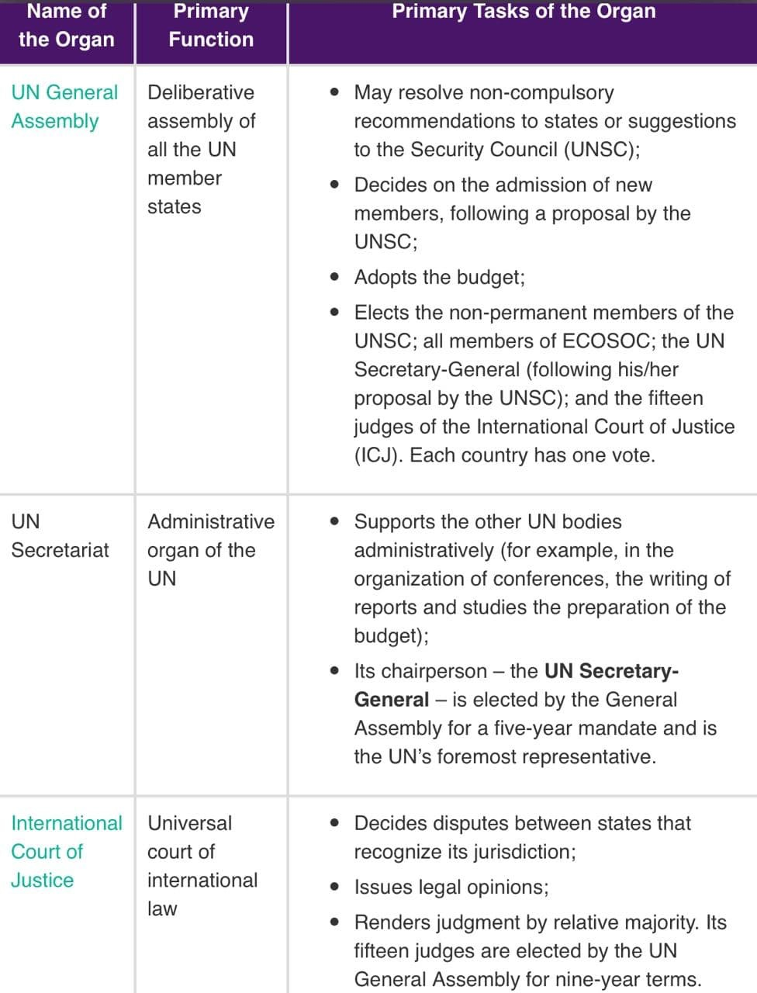role as have common element s with developed as well as developing C, promote intrests in CC, Terrorism, Nuclear negotations

##### photo_2021-03-10_20-43-10.jpgECOSOC

* + Intro
    - ECOSOC one of the six principal organs of the [United Nations](https://byjus.com/free-ias-prep/united-nations-organization/)(HQ-New york)
    - has 54 members that are elected by the UNGA. Indian term expired in December 2020. Each member has one vote and voting is done by a simple majority.
  + In News:
    - June-21: India has been elected to UNESCO for 2 year term starting from 2022 🔥
    - Apr-21: India has been elected to three UNESCO key bodies which include, Commission on Crime Prevention and Criminal Justice, the Executive Board of UN Women, and the Executive Board of the World Food Programme
  + Functional commisions (structure)
    - Commission on Narcotic Drugs (CND), Commission on Population and Development (CPD), Commission on Science and Technology for Development (CSTD), Statistical Commission, Commission for Social Development (CSocD), Commission on Crime Prevention and Criminal Justice (CCPCJ), Forum on Forests (UNFF)
    - Commission on the Status of Women (CSW)
      * September 2020- India elected as a member for four years from 2021 to 2025. (China failed to win a seat)
    - Disbanded Commision- Commision on HR replaced by UNHRC, Commsion on Sust dev replaced by High Level Pol Forum on SD
    - Regional commisions-United Nations Economic Commission for Europe (ECE),United Nations Economic Commission for Africa (ECA),United Nations Economic Commission for Latin America and the Caribbean (ECLAC),United Nations Economic and Social Commission for Asia and the Pacific (ESCAP),United Nations Economic and Social Commission for Western Asia (ESCWA)
  + Mandate/functions in brief
    - main central body responsible for coordination, policy dialogue, policy review and recommendations on social, economic and environmental issues
      * It coordinates the work of the 14 UN specialized agencies(such as FAO,WHO,UNESCO,ILO,WB,IMF,UNICEF etc) ten functional commissions and five regional commissions, receives reports from nine UN funds and programmes and issues policy recommendations to the UN system and to member states.
    - engages in encouraging debate and innovative thinking to attain gloabal goals, follow-up United Nations summits and conferences.
    - It is an international meeting point for governments, leaders, academicians, policymakers, parliamentarians, NGOs, etc.
    - Promoting sustainable development , Financing for sustainable development
      * The UN High-Level Pol Forum on Sustainable Development is held under the auspices of the ECOSOC- it reviewsthe 2030 Agenda for Sustainable Development Goals (SDGs).
    - It conducts special meetings to address emergency issues and situations such as health emergencies like the Ebola outbreak, the global food crisis in 2008, etc.
  + Current status and issues with the org
    - Basic issues- too large, too much work, policy duplication, Buereaucratic, ineffective review, recommendations - dead letters of non compliance
    - Pick a topic like SDG, women, children,refugee and write their issues wrt failure of ECOSOC
  + Reforms needed
    - Covered above + can explore smaller ECOSOC, annual ministrial meetings etc
  + India- focus(i.e how India benefits from it, what India should do for its interest wrt org, how India can play leadership role wrt other small nations etc)
    - Like commission on W- focus on getting elected to other commisions, including main ECOSOC body
    - Myriad challanges in India- use ECOSOC for better leadership and policies for developing world
    - Funding for global challanges like poverty etc as well provide techinical support to nations in Africa, middle east wrt policy making at ECOSOC and imp outside

##### UNHRC

* + Intro
    - Estb in 2006 by UNGA resolution- intergov body mandated for promotion and protection of HR along with taking action on HR violations. It replaced earlier UN commision on HR. It reports to UNGA
    - 47 member states elected by UNGA for 3 yrs term with one-third retiring each year(India member 2019-2021), has pre-defined geo distribution of seats(like 13 from asia-pacific etc)
    - Decision/resolution/recommendation not legally binding on states
    - Gets technical support from UN office of the High Commisioner for HR(dept of UN secretariat- mandate of preventing HR violations,integrating HR within all Un work etc)
  + mandate/functions
    - Assesing HR record of states through review, independent experts for specific HR violations,Examine HR violation complaints
    - HR education,services,diologue on HR, recom to UNGA for Int law wrt HR
    - Monitoring and imp of HR commitments commited by states during conferences
  + Current status and issues with the org
    - Membership issues- No account of state HR record during nomination(eg pak elected recently), other states such as Saudi, Tainted democracies nominated, states like US says only democracies should be eligible- but debate on priorising pol rights over eco,social rights
      * Secret ballot- need for open ballot for more HR discussions
    - Geographical quota system- Regional groups usually nominate actual no. of states- limits choices for small uninfluential countries, also lead to election of states with bad HR records
    - Focus on states own interest rather than HR as an issue- makes it highly politicised
    - Israel and UNHRC- accusation of being biased towards Isreal- most no. of resolutions- in 2018 US pulled out of UNHRC calling it cesspool of pol bias that makes mockery of HR
  + Reforms needed- adress above issues in prescriptive way
  + India- focus(i.e how India benefits from it, what India should do for its interest wrt org, how India can play leadership role wrt other small nations etc)
    - Kashmir, Pak elected till 2023 so need for active diplomacy to contain, India member till 2021 should be used to make long term friends in council, address HR internal concerns too apart from diplomacy.

###### UN Peacekeeping

* + to help countries torn by conflict to create the conditions for lasting peace.
  + financial resources of UN Peacekeeping operations are the collective responsibility of UN Member States. Decisions about the establishment, maintenance or expansion of peacekeeping operations are taken by the United Nations Security Council.(India wants reforms at this aspect)
  + UNPK forces deployed on consent of main parties to conflict, UNPK is impartial and use force only in seld-defence, use force only at tactical level with UNSC authorisation

India’s contribution to UN peacekeeping

* + Contribution dates back to 1950 Korean war when India provided forces an doctors as peace building activity, provided more than 2 lakh military and police officers to UN Peacekeeping over 70 years, in more than 50 missions.
  + Currently among the largest troop contributors in the world, with over 7,500 personnel deployed in Cyprus, Congo, Haiti, Lebanon, the Middle East, South Sudan and Western Sahara
  + Also lost the **highest** number of its peacekeepers in various UN peacekeeping operations in the last 70 years, with 168 military, police and civilian personnel from the country laying down their lives in the line of duty, In 2007, India became the first country to deploy an all-women contingent to a UN peacekeeping mission in Liberia.
  + Peacekeepers have also brought the ancient Indian practice of yoga to UN missions.

###### Non Aligned Movement

* + Intro
    - formed during the Cold War as an organization of States that did not seek to formally align themselves with either the United States or the Soviet Union, but sought to remain independent or neutral.
    - Idea at Asia Africa conf at Bandung 1955 (indonesia)(10 bandung principles identified - respect for sov, racial equality, non-interv, no collective defence pacts, UN lead peaceful solution to issues, HR etc)
    - first NAM conf at Belgrade(Yugoslavia) in 1961 under leadership of India,Indonesia,Egypt,Yugo,Ghana
    - 120 members currently, based on ideals on Panchsheel- non iterference, mutual respect,non aggresion etc
  + Current status and issues with the org
    - With the end of CW- loosing relavance, mere talkshop, unable to address concern of third world
    - Several members like India first close to USSR then now USA in post 1991 need for tech, FDI,China etc
    - As larger bloc- very diff to frame common views, absence of clear lack of leadership
    - Alternative platforms like BRICS, IBSA, SCO Etc have emerged with overlapping agendas
    - However still holds relavance as
      * Strategic independence for developing C always relavant- new power centres-China-US,USSR etc- autonomy for policy to follow always relavant in global talks and diplomacy
      * Collective voice of developing world with common challanges- need to act as coherent groups in trade,CC talks, environmental degradation, terrorism, radicalisation, poverty, public health emergencies - can only be faced together, not when world is divided- requires collaboration, not coercion. In short, effective multilateralism remains the only answer. NAM can be that answer.
  + Reforms needed
    - India called for need to keep on updating agendas wrt global challanges and act as collective voice on issues, reforming international inst, pool best exp etc
    - No need for broad position on selecting any idelogy or group rather based on micro issues facing developing C.
  + Conclusion
    - A democratic, effective, flexible, credible, transparent and representative, multilateral organisation like NAM is imperative for 21st century world order.
  + India- focus(i.e how India benefits from it, what India should do for its interest wrt org, how India can play leadership role wrt other small nations etc)

##### BRICS

* VP attended 18th NAM summit in Baku(Azerbaijan), Modi-Online summit for COVID 19- called it world’s moral voice, pointed out limitations of int orgs
* India should provide leadership as biggest platform for dev C outside UN, south-south co-op, UNSC reforms along with PM level participation in summit to give it more imp for Indian FP (Both in Venezuela and Azerbaijan- VP went)

India to host summit in 2021

* + Intro
    - BRICS nations account for 23% of world GDP, 43% of world population, based on notion that its economies will collectively dominate global growth by 2050
    - aim to promote peace,dev an co-op along with estab a more euitable and fairer world.
  + Achievement of BRICS
    - NDB- non-western dominated bank, have Contigency Reserve Arrangement for BOP crisis support, expanding footprint by inc new members, 10b$ for pandemic
    - Medical collab- Ufa declaration in 2015 to jointly combat infectious diseases, • BRICS Science, Technology and Innovation (STI) Framework Programme for collab btw experts
    - Expanding trade: Over the past five years, intra-BRICS exports grew by 45%, BRICS Rapid info security channel for exchange of info on cybersecurity(LOL)
    - Recent Moscow declaration on online BRICS summit- Strategy for BRICS eco partneship 20-25, BRICS counter-terrorism strategy- strenghtening intra-BRICS ties in the area, improving intelligence sharing, urgency for extension of 2010 Russia-USA START treaty, need for glbal governance reforms wrt UNSC,IMF,WTO,WHO(although diff views on type of reform)
  + Significance fo India
    - Safe space to manage conflicts- eg India-China remained discussing within BRICS during Doklam and recent clashes
    - Maintain strategic autonomy during growing India-US convergence
    - Provide transcontinental reach as Brazil,SA members- India as a global leader opportunities
    - Boosting demands for reform of multilateral inst, along with creating new nonwestern inst
    - Though initial start focused on economy, BRICS has been a platform to advocate for UN and UNSC reforms
    - NDB loans- India largest beneficiary so far, non-conditional financing unlike WB,IMF- better for global south
  + Current status and issues with the org
    - Political disparities among members, includes both democracy and authoritarian regimes( recent SA criticism of China due to racist attacks), other chinese issue of BRI debt trap, post pandemic hesitance wrt China etc
      * US-India convergence, China-Russia bonhomie, India-China issues
      * Lack of concentrated focus - India’s closer ties with USA, Russia itself being cast out of G8 grouping, China’s aggressive stance
    - Grouping seeks to reform global financial governance but is divided over UNSC reform- countries such as china want to maintain status quo - focus only on selective reforms
    - Dependency on other global inst- lack strategic vision of own due to differences over many issues
    - Inadequate funds as compared to WB,IMF- need more capital in NDB
    - Dominance of china in trade, other 4 countries have limited trade within themseleves
  + Way ahead
    - increased intra-BRICS cooperation in areas like health, science and technology, finance, trade
    - Better P-P ties- easy visa requirements for member nations, inducing collaboration among researchers, private sector collaboration.
    - The future of BRICS will depend on how much the leaders agree to stand collectively against trade protectionism, global commons issues and ability to share a common political agenda.

##### WTO

* + The World Trade Organization (WTO) - only global international organization dealing with the rules of trade between nations- has 164 members (including European Union) and 23 observer governments (like Iran, Iraq, Bhutan, Libya etc).
  + Brettonwoods conference delegates recommended the establishment of the International Trade Organization (ITO)(apart from WB, IMF), which they envisioned as the third leg of the system.(however not formed) rather GATT formed- to phase out the use of import quotas and to reduce tariffs on merchandise trade, GATT sponsored 8 rounds of multilateral trade negotiation rounds.
  + The Uruguay Round, conducted from 1987 to 1994, culminated in the Marrakesh Agreement, which established the World Trade Organization (WTO)(included trade related aspects of services and IPR )
  + WTO-not a UN spec agency

Functions

* + The WTO’s global system lowers trade barriers through negotiation and operates under the principle of non-discrimination which promotes global growth
    - In addition, the WTO agreements are full of provisions that take into account the interests of developing countries
  + The WTO can give the weak a stronger voice: Small countries would be weaker without the WTO.
    - Coalitions give developing countries a stronger voice in negotiations.
    - The resulting agreements mean that all countries, including the most powerful, have to play by the rules. The rule of law replaces

might-makes-right.

* + The WTO can contribute to peace and stability: When the world economy is in turmoil, the multilateral trading system contribute to stability, deter protectionism and increase certainty

Structure

* + Ministerial Conference- The topmost decision-making body- meets every two years.
  + General Council- has representatives of member governments and has the authority to act on behalf of the ministerial conference.
    - It also meets as the Trade Policy Review Body (Trade policy review of member states) and the Dispute Settlement Body (DSU)( establish dispute settlement panels,refer matters to arbitration, apoint persons to Appellate Body(standing body of 7 persons that hear disputes, its reports if accepted by DSB must be accepted by party ) for 4 year term, authorize suspension of concessions in the event of non-compliance with its recommendations and rulings.)
  + General council has 3 specific councils(for goods(GATT),for services(GATS)for IPR(TRIPS)
  + Global trade rules: Decisions in the WTO are typically taken by consensus among all members and they are ratified by members’ parliaments. This leads to a more prosperous, peaceful and accountable economic world.

The Doha Round

* + The Doha Round is the latest round of trade negotiations among the WTO membership- aim is to achieve major reform of the international trading system through the introduction of lower trade barriers and revised trade rules- also known as the Doha Development Agenda as fundamental objective is to improve the trading prospects of developing countries- launched at the WTO’s Fourth Ministerial Conference(MC4) in Doha, Qatar, in November 2001.
  + The Doha Ministerial Declaration provided the mandate for the negotiations,including on following subjects:
    - Agriculture: More market access, eliminating export subsidies, reducing distorting domestic support, sorting out a range of developing country issues, and dealing with non-trade concerns such as food security and rural development.
    - Non-agricultural market access (NAMA): To reduce or as appropriate eliminate tariffs as well as non-tariff barriers, in particular on products of export interest to developing countries.
    - Services: To improve market access and to strengthen the rules.
      * Each government has the right to decide which sectors it wants to open to foreign companies and to what extent, including any restrictions on foreign ownership.
      * Unlike in agriculture and NAMA, the services negotiations are not based on a “modalities” text. They are being conducted essentially on two tracks:
      * (a) bilateral and/or plurilateral (involving only some WTO members) negotiations
      * (b) multilateral negotiations among all WTO members to establish any necessary rules and disciplines
    - Trade facilitation: To ease customs procedures and to facilitate the movement, release and clearance of goods.
    - Dispute settlement: To improve and clarify the Dispute Settlement Understanding
  + With 2008 crisis and fear of protectionism, Doha round enthusiasiam subdued
  + The 2013 Ministerial Conference (MC9) in Bali, Indonesia, delivered a significant achievement, the first multilateral agreement since the creation of the WTO- Trade Facilitation Agreement (TFA), which aims to speed up customs procedures and make trade easier, faster, and cheaper.
    - also reached an interim agreement (a peace clause) on “public stockholding” continuing exceptions that allow developing countries to stockpile agricultural products to protect against food shortages.
  + 2015 Ministerial Conference Nairobi, Kenya (MC10) focused on a selected number of issues that are part of the Doha Development Agenda (DDA).

Agreement was reached on - Stopping the use of subsidies and other schemes unfairly supporting agricultural exports and other misc issues

* + But for many Nairobi signalled the end of the Doha talks, a sentiment that intensified after the 2016 election of Trump.
    - President Trump made clear his preference for bilateral trade when he withdrew from the 12-country Trans-Pacific Partnership (TPP) shortly after taking office.
  + In 2017 Ministerial Conference Buenos Aires (MC11), USA reflected the skepticism toward multilateralism when itblocked agreement on a draft ministerial declaration that would have “reaffirmed the centrality of the multilateral trading system and the development dimension of the organisation’s work.”
    - Meanwhile, India, which has repeatedly threatened to block WTO agreements (including the Trade Facilitation Agreement) unless WTO members conceded to its demands on public stockholding for food security. India also toughened its stand on new issues including

e-commerce and investment facilitation.

* + - In the end, it was a relief to many that the United States did not actively seek to dismantle the WTO—as some had feared. But giving up its traditional leadership role could lead to a similar result, only more slowly.

Indian stance on WTO negotiations

* + - India is a founder member of the General Agreement on Tariffs and Trade (GATT) 1947 and its successor, the WTO.
    - Services exports account for 40% of India's total exports of goods and services.
      * India has an obvious interest in the liberalisation of services trade and wants commercially meaningful access to be provided by the developed countries.
      * Since the Uruguay Round, India has autonomously liberalised its Services trade regime across the board.
    - Ensuring food and livelihood security is critical, particularly for a large agrarian economy like India.
      * India is persistently demanding for a permanent solution on public stockholding subsidies at WTO.
        + At 2013 Ministerial Conference (MC9) in Bali, an interim agreement (a peace clause) was made on “public stockholding” continuing exceptions that allow developing countries to stockpile agricultural products to protect against food shortages.
    - India strongly favours extension of higher levels of protection to geographical indications for products likeBasmati rice, Darjeeling tea,

and Alphonso mangoes at par with that provided to wines and spirits under TRIPS agreement.

* + Developed countries have been putting pressure on inclusion of non-trade issuessuch as labour standards, environmental protection, human rights, rules on investment, competition policy in the WTO agreements.
    - India is against any inclusion of non-trade issues that are directed in the long run at enforcing protectionist measures (based on non-trade issues, the developed countries like USA and European Union are trying to ban the imports of some goods like textile, processed food etc.), particularly against developing countries.

WTO concerns

* + Failure to reach conclusion of Doha dev agenda with 150+ members, diff to get a consesus
  + The 2017 WTO Ministerial Conference **(**MC11) Buenos Aires ended without any substantial outcome as consensus failed - USA blocked a permanent solution on government stockholding for food security purposes, resulting in India’s toughened stand on new issues including e-commerce and investment facilitation.
  + Developed countries led by the US and the European Union sought to find a way out of the deadlock at the WTO talks by forming large pressure groups on e-commerce, investment facilitation and MSMEs within the WTO with more than 70 members in each formulation.
    - Though WTO is driven by consensus and even a plurilateral agreement needs approval of all members, the formation of these groups as an attempt to steer WTO away from its focus on multilateralism.
  + It’s fierce defense of ‘Trade Related Intellectual Property’ rights (TRIPs)—patents, copyrights and trademarks—comes at the expense of health and human lives
  + The U.S.A. has consciously (or not) destroyed the Doha round of trade negotiations process in formulating excessive demands that no country was prepared to meet.
    - The priority of the Obama administration was not to revive a dying WTO negotiation, but to concentrate on its newly created alternative, the TPP(Trans-Pacific Partnership), to contain its competitors: Europe andChina.
  + For years now, the multilateral system for the settlement of trade dispute has been under intense scrutiny and constant criticism.
    - The U.S. has systematically blocked the appointment of new Appellate Body members (“judges”) and de facto impeded the work of the WTO appeal mechanism.
  + Chinese mercantilism (encouraging exports and putting limits on imports), the USA’s aggressive use of unilateral tariff measures, and the inability of WTO members to reach consensus on expanding its disciplines to important new sectors
  + Challenges faced by WTO: Restoring dispute settlement mechanism, Divide over Doha development agenda, push for changing definition of ‘developing’ under S&DT, Tackle vaccine nationalism, Voluntary sharing and pooling of IPR to fight COVID

Way forward

* + Since the WTO is consensus-based, reaching an agreement is difficult. Explore plurilateral agreement with a group of like-minded countries (applied for Indian interests too) on a new set of rules that serve as an addendum (supplement) to the broader WTO.
  + World is going through the protectionism, trade war (like USA & China), and Brexit making global economy squeezed. The role of WTO in future is very

crucial to preserve global liberalised economic system evolved since the end of the 2nd World War.

* + It is right time when countries like USA giving threat to withdraw from WTO making it dysfunctional, India and other emerging economies like Brazil, South Africa etc can provide a strong base for strong WTO with saving interests of

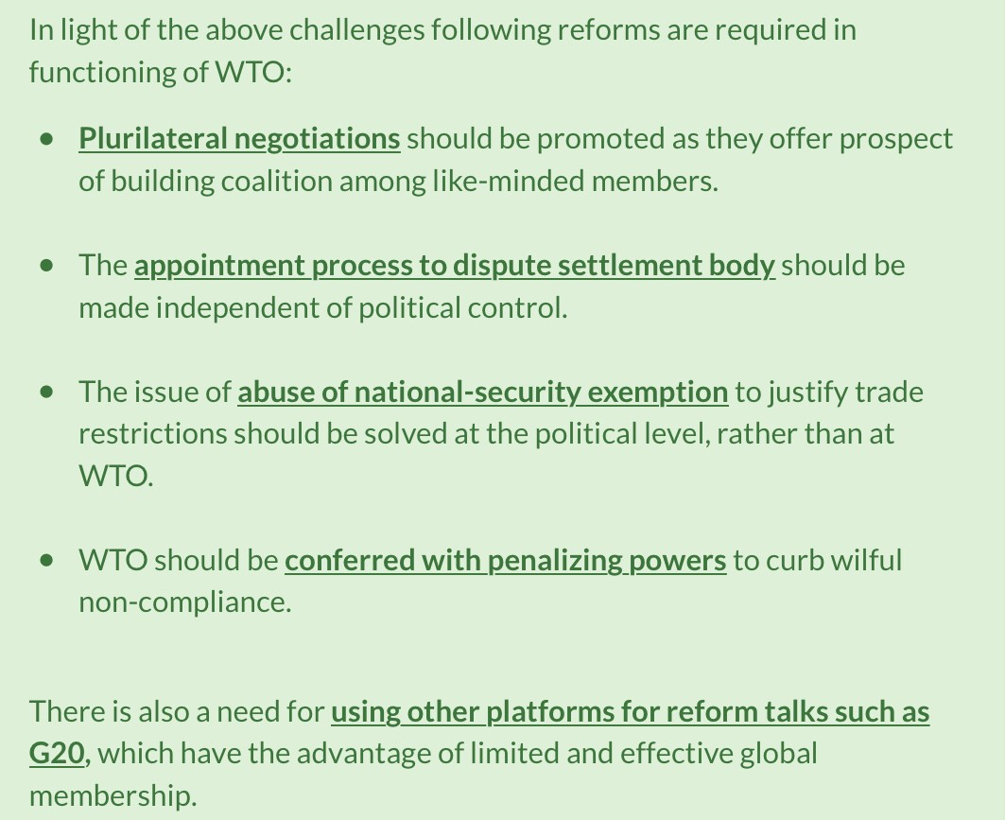developing countries.

## Current Updates and Value Additions

🔸 ***The value additions here have drawn from Dipin Sir’s classes, M365, and newspapers. Due credit is respectfully acknowledged to all these sources.***

* + **2024 - Latest Current Affairs (from M365)**

### Bangladesh Crisis:

* + - * Lost a Trusted Ally; **Anti-Indian Sentiment** (as Hasina-India had

good ties); **Arc of Uncertainity**; Indian **owned 25% textile business in BG**; China advantage; Minority question;

Uncertainties for Indian Investments/Connectivity (8bn LoC + Akhaura-Agartala rail link);

* + - * **Challenges with new govt: Extradition of S. Hasina; Purani govt ke positives (Border M, NE, Rohingya issue pe stance chance)**
      * **BG**: **China's proposal for Teesta Project (chicken neck) - China advantage also an issue**;
      * **EAM Jaishankar** said - **‘India has to find a ground of mutual interest** with Bangladesh and **India would deal with 'the**

government of the day'.

* + - * **Conclusion: C. Raja Mohan says, ‘India will need enormous strategic patience**, faith in the logic of geography and strong political commitment **to build relations with changing Bangladesh’**

### Myanmar:

* + - * **Signif** (**Border Mgmt**, Sub-regional devt-ASEAN, **Infra**

**diplomacy-IMT/Kaladan**, P2P ties, Dvt of NE, **Buddhist diplomacy**);

* + - * **Status: Three Brother Alliance**, **NUG (Nt. Unity Govt of Myanmar - in exile**), **Military Junta** (90k refugees, 2mn displaced), **FMR suspended**;
      * **India** is now following a “**twin-track approach**” (**Junta coop to ensure China does not get close**, **ASEAN coop, return to democracy**, Neighbourhood 1st Policy);
      * **WF**: BIMSTEC, **Mekong Ganga**; **Accountability for crimes against humanity**;
      * Concl: Need - **Pragmatic, Cautious & Calibrated approach**;
      * **Rajiv Sikri** - Arc of Instability, Arc of Uncertainity (due to unstable neighbourhood) + **3Us-BRO**

### Neighbourhood:

* + - * 7 Leaders from the neighbouring countries were invited to the swearing - in ceremony;
      * Prof Happymon Jacob-"*Paradox of India's global rise its regional decline*";
      * **Parl Std on Cmt on EA** (**Set up for regional development fund for connectivity infrastructure**; **Strengthening** multilateral organisations **SAARC**-**BIMSTEC**; Establish a common platform for countering terrorism under NFP

### WA & Red-Sea:

* + - 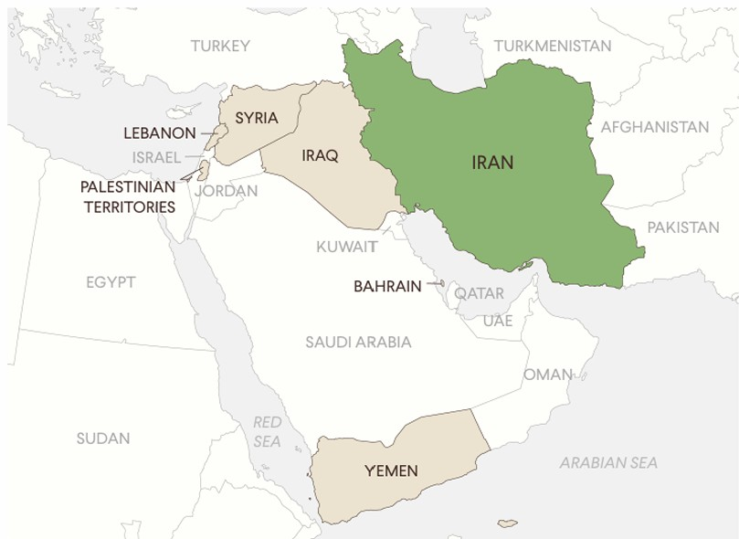
      * **Axis of Resistance** (**3H**- HAMAS, HEZBOLLAH AND **HOUTHIS**

NEXUS); Proxy wars, **Regional instability, US/Israel vs Iran**; **Arms race; Failure of UN**;

* + - * + ***The ‘Axis of Resistance’ should not be seen as acting in solidarity with the Palestinians, but rather using the Palestinian issue as a tool + Iran’s strategy is designed to sow instability***
      * Implications for India: Diplomactic balancing; **I2U2 group becomes defunct**; Investments **IMEC/Chabhar/Farzad-B** (**recently contract signed for 10 yrs**); **Energy security**; Diaspora-humanitarian; Security threat;
      * **India's approach** (**Trilateral FP**, Soft power), **Operation Sankalp**

by India

### BRICS:

* + - * **Status**: **Expansion (I-SEE-U)**; **42% popu, 24%** GDP; **NDB**,

**CRA**-Contingent Reserve Arrangement, Ulfa declaration;

**Johannesburg II declaration (adopted in 2023 summit)**; Use of dometic currency; **55% voting** of BRICS)

* + - * The **combined GDP of BRICS** nations, which are dominated by the Global South, has already **surpassed that of the G7 countries**; **Continental reach of BRICS**
      * **+ves** of **Expansion: 46%, 38%; Intra-BRICS trade/market**; **Strengthen NDB**; Multilateralism, Enhanced S-S; **Space to**

**manage conflicts: Ind-China kept discussing** during Galwan/Doklam clashes; Greater diplomatic weight

* + - * **Issues**: China's trying to bring pro-china nati**ons** to counter India; Geo-pol rivalries in members (Iran vs SA, Ind vs Ch, Egypt vs Ethio); **Competing interest (IMEC vs BRI**); **Conflicting views (UN reforms);** Strategic distrust; Economic disparity; China see it as anti-west but India see it as non-western body
      * **WF:** Permanent secretariat, Internal unity, **P2P, Cultural exchange**
      * ~~PM Modi - Influence of BRICS has grown as it has undertaken~~ ~~structural changes and acted with practical steps~~
    - **ICJ**:
      * **Principal organ** of UN; 9 yr term; **15 judges**; **Judgement binding**

+ **compliance by UNSC**;

* + - * Context: **ICJ demanded Israel to stop military actions in Rafah area** + **ensure “unimpeded access” to UN-mandated investigators** to check genocide allegations
      * **Signif: Settling legal disputes; Peaceful resol; Prevent of HR violation;**
      * Challenges: Non-complainces, **Delayed justice**;
      * WF: Updation of ICJ Charter;
      * v/s ICC (Rome statue, not part of UN, appeal allowed vs no appeal in ICJ; prosecution of individuals, charged genocide, war crimes, India not signed)

### IMEC:

* + - 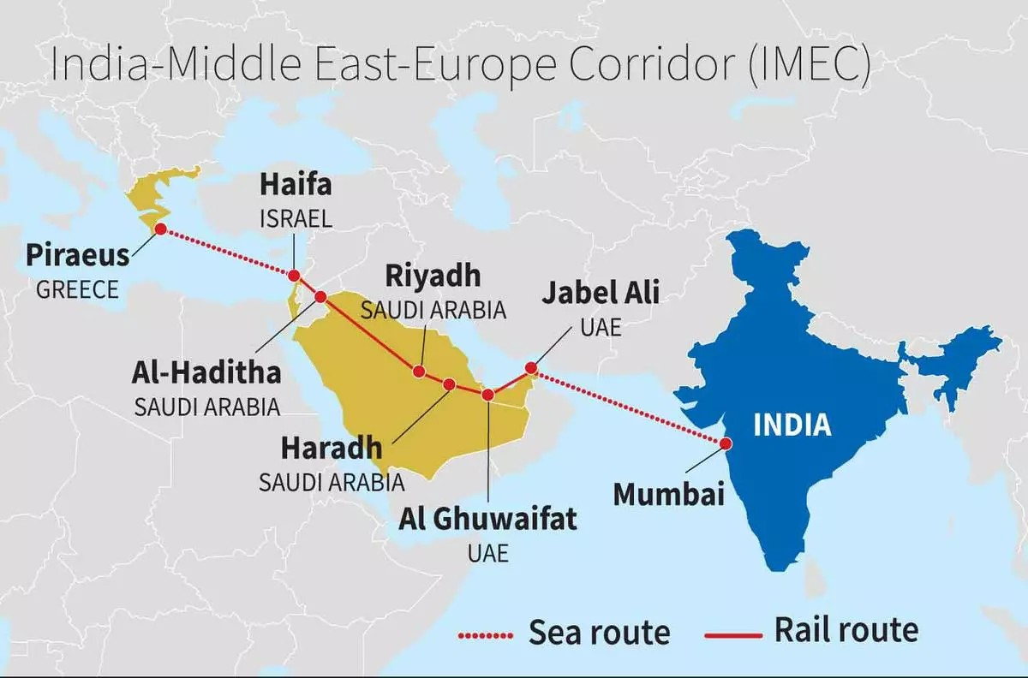
      * Ports: JNPT/Kandla, **Jabel Ali UAE**, Riyadh in SA**,** Haifa in Israel**,**

Piraeus Greece; (use 2 colour pen + make medi sea area also in map)

* + - * Features: Railroad, Ship-to-Rail networks and Road transport; **East**

corridor; **Northern** corridor; **Singatories: I2U2, EU, S.Arabia,**

**France, Germany, Italy**; Significance: **Thwart to China’s BRI**, Integration Across Civilizations, IMEC bypasses Pakistan Overland Veto, Intra-Regional Connectivity & Peace, Africa (Trans-African corridor); Enhanced **Trade (40% faster than Suez**); Job creation; **Industrial growth via SEZ**; **Energy Security**;

* + - * Challenges: **Complex logistical planning** and coordination; **Missing Rail Links**; **PotentialOpposition (Egypt's Suez Canal)**; Cost & financing;
    - **UAE**:
      * India’s third-largest trading partner; Trade (**New FTA - CEPA** led to

trade inc by **15%** same as AUS); Energy security (**partner for strategic petrol reserve,** oil imports); Multilateralism (IMEC - Jabel Ali Port, I2U2, UAE guest in G20), **India-UAE Startup Bridge**; P2P (**BAPS Swaminarayan Temple + IIT-Delhi in UAE**, 3.5 mn diaspora); Look West Policy; **Part of BRICS**+**UAE brokered backchannel dialogue** b/w India-Pak for ceasefire; **UAE presidency of COP28;**

* + - * **High level political visits; 4th largest FDI, I2U2 facing issues**

### Maldives:

* + - * Issues: **Undiplomatic words** used by ministers against PM Modi;

**Singed 20 agreements with China**; Withdrawal of Indian troops;

* + - * Signif: **70nm from Minicoy**, Eco trade, **70% training of mil done by India**; HADR
      * **Use Quad to counter-balance China**

### US President Elections:

* + - * CC (withdrawal), **Close ties of Republican with Pak**, HR issue

democrats, **VISA Policy, Tarriff/GSPwithdrawal**, Kamala Didi (Diaspora, women empowerment), **Indo-pacific**

### Russia

* + - * Nearly **100 Indians recruited** by Russian Army (the Hindu);

**Geneva Convetion (Mercaneraires are** - motivated by fin gain, not resident of conflict states); UN Mercenary convention

### Sri Lanka

* + - * (**Katchatheevu Island**-on side of Int Maritime Border Line of SL;

**India recog SL sov**; Fishermen Issue regular, **TN-earlier urged**

**centre to retain island)**; Suggestion (**Regular meeting of JWG**on fisheries; **Joint Patrolling, Meena Kumari Cmt**); WF: BIMSTEC, **NFP, SAGAR**

### Africa:

* + - * WF: Amb Gurjit Singh - Establish **India-Af track 1.5** dialogue;

**Adopt pvt sector invst led approach**; **Rupee based trade;**

* + - * **Operation Kaveri in India-Af relations** (Wf as **Ubuntu** philosophy), **Neo-colinialisation of Af**(China); MEA said For India-rise of **Africa is key to global balancing**

#### China

* + - * **China’s Maritime Silk Route** led to its acquisition/operation of

around **100 ports globally**; **Dual use of ports**; Debt-trap; Grey zone; Yuan Wang 5

* + - WIPO - Treaty on IPR, Genetic resources, Associated trad knowledge with India
  + **Padhte waqt socho kahan kahan aur utaroge yeh (inter-linakge)** 🔥

### Draw Maps + Ǫuote policy

* + - (Neighbourhood F, AEP, Look W, SAGAR doctrine, C2CA, Multi-alignment)
    - **Map of Indo-Pac**, Map of **West Asia**, Map of **Neighbourhood** (eg: Nepal border dispute), **South China Seawith 9 dash line** (**upar Paracel, neeche** Spartly), Diaspora ka data wise (gulf, USA, south east) ya Old n new mention kr skte, **Egypt ka strategic location** mark kr skte, Africa me Sudan mark kr skte, **Foreign policy evolution**, FIPIC mein map
    - 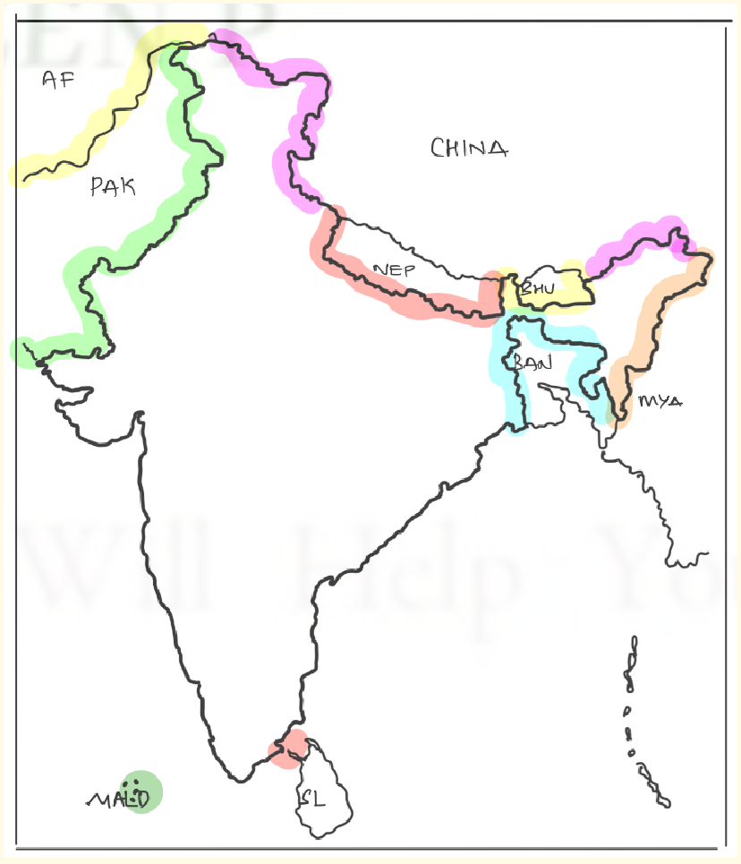

### Key Value Added Terms:

* + - **Different Policies of India** - Neighbourhood F, AEP, Look W, SAGAR

doctrine, C2CA, Multi-alignment + Aid focus in **Gujral** doctrine, Indo pacific (will come with bilateral countries)

* + - **ABCDEFGHI**: Agriculture/Aadmi (P2P), Border, **Culture/Connectivity/China/Common Ch**, **Defence**, **Economy/Energy/Market**, Foreign policy approach, **Geog location/Global grouping**, **Hitech/S&T/Space**, **Internal Security angle** (maoism, terrorists, refugee)
    - **Strategic autonomy**
    - **China dimension always, China+1**
    - **Common Challenges: Counter terror/Rules based order in I-P**
    - **WHY BHARAT MATTERS - Demography, Mother of Democracy, Large geog-Indo-Pac; Rich culture & history; DPIs; Voice of global south;**

**Institution bldg and agenda setting; Engine of global economy**

* + - **Kindleberger trap (Vacuum of global public goods-Security, CC, cyber sec), Friendshoring, Decoupling**
    - **Diaspora**: **Temple at UAE**, **Oscar for RRR**, **Little India in Aus**;
    - **ES 2024:** After gap of 10 yrs - **4 New FTAs** assigned (**Mauritius**, **UAE**, Aus,

EFTA)

#### Quotes

* + - People want to listen to india. They want to be seen with India

**(global south, world order)**

* + - The **G20 has contributed** to making India world ready and the world India ready - **EAM**
    - **Asia of rivalry** will hold us back and **Asia of Co-operation** will shape this century
    - EAM - **Leverage dominant, Collaborate convergent, Manage competition**
    - **Neighbourhood - Dr. Shashi Tharoor** - **India’s global ambition depends on its power to convince**neighbours that **India’s rise is opportunity for them, not threat**;
      * **Shyam Saran** said **No Country has become great power, w/o achieving leadership in its own neighbourhood**
    - **Indian Diaspora serves as a living bridge**
    - **Europe's problems are world's problems but.** **EAM**
    - We are headed for a **poorer, meaner and smaller** world (global order/ essay)
    - We are not pro-R, not Pro-America, we are pro India, We are on our side no one elses
    - Today, World order is militarily unipolar, economically multipolar, and politically confused. (emerging world order)
    - India and are Natural partners (sb bilateral me pelo)
    - Ex-Foreign Secretary Vijay Gokhale said - India has moved from its non aligned past and has become **an 'aligned' state on isssue-based**

coalitions

* + - **Middle east is looking east - Sanjay Baru**
    - Heteropolarity - **Non state actors** (**Starlink** helping Uk)
    - Democracy is in DNA of India - PM Modi
    - **Focus on eco diplomacy** - 3.5TD, 4 new FTAs signed
    - Washington Consensus, **Cornwall Consenus (state role, reform global governance)**
    - **Trilateral FP - Israel, SA, Iran** - challenge and **success** of India
    - Border Infra Data - 4k to 14k
    - Washington Consensus, Cornwall Consenus, New Washington Consensus
    - FP Challenges: Geo-pol, Geo-eco, Narratives, Neighbourhood (Arc of instability, 3Us-BRO)
    - **India wants multipolar asia multipolar world** (unlike China, USA)
    - USA encircling China eg: AUKUS
    - **Emerging global order as intro** - 2 bloc world, deglobal,

**anti-immigration, arms race,** New WS consensus, Era of leader and led is gone

* + - Kindleberger Trap [vaccum of global public goods (Security, Cyber, Climate)]
    - **Signif**: Hub of **SLOC**, **Net security provider**, P2P, 5 ARCs (R. Sikri) - UEPIC (uncert, Energy-WA, Prosperity, Instab, Communication/SLOC/Ocean)
      * Look east vs **Act East Policy** (**3Cs, Security, beyond SEA**)
    - A **failed pak is not solution** for India + Pak centralised monolithic identities + Track II diplomacy + **CBMs**, More closer to india (cuisine, culture) than Arab; **2D approach (Direct action or Diplomacy)** → '**Terror by night, trade by day is not acceptable**': Jaishankar in veiled attack on Pak+ misuses stragetic innocence + Deep state **+ IWT revision**

**+** Pol instability

* + - China's **dual use villages** 'Xiaokang' + China's **mission Creep** (gradually expanding in the region/everywhere), **Sino Centric world order** +

**Saudi-Iran deal** Mediated by China, **Cartographic aggression (salami slicing)** + **US fear tech dominant China**, **Decoupling China is not easy (ES24 not giving space); 3 sector border dispute,** Water bomb issues as low riparian for BH river

* + - Diplomacy ~~is~~ was replacing conflict in West Asia + **Trilateral balancing** (diplomatic success, **Israel-dehypehn, SA, Iran**) for India in WA + **I2U2**+ India’s strong **diaspora** must mention; **Knowledge diplomacy (IIT in Tanzania**, **UAE**), **De-Americanisation**; **30% remittances** from region (**RBI**), **Sino-centric** world order, **JCPOA, Arc of Energy**
      * India and West Asia **share long civilizational links and**

**convergence of interest** on issues of global ramifications. **use such intros as well!!**

* + - Asian Coop - **Asian Century** + At the centre of Asia-Africa unity, India-Af ties holds immense potential
    - **R-Uk:** India **gave Buddha** not Yuddha + **Not the era of war**, Revanchist claims of R, NATO-isation of Neighbourhood, **Frozen** conflict, **10k lost** life, **Japan def budget inc** (**Ukraine could be future of Asia**), Peace efforts **by India (Black sea** grain)**, No limits P’ship with China**
      * **Weaponisation**, **UN-Crisis of Confidence & Legitimacy**, **Sanction dodging, Geneva Convention**(rules to limit the brutality of war)
    - **3Us** - Way Fwd (Unsettled borders, unintegrated region and under exploited opportunities) - **neighbourhood/regional**
    - Engagement is not endorsement + engaging with ppl of aghanistan + mini-maxing
    - **Japan**: **Pacifism to Japanese realism** (Ukraine War - C **Rajamohan**) + **70 years** of ties EAM - **Asian color to G7** + Civil Nuclear Deal (**India 1st Non NPT**) + Ahmedabad-Kobe (**Sister Cities**) + **natural partners** + monetary incentive for migration by Japan; **Both want multi-polar asia &**

multi-polar world + CEPATrade ~20 bn vs China 350 bn;

#### Conclusions:

* + - India's guiding principles for Neighbourhood/Indo-Pac/etc will be the

five point S articulated by PM Modi namely **Samman** (respect) **Samvad** (dialogue), **Sahyog** (cooperation), **Samriddhi** (prosperity) and**Shanti** (peace).

* + - Common WF: Use Track 1.5 diplomacy + P2P, Cultural exchange
    - **FP/Relation** is about **forging convergences** and **managing divergences (EAM); Mini-maxing (Shiv Shankar Menon)**
    - **Art 51**: Promotion of **International peace** and security; **Respect for international law**; Just and honourable relations
    - **4D of India** Democracy/Demography/Decisiveness/**Diaspora**
    - IR ka generic question aaye **usme specific terms** - **Geographic location**

(India located in IOR), Role of**Diaspora** (must mention);

#### G20: (made into G21 by India)

* + - India’s G20 agenda will be inclusive, ambitious, action oriented and

**decisive (IAAD) - PM Modi (unlike G7)**

* + - **Inter-govt forum** founded in 1999 (G20 - **85**% GDP; **75**% of global trade;

**2/3** population) **G.T.P.**

* + - Structure: **Finance Track, Sherpa Track** (Amitabh Kant, wider track), **Troika** (Indo, India, Brazil), Engagement groups (B20, W20, Y20, Urban/Rural/Civil20); **Original obj narrow (eco stab, promote fin regu** to reduce risk, now expanded)
    - Why India? Demo in DNA, Cultural diversity, Huge Pop, 5th GDP (surpassed coloniser), Bridge b.w GS and GN, Voice of GS
    - Priorities of India (1 GS1, 2 GS2, 3 GS3) - Key highlights of the New Delhi Declaration
      * **Global South/Hunger - Adoption of the Deccan High-level Principles (HLP) on Global Food Security**
  + 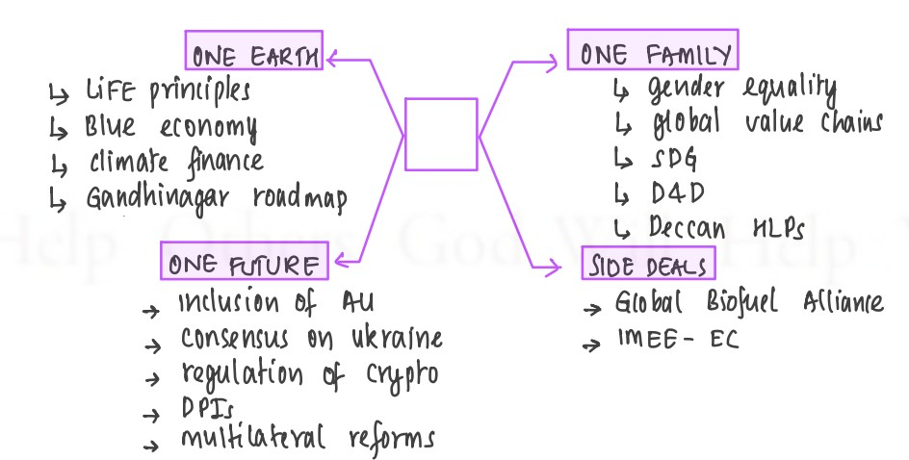
* Green Development, Climate Finance and Lifestyle for Environment (LiFE)
  + in the **background of technological non sharing**, Loss & D
* Technological Transformation and Digital Public Infrastructure
  + we need **Tech multilateralism** like India **UPI**, **COWIN**, JAM)
  + India plans to build a Global Digital Public Infrastructure Repository (GDPIR)
  + Bridge digital divide (half world has no digital identity)
* Accelerating progress on SDGs
  + Endorsed Harnessing Data for Development (D4D), Adopting a one-health approach
  + **Food** security, **Weaponisaton** (black sea), **Millets promotion,** Energy security
* Accelerated, Inclusive & Resilient Growth
  + In the **era of polycrisis** (India can play a moderator/***leading power***), **secure global value chains**
  + Inclusive Voice of Global South, Wide destination choice
* Multilateral Institutions for the 21st century
  + **NORMS** approach, Reform WTO/IMF/WB/UNSC (**60% low income countries debt crisis IMF**)
  + Agreement on UNGA 75/1 (UNSC reforms)
* Women-led Development
  + **W20, Global Healthcare**, Tax problems
  + Full-fledged working group on women’s empowerment
* **Build consensus on Ukraine issue**
* **Significance of G20: (use priorities)**
  + Group of developed & developing;
  + **Inclusive** approach (**9 other invitees, Af Union as member** of G20)
  + Decision by consensus unlike veto of UNSC;
  + **To prevent kindleberger trap**
  + Accelerate progress on SDGs (via inclusive green growth)
  + Past Achievements: **Spearheaded reforms in the past like G20/OECD BEPS**; Steered economy out of GFC 2008/AFC 1999; Role in shaping and strengthening global architecture on international economic issues;
* **Challenges**: Diff to drive consensus geo-political scenario (table **,**

**Geo-eco protectionist/friend-shoring**; Underrep of Africa; **GZero world** (no country has power), Informal forum as **no enforcement/talk shop eg: IMF reforms**; **Lacks objective framework**; India stayed away from OSAKA track

* **Major Outcomes:** Consensus based Delhi Declaration; African union; IMEC; Global Biofuel Alliance
* **WF: G20 must also reach out to non-member states** and non-state actors; **Establishing a code of Conduct**for the members; **Avoiding**

**Internal Fracturing** and promote collective action

* **Conclusion**: Theme of Vasudev Kutumbakam - One EFF

#### FTAs in News

* + **Benefits**: Domestic (**Assemble in India; Sectors for**

**UAE-textile/Gems/jewellery; Aus-pharma/service sector**); **Geo-economics (China+1,** Asia emerging as global factory, GVC);

Geo-politics (**when Geo-economics there → Geo-political increases**) Other: Trade/Exp/Investment, Lab Movt

* + - **Bilateral trade** rose 15% post CEPA came into force + **ECTA** is with Australia
  + **Issues**: Trade (**$122bn deficit**, **inverted duty**), **Policy (criss crossing FTA rule** of origin violation), Dom mrkt (regu cholestrol, **agri affect**, manuf incompetent), Other (**WTO+ elements, withdrawl from RCEP, fortress economies**); **Low FTA usage in past (ADB 5-25%)**
    - Why slow negotiation: Issues **remain on env, labour, rules** of origin, **IPR, digital** trade, **Labour issues**
  + **WF**: **Surjit Bhalla Committee (Integrated approach G/Serv/Inv; Data on utilisation of FTA,** stakeholder/inter-min coordination); **Best practice** (**India-AUS FTA called ECTA** avoided dairy/agri, service sector liberalistion, **safeguard mech if sudden import surge, regular review, target 50bn from 25bn current**); **UK has D/o International Trade (for coordination)**

#### India-USA Relations:

* + Recent events: 2nd address of PM Modi; US is India's largest trading partner (128 bn Fy23, surplus 28bn)
  + Initiatives: Initiative on Critical and Emerging Technology (**i-CET**); **MoU for Semi conductor** supply chain; **Manuf GEF414 engine for LCA Tejas** Mk2 in HAL (80% **technology transfer**, promote indigenisation); **IndusX**- for collab on **defence** btw Ind and US startups; Mineral Security Partnership (**MSP for critical minerals**; aimed at catalysing investment); **Artemis**

Accord, 4 defence agreements

* + - Past collab: QUAD, **I2U2, IPEF**
  + Changes in r’ship: Beginning of end of technology denial regime; Overcome the hesitations of history
    - Ties have maintained their rhythm under Biden as US showed understanding on India's complex ties with Russia (60% defence); Shyam Saran- if you told me 20 years before that we we would have such strong defence and militaty r'ship with USA, I would have said this is unrealistic
  + Issues: Did not join **trade pillar of IPEF**; Sees **india as protectionist**; **Withdrawal of GSP**, **Russiandepdendence for oil/defence** (one of *reason for strong defence ties*); Democrats vocal for human rightsissues;

**Afghan withdrawal made india vulnerable and china occupied space** (brokered deals in W.Asia); **India rejected** the US’s invitation to join the **NATO Plus arrangement**; **Digital trade** barriers highlighted; **VISA denials, IPR 301 list**

* + Concl: Biden said defining r’ship of 21st century;
  + Application: iCET in S&T, MSP in Geog, GEF414/IndusX in Defence indigenisation; Semiconductor topic

#### Foreign Policy

* + **Evolution**: Simple diagram: **Cold war mein NAM → Post cold war**

Economic integration + Neighbourhood → Current Energetic and Assertive diplomacy FP

* + - Complex: Optimistic Non Alignment in bipolar phase →

Eco-integration/Strategic Autonomy in uni polar phase → Energetic and assertive diplomacy (omnidirectional policy) in heteropolar/multiporlar

* + **FP Changes**: **Global image improved** (**suburban rail in Mozambique**/also **pulse** deal); **Eco diplomacy (new FTA**), tap

**opportunities (R-Uk oil**), **deliver for ordinary citizen (DPI, Maitri**), Asian solidarity to **engagement with world** - *People want to listen to india they want to be seen with India*

* + **Challenges**: **2 bloc world**, Manmohan S said **geo-eco eq** changing,

**Anti-India** narratives, Double border**threat, Strategic confusion** (**cont vs maritime**)

* + **FP Continuity**: **Peace/sec, strategic autonomy same**, **Aid** focus as **per Gujral** doctrine (SL support), **Multialter focus**, **Against nucl proliferation**, etc
  + *We are not pro-R, not Pro-America, we are pro India, We are on our side no one elses*

#### Voice of Global South

* + **Diagram**: GN vs GS in population **85%**, GN vs GS in **GDP 39**% (Source

**PIIE**), EAM said India’s duty (dharma) to become voice of GS

* + Challenges: Group not cohesive, Colonial history, India boxed up in SA, Power conflict (China’s debt trap), Kindleberg trap, Low rank in HDI, Weaponisation, econ crisis, Create Anti-West perception
  + **India as leader**: **Eco sanction ineff w/o them**, Leader in **NAM**, **4th IR**

**DPI**, Has **own GPS**, **Alternative model to china**/west **eg: African Union in G20**, Inclusive model in Africa, dev p’ships

* + *Unity of voice to Unity of Purpose*
  + **WF**: **4R - Respond** to priorities, **Recognise** principles of CBDR, **Respect** sov of nations, **Reform**international inst/multilateralism; **Human centric global**

#### Diaspora

* + **From Active disassociation to Strategic asset** (closer engagement);

Living bridge

* + **Diaspora:** Devesh Kapoor - 4 channels **Prospect** (**net brain gain,** huge inv in IT, eng colleges), Absence (jobs for ppl left behind), **Remittances** (**both soc-eco**), **Return** channels; **18 mn; $125 bn**;
  + **Diaspora mein** can mention **WB President - Ajay Banga; Operation Ganga/Kaveri for evacuation** (sensitivity); Pichai, Nadella, **Fiji PM Mahendra Chaudhry**
  + **Challenges:** Kafala, Rising protectionism, Security/racist attacks in AUS,

-ve fallouts Khalistan, Heterogenous needs (American vs WA);

* + Schemes: PB divas, 1st PIO Parliamentarian Conference, VAJRA, Know India
  + **PYQ - Old vs New:** FIPIC **Old + 60% + Girmitya** + **push factor** + Namaste Pacifica in FIPIC + **Mahendra Chaudhry Fiji PM V/s** New: **Post indep/mid 1960s+ Push+Pull**, Eco const **Lulu Group Yusuf Ali**, **diaspora of diaspora,** Pol influence, **temple at UAE**; *Present govt went*

*beyond demanding and promised India would do more for them as well*

### Indo-Pacific:

* + **Geo-strategic construct promoted by Shinzo Abe**; What happens in

one ocean affects the other

* + **UPSC asks signif** use **ABCEDF** → **7500km/90%** trade; **PMN** minerals, Climate change, defence, **critical choke points**
  + Indo-pacific/maritime: **String of pearls vs Necklace of diamonds** (China vs India-**Agalega Isl, Assumption Isl, air strips/listening posts,**

**docking**) + Indo-pac **mention ASEAN centrality** (convergence of our Act East with ASEAN vision on Indo-Pacf) + **rules based order/**env L&D fund/HADR**/**Strategic p’ship like QUAD as **diamond** democracies + **All**

our policies Neigh F, SAGAR, Act E are complimentary to FOIP

* + **Diverging interests:** India **sees to become net sec provider** while **US as a flash pt with China; *Global Security Initiative brought by China*** *to counter Quad (****deep pockets, eco clout,*** *high trade;* ***unreliable track***

*record of USA);* India’s ties with R-Ch at odds with Quad, Asymmetry among members;

* + ***Yet QUAD is better*** *(as* ***democractic*** *and* ***soft power****;* ***better than* debt trap**); (use in I-Pacific, IO, SC sea) or Indian Ocean is where India asserts, China eyes and US intervenes
  + Indo Pacific wale me **FIPIC**, **USA encircling China**, **China-Soloman** deal
* Geopolitical volatility of 2022 is set to continue in 2023
  + Emerging world order
    - **USA encircling China** (S.Korea, Taiwan, AUKUS)
    - **New cold war** unlike the past cold war **has no treaties (START), Proxy wars** in Taiwan/BRI by China
  + India as world leader Give eg: recently **India was invited to participate in talks with the Taliban**, India’s rising role in **QUAD** and Indo-Pacific, **successful G20**
  + R-Uk war, Ch-Russia axis, Chinese aggression in Arunachal, **Rebirth of Taliban**, **Neighbourhood crisis (Pak, SL)**
  + **WF**: **Issue based** coalitions, **Self strength is key (economic policy** must match strategic engagement), **Avoid over securitisation** policy towards neighbours which **drives trade underground**, While building new friends must not forget old ones like R (need R for Afghan-Central

Asia-Iran), **Engage all countries including China** to resolve outstanding disputes

* Multilateralism
  + **Multilateralism is always better** because in a Bilateral Framework,

developing countries especially small countries do not have bargaining power. It is also very important for India **(in context of WTO reforms, MDBs, etc)**

* + **WTO Concerns for India:** Agri, Fisheries subsidy; non-trade barriers by states; **TRIPS as hindrance** to **affordable medicine**; **Movement of labor** constrained by barriers; WTO+ mechanism (with higher env/lab stds); Dysfunctional WTO appellate body; **New ideas like E commerce** have come to the fore without settling old issues
  + WTO importance - **level playing field, rules based order, S&D approach**
  + **WF:** Update the trade rules, **Preserve core principles**; **Strengthen notification req**; **Agree on definition** of developing countries;

**Permanent solution**)

* Multilateral Financial Institutions:
  + Institutions established by two or more countries to encourage

international cooperation in managing the worldwide financial system

* + FM highlighted that multilateral financial institutions **need to recalibrate their functioning to remain relevant** in the post-pandemic world; Also agenda at G20 (discussed at FM-CBG Meeting Bangalore)
  + Relevance for India/dev countries: Funds (India largest borrower in AIIB, Rise of NDB of BRICS); Better rates of int (while our credit rating BBB-); Technical advice (IMF helped from license quota to LPG); Climate/Pandemic finance; Support to investors
  + **Isses:** Skewed ownership, Conditionality (**Structural Adj program of IMF,** Washington consensus of WB); **Bureaucratic issues deter expansion**; **Dispute settlement not working (WTO); Lack of transparency (WB EoDB rankings); Dominated by Global North rather than GS eg: Only 15% quota of BRICS in IMF; Virtual veto of USA in IMF**
  + WF: Strengthening of new financial institutions like NDB; Phase out conditionalities; External oversight on MFIs;
  + **Side Note: Global Debt Management:** as per **IMF 60% of low income countries are debt distress** compared to 25% in 2015 (reasons disruption of global supply chain, food and energy prices); China has been the deterrent in restructuring debt; Solutions: Debt suspension,

debt relief, granting unhindered market access to these countries so that they can boost their exports; Favor green and inclusive growth **and live the slogan one earth one family one future**

* UN ECOSOC
  + **Achievements:** Commission on the Status of Women (**CSW**) has played a

significant role in **drawing attention to women’s rights**; Played a key role in **drafting UDHR**; **Convening High-level Meetings with the WTO**, and **UNCTAD:** Also ECOSOC **engages the global MFIs**

* + **10+5 strucutre: 10 include CSW, CPD (Comm for Popu & Dvt), CND**

**(Narco drugs) ~~~ while 5 include (ECE, ESCAP, ECA) - Europe, As/Pac, Africa**

### UNESCO

* + Role**:** Coordinating **international cooperation in Edu/S&T/Culture**;

**GEM Report**; Help dev **national science policies**; World **Heritage**

program; India **formed INCCU** (Indian Nat Comm for Coop with UNESCO)

* + Reasons for US re-joining: To reassert US’s soft power; To Challenge Chinese influence (became largest funder);
  + Issues Faced by UNESCO: **Financial Woes (20% loss after US** withdrawal); **Inability** to Protect World Heritage Sites like the **Bamiyan Buddhas** of Afghanistan; **Chinese Influence (indirectly pushing job training programs** in countries partnering with it on its BRI); **Selection Process** of World **Heritage Sites is vague**; Reduced focus on Education (budget allocation has reduced); **Bloated bureaucracy**;
  + WF: **More contributions from developed** countries; **Revamp in the selection** process; Enhanced partnerships with UN bodies/agencies/civil socities/academia; **Reforms in ECOSOC**
* India-France:
  + **Terms**: **25th yr of strategic p’ship**; No friction point, marked by 'total

convergence', **both value strategic autonomy** and **seek a multipolar world**, seen as mirror image of each other by former diplomat of India, stood the **test of time (did not allow article 370** revocation to be **discussed in UNSC**), Shift **from buy-seller in defence to sharing of technology/know-how** shows **trust** in relationship; Can aid India's **Maritime**protection in Indian Ocean along with QUAD (via NMDA centre, **IFC-IOR, La Reunion** territory of France), **Horizon 2047** statement discussed; Post Ukraine conflict India has learnt necessity of **defence diversification for which France is crucial**; Past: **Supported india**

**after nuclear** tech, called for reform before Indo-US deal; **Jaitpur, TRISHNA, Smart Cities, 1st EUR country to launch with Indo-Pacific Strategy**

* + **Defence (Rafale-M**, **Scorpene**, **100%** engine **tech transfer**), **Climate** (Road map to Green H2), Tech (**NPCI**and **Lyra** roadmap for digit tech), Personal rapport among leaders
  + Challenges: **Delay in delivery** of Rafale, **France joined China’s BRI**, Bilateral **trade below potential**
* India-Egypt:
  + Areas of cooperation: Egypt is **fighting terrorism thus would procure**

**defence equipment** from India (interested in **LCA Tejas**, Akash, radars, **both use French Rafael**); **Facing food grain shortages** (wheat dependence was on Russia & Ukraine); Also has **low forex reserves thus need Indian investments** in infra (**approached IMF for a bailout 4th time in 6 years**); **Geo strategic (12% trade passed through Suez Canal**); Egypt has **bilateral trade pacts with Africa/Europe/Arab** world thus can be **India’s gateway**; Together **raise Voice of Global south**

**(earlier NAM leaders**); **Energy (MoU for Green H2** in Suez Canal Economic Zone**), Dawoodi Bohra community diaspora, ITEC given, Invited to G20, BRICS**

* + R’ship **elevated to strategic partnership** and agreement signed;
  + New Delhi **views Egypt has a moderate Islamic voice** and **friend within OIC** (Cairo did not join to condemn Nupur Sharma’s remarks over prophet); Sisi himself is tough on religious extremism;
  + Challenges: **Going through economic crisis**; **China trade is double of India**, **Political dynamics of** region
  + Concl: 75 years of diplomatic relations, Afro-Asian solidarity, New member for BRICS
* Q: The recently concluded initiative on Critical and Emerging Technology (iCET) between the United States and India promises a long overdue transformation of their partnership in the field of technology. Examine
  + 2 parts of the question: One is the positive and the **other is hurdles in the p’ship**, You missed the 2nd one here!!
  + Features of iCET: 4 Defense P’ship; U.S. National Science Foundation and D/o S&T will cooperate; US will contribute to six of India’s Technology Innovation Hubs
  + **Issues**: Bureaucratic hurdles; Lack of R&D; Lack of skilled manpower; Global hurdles; Ltd pvt sector participation

### FIPIC:

* + Estb in 2014; India & 14 PIC, **3rd** FIPIC summit, **Old Diaspora + Net**

Security Provider, SAGAR

* + Diagram: FIPIC (Indo pac with PNG on left, Fiji and Cooks in south), **PIC are large ocean countries**, not small island states - PM Modi (FIPIC, Indian ocean)
  + Signif: ***Strategic*** (**Indo pacific, maritime** sec, **counter china, location of Fiji for space missions**)*,* ***Eco (SLOCs, resources****,trade),* ***CC (+disast*** *mgmt), Foreign policy (****soft power****), Diaspora (****old disaspora****)*
    - **eg: China - Solomon islands (alliance) *v/s* Fiji cancelled agreement** with China + **Fiji : 40% pop** of Indian origin
  + Issues: Similar to GS (Internal troubles, Low GDP, low diplomatic

presence-**only 3 summits**, **china/aus**);

* + Concl: **12 point Action** plan by India

### Australia:

* + Qs mein bhi **Indo-Pac aayega** + **ECTA signed** (**96% exports zero duty**),

**natural resources**, **3% diaspo**ra + Evolution from Cricket/Commonwealth → Demo/diaspora → Eco/Energy; Friendshoring/Counter terror/Rules based order in I-P

### Germany

* + pe question: Mention **Groupings (G4); State-sponsored terrorism and**

climate change (commonchallenges), Largest trading partner in Europe

* Boosting engagement with South African Development Community (SADC) - for critical minerals (lithium, graphite, cobalt), counter China’s monopoly in REE
* **Key aspects of BALI Declaration:** Highlighted its differences in the on-going war & **asked Russia for complete withdrawal**; W**elcomed the Black Sea Grain initiative**; Applauded New Financial Fund for Pandemic by WB; **reassured its Commitment to secure Global Food security**
* China brought China+5 Summit in Central Asia